

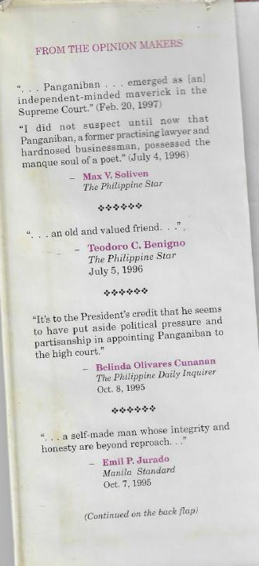

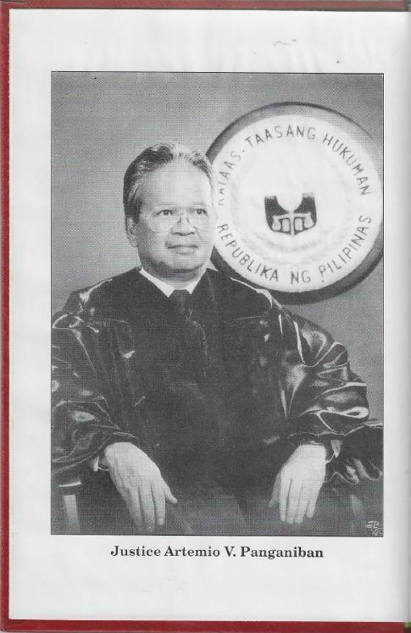



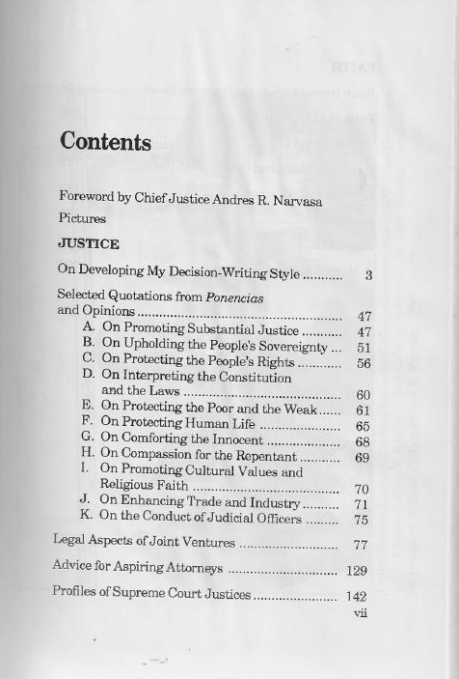
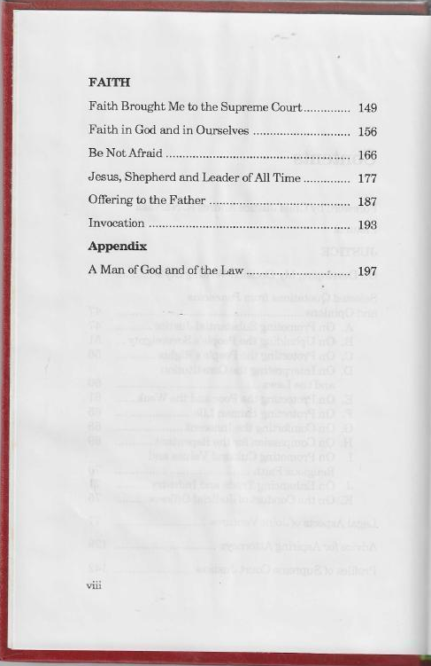

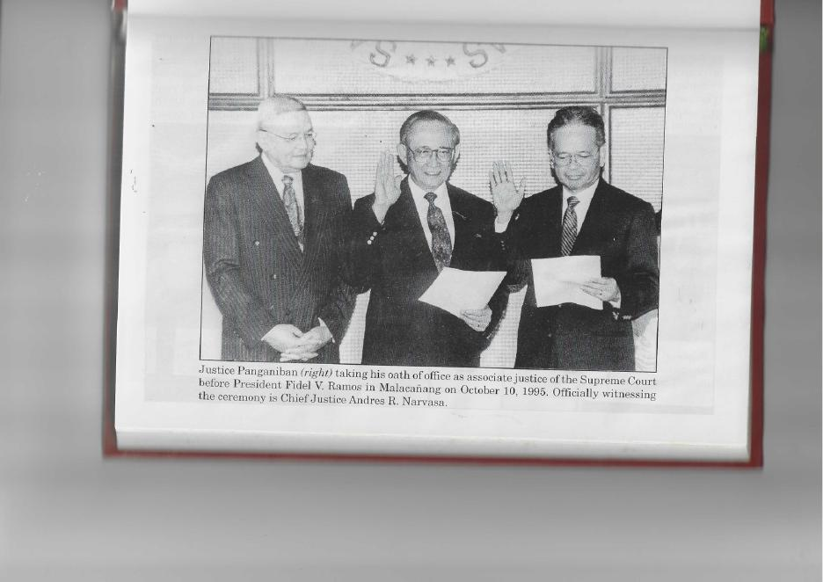
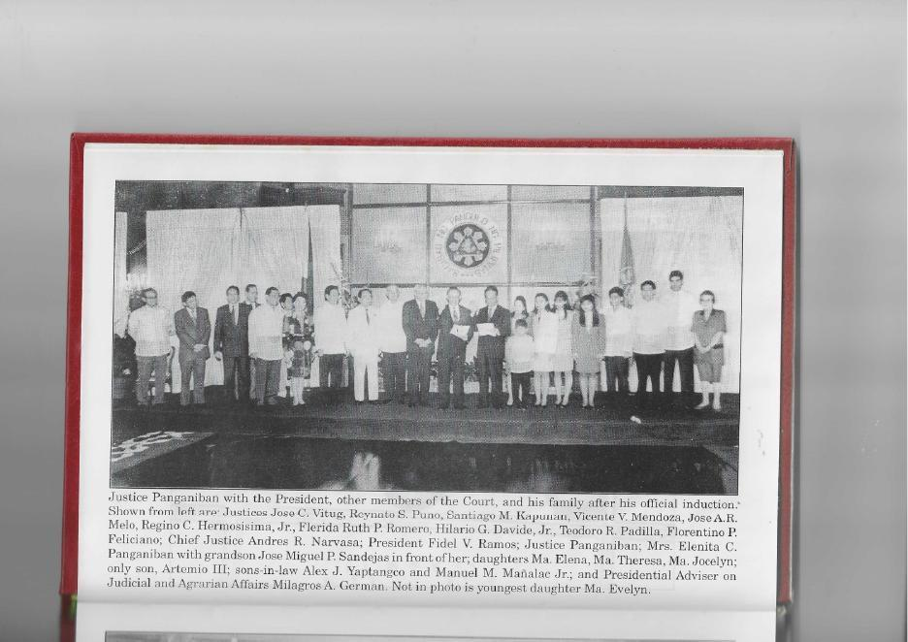
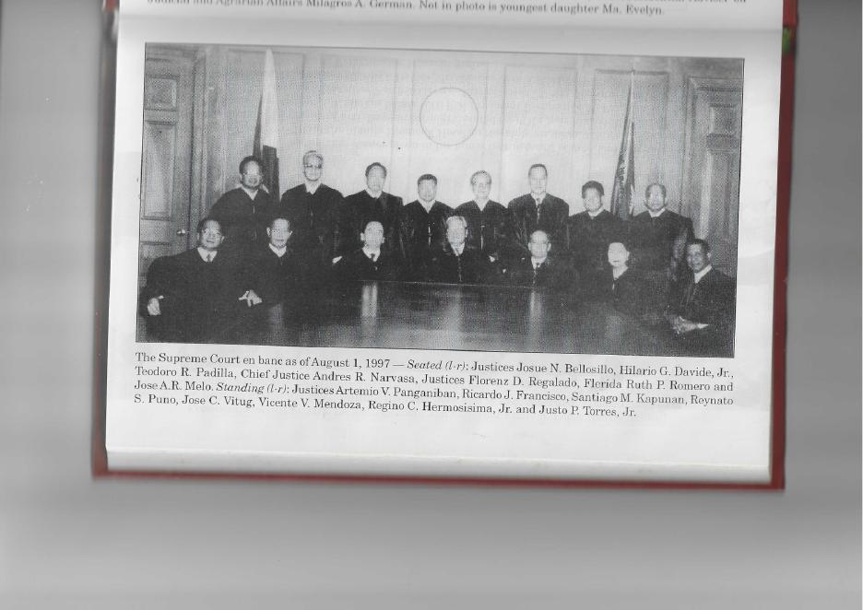
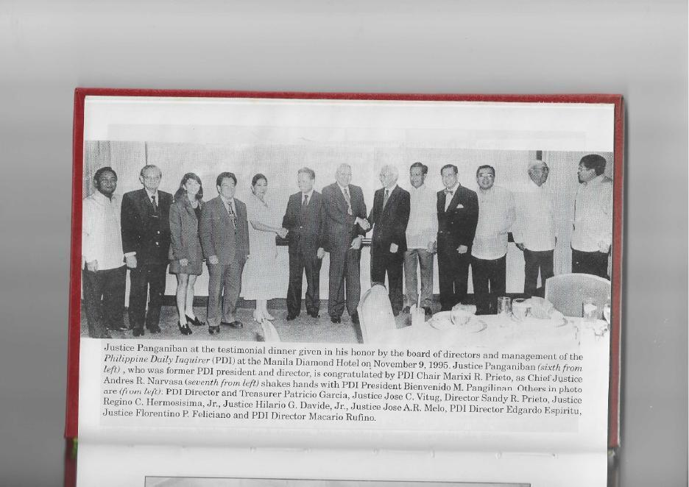
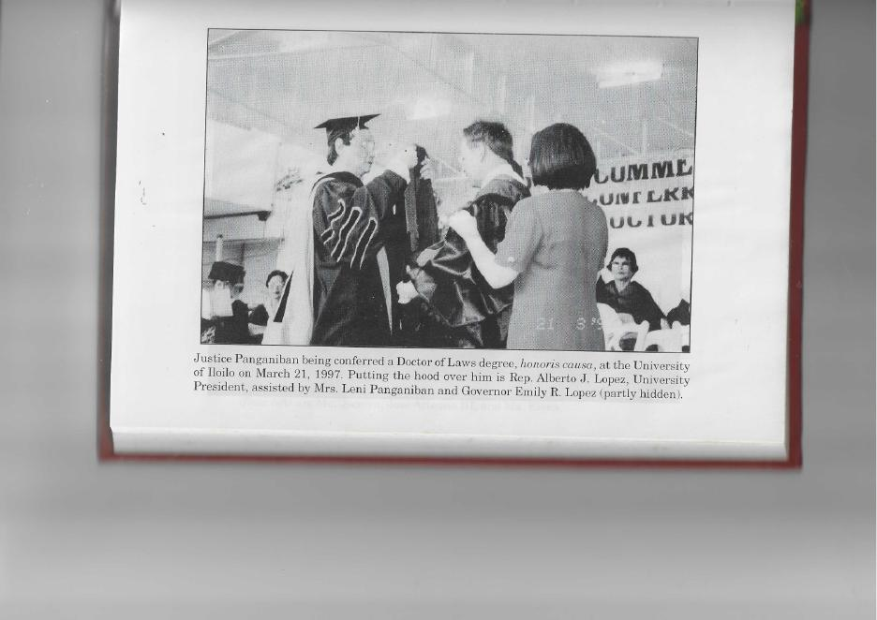
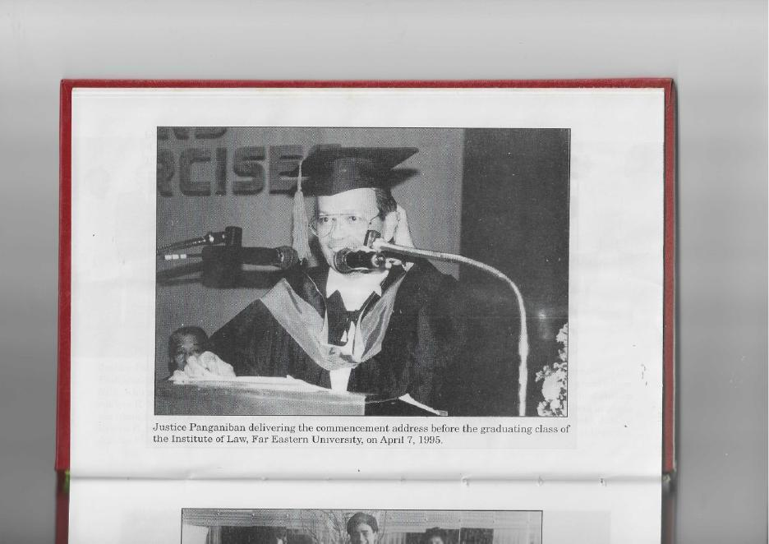
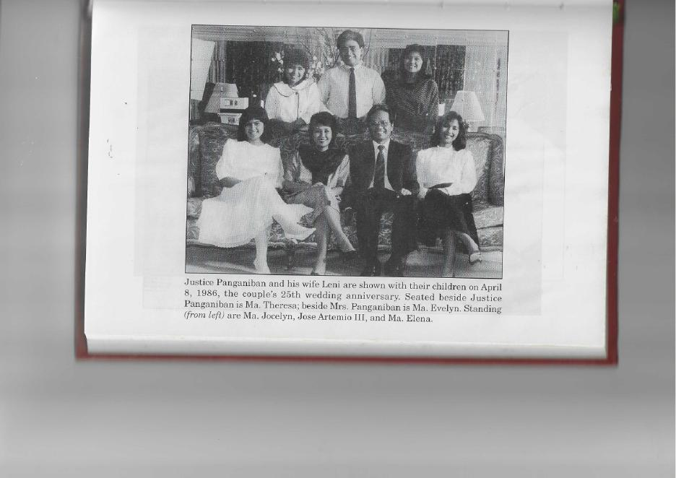
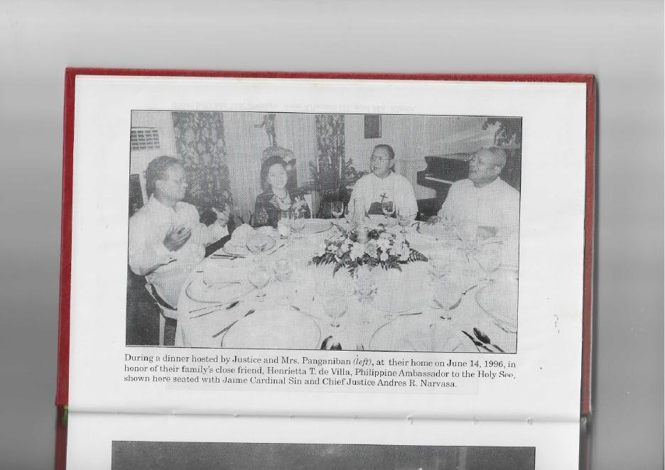
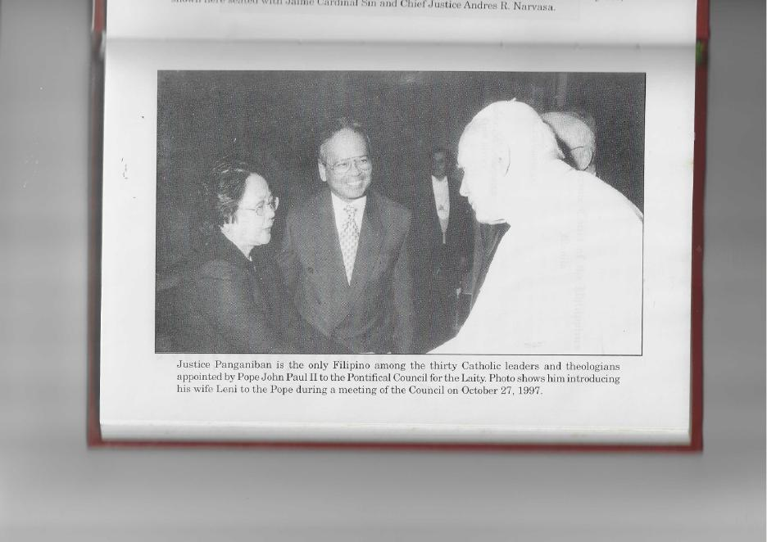
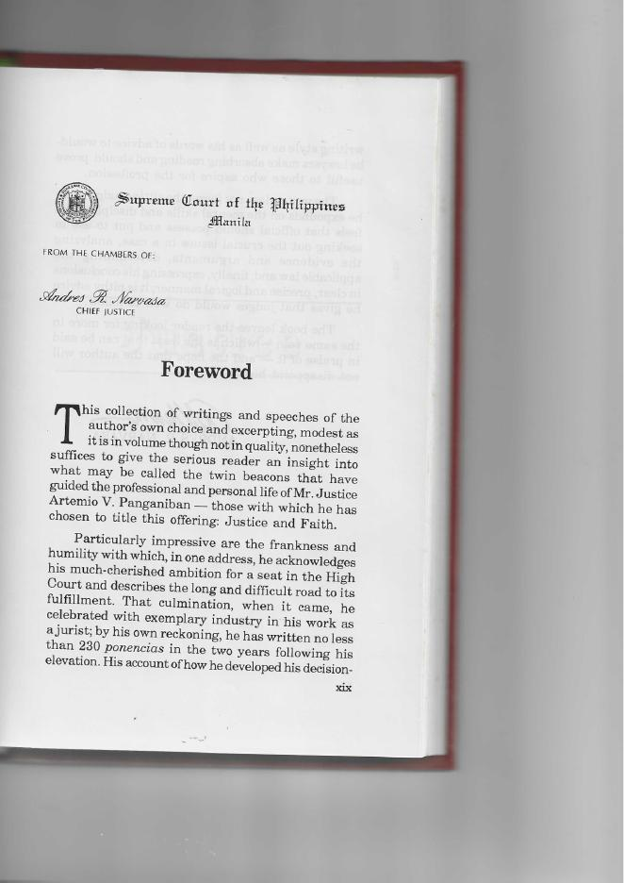

Foreword
Chief Justice Andres R. Narvasa

The collection of writings and speeches of the author’s own choice and excerpting, modest as it is in volume thought not in quality, nonetheless suffices to give the serious reader an insight into what may be called the twin beacons that have guided the professional and personal life of Mr. Justice Artemio Panganiban – those with which he has chosen to title this offering: Justice and Faith.
Particularly impressive are the frankness and humility with which, in one address, he acknowledges his much-cherished ambition for a seat in the High Court and describes the long and difficult road to its fulfillment. That culmination, when it came, he celebrated with exemplary industry in his work as a jurist; by his own reckoning, he has written no less than 230 ponencias in the two years following his elevation. His account of how he developed his decision-writing style as well as his words of advice to would-be lawyers make absorbing reading and should prove useful to those who aspire for the profession.
The writer does not forget the sitting judge when he expounds on the mental skills and disciplines he feels that official should possess and put to use in seeking out the crucial issues in a case, analyzing the evidence and arguments, determining the applicable law and, finally, expressing his conclusions in clear, precise and logical manner; it is pithy advice he gives that judges would do well to follow.
The book leaves the reader looking for more in the same vein – which is the least that can be said in praise of it – and the hope that the author will not disappoint him.

ANDRES R. NARVASA

JUSTICE

On Developing My Decision-Writing Style

Prologue

To commemorate my second year as a member of the Supreme Court, I thought of setting down the main features of the decision-writing style I have been developing. Being a non-career jurist – my appointment to the Supreme Court being my first full-time government job – I took my oath before President Fidel V. Ramos on October 10, 1995, without having authored a single judicial decision. Hence, I had to put together and evolve rather speedily my own decision-writing style and format. It did not take long, however, for me to produce my first opinions and decisions. My first extended opinion was my Dissent from the court’s en banc Resolution (denying the Motion for Reconsideration) in Imelda Marcos vs. Comelec promulgated 15 days after I assumed office. My first ponencia, on the other hand, was the unanimous en banc case of Ty vs. Trampe, promulgated 52 days after my said assumption. This case is significant not only because it was the first decision I penned, but also because it nullified an unreasonable increase in real estate taxes. Since then, I have written over 230 full-blown signed ponencia, 11 separate opinions (including dissenting and concurring ones), about 140 extended resolutions and some 675 minute resolutions disposing of cases. The ponencias and opinions have been bound into 11 volumes consisting of about 500 pages each or a total of 5,500 pages. Each ponencia averages 25 pages and each opinion, 12 pages. The unsigned extended resolutions constitute another volume. The minute resolutions, each consisting of only a few sentences, have not been collected and bound.

—--------------
I started preparing unsigned extended and minute resolutions right after my assumption into office.
An inventory by my staff showed I "inherited" over 700 pending cases from my predecessor. An additional 280 cases were "unloaded" to me by the other incumbent members of the Court when I assumed office. Thus, I was initially assigned about one thousand cases, excluding administrative matters and complaints against lawyers numbering about 100 more. Every month, each member of the Court, including me, receives, by raffle, about thirty-five (35) new judicial cases plus about 10 administrative cases (Because of their other responsibilities, the Chief Justice, the two senior justices who are Division chairmen and the next senior justice who is a "working chairman" receive about 50% less).
The longest is 72 pages, Tañada vs. Angara, G.R. No. 118295, May 2, 1997; while the shortest is four (4) pages, Cruz vs. Correctional Institute for Women, 262 SCRA 552, September 27, 1996.
The longest is 32 pages - Separate Opinion in People vs. Echegaray, G.R. No. 117472, February 7, 1997; and the shortest is three (3) pages - Separate Dissenting Opinion in Manila Prince Hotel vs. Government Service Insurance System, G.R. No. 122156, February 3, 1997.
Most of them consist of one or two pages. The longest is 12 pages.
—--------------
Even though my decisions are written primarily to resolve legal issues and are thus emblazoned with a considerable amount of endeavored to write in sim legalese, I have ple English, comprehensible as much as possible to a high school graduate. I want to be understood not only by the legal profession but also by the parties themselves, especially by persons accused of crimes, and by the public at large as regards cases involving interpretation of the Constitution. As I wrote in my Dissenting Opinion in Marcos:

"The Constitution is the most basic law of the land. It enshrines the most cherished aspirations and ideals of the population at large. It is not a document reserved only for scholarly disquisitions by the most eminent legal minds of the land. The Constitution is not intended for lawyers to quibble over, nor to define niceties and articulate nuances legal about, in the ascertainment of its import. Its contents and words should be interpreted in the sense understood by the ordinary men and women who place their lives on the line in its defense and who pin their hopes for a better life on its fulfillment."

More than lingual elegance and even legal pugnacity, I strive for simplicity, clarity and precision in nuances and shades of meanings. I believe that the trend in all professions and occupations - be they medicine, theology, science or music - is to be understood not just by the members of a particular discipline but by the public at large. While specialization cannot be avoided, generalization of public understanding is at the same time demanded in this age of mass communication, globalization and universal education. Indeed, no principle is so complicated and no mystery so deep that cannot be explained in clear and simple language to be capable of general understanding.
In my decisions, I also endeavor to answer and settle all relevant issues and questions raised by the parties. As a former practicing lawyer, one of my worst nightmares was to read a decision disposing of a case I argued based merely on one or two of the many issues I raised - or worse, on issues other than those raised. Sometimes, courts would narrate facts not backed by the records or the evidence. To avoid these — now that I am on the backside of the judicial bench - I strive to state facts as accurately as I can, in the words of the parties if possible, and to resolve all issues raised.
The features of the writing style presented here are progressive and cumulative. Thus, some of them may not be found in my first writings. They are collected and used gradually and increasingly as time goes by. The perceptive reader will find, for instance, that in my earlier ponencias, I did not capitalize the "R" in "Respondent Court,” or the “A” in "Appellant Juan dela Cruz.” Neither did I separate a topic under the title "Statement of the Case” or “The Case” as much as I did toward the latter part of the two-year period. Prospectively, I shall use much, if not all, of the features described here. In fact, it is possible that in the future I shall use more features than what are now included here. Thus, an update of this work may be needed from time to time.

—---------------
I must concede, however, that there are technical fields, like remedial law, which laymen may find difficult to comprehend. See, for instance, Arcelona vs. Court of Appeals, G.R. No. 102900, October 2, 1997, dealing on the grounds for voiding a final judgment; and Mondonedo vs. Court of Appeals, 252 SCRA 28, January 18, 1996, reiterating the doctrine that certiorari is not a substitute for a lost appeal.
In Municipality of Candijay, Bohol vs. Court of Appeals (251 SCRA 530, December 28, 1995), Cal us. Court of Appeals (251 SCRA 523, December 28, 1995), Jao & Company, Inc. us. Court of Appeals (251 SCRA 391, December 19, 1995) and Yu vs. Court of Appeals (251 SCRA 509, December 26, 1995) , I did not use many of the features explained in this article. These ponencias were originally intended as unsigned extended resolutions but my colleagues in the Third Division thought the Resolutions merited the signatures of the justices who unanimously concurred with them.
By “style," I do not refer to a distinctive form of prose or literary expression, as in "the style of Mark Twain," or “the style of St. Paul.” Rather, it is my own preference of subject presentation, typographic arrangement and display, use of tenses, punctuation, abbreviation, capitalization, etc., which I have adopted in writing my decisions.
—--------------

Each justice and judge in the Philippines or elsewhere has his/her own style of writing which characterizes pathways in his/her mind. By and large – except for glaring lapses in grammar, sentence construction, tenses, numbers, or typing - I believe there is no right or wrong style. And any claim of superiority or dominance in writing style by anyone would be pure hubris.
I would like to acknowledge the invaluable contribution of my Supreme Court staff in the evolution and development of my decision-writing style, particularly Atty. Joseph T. Cohon, who was my chief judicial staff officer from October 10, 1995 to December 31, 1996, Atty. Francisco Roberto D. Quilala, who took over from Atty. Cohon from February 5, 1997 to the present, Attys. Jonnel D. Espaldon (who joined my staff on November 13, 1995), Ramil A. Japa (March 18, 1996), Jerome L. de la Vega (October 1, 1996), Emma C. Matammu (November 5, 1996) and Suzanne D. Cobarrubias (May 29, 1997), as well as Ms. N.R. Evangelista (February 3, 1997), our English grammarian who, though not a lawyer, endeavors to cross all the t’s, and dot the i's in her final proofreading of my writings. May I also express my appreciation to my wife, Leni - who was herself a college editor and now a dedicated professor at the Asian Institute of Management – for her generous critique of some of my peregrinations after they have been released or promulgated.
Finally, may I express my deep appreciation to my colleagues in the Court, present and past, for their comments, suggestions, observations and questions: Chief Justice Andres R. Narvasa who is my current chairman in the Court's Third Division, Justices Florentino P. Feliciano (who December 17, 1995) who was my first retired on chairman, Teodoro R. Padilla (who retired on August Florenz D. Regalado, Hilario G. Davide 24, 1997), Ruth P. Romero, Josue N. Bellosillo, JoseJr., Flerida Reynato S. Puno, Jose C. Vitug A.R. Melo, Kapunan, Vicente V. Mendoza, Ricard , Santiago M. o J. Francisco, Regino C. Hermosisima Jr. (who will retire on October 18, 1997) and Justo P. Torres Jr. (who will retire on November 2, 1997). By their concurrence with and sometimes even by their dissents from my ponencias, they have inspired me to strive for excellence in doctrinal content and for improvement of my writing style. Whatever merit there may be in my ponencias, I ascribe to their kindness, grace and patience with this new jurist. But all the errors and faults are mine and mine alone. To all of them: Maraming salamat po.

PART I. FEATURES OF MY DECISION-WRITING STYLE

A distinct visual feature of my decisions is the use of topical titles or nomenclatures for their different parts. In general, the main parts of these decisions consist of: (1) an introduction or prologue, (2) the statement of the case, (3) the statement of facts, (4) the issues or assignment of errors, (5) the Court ruling in which each issue is separately considered and resolved, followed finally by (6) the dispositive portion. In cases in which controversial issues are involved or where new principles are introduced, an epilogue is included just prior to the disposition. In discussing my decision-writing style, however, I differentiate between criminal and noncriminal cases.

A. CRIMINAL CASES

1. Introduction, Prologue or Opening Statement
Decisions involving criminal cases usually open with a concise statement of the principal factual or legal issue/s of the case. For example:

"In seeking acquittal, appellant insists that the complainant was his sweetheart who willingly consented to the sexual congress.
or
"The appellant admits to having sexually molested the ten-year-old victim in this case, but claims that he merely used his fingers and is thus guilty only of acts of lasciviousness and not of rape."
or
"The accused-appellant admits having killed his wife but insists that he did so only after surprising her in the very act of sexual intercourse with another man. However, he fails to substantiate the stringent elements required by law to absolve him of criminal responsibility. His defense appears no more than an amalgam of confusion, contradiction and concoction.”

In some instances, the opening statement is an iteration of a legal maxim or principle most relevant to the resolution of the case. Thus, in People vs. Quinao, et al.," I wrote:

"In resolving this appeal, this Court once more stresses these general rules: alibi and denial are weak defenses which cannot prevail over the prosecution witnesses' unhesitating, positive and firm identification of the accused as the persons responsible for the crime; and conspiracy, like any element of the offense, must be proved as clearly and as convincingly as the crime itself."

In People vs. Binamira, I said:

"In acquitting the accused, this Court stresses two doctrines: (1) a violation of the accused's right to retain a counsel of his own choice during custodial investigation renders his extrajudicial confession inadmissible even where such confession was extracted on October 3, 1985, i.e., before the effectivity of the 1987 Constitution, and (2) to sustain a conviction anchored on circumstantial evidence, the prosecution must convincingly prove an unbroken chain of events from which only one fair and reasonable conclusion can be inferred - that of the guilt of the accused beyond reasonable doubt. Where such circumstances can be the subject of two possibilities, one of which is consistent with innocence and the other with guilt, then such evidence has not fulfilled the test of moral certainty and the constitutional presumption of innocence must be upheld." In other instances, I state my view on the nature and implications of the crime involved, such as in People vs. Julian:

"Rape is chilling, naked sadism. It is marked by the savagery and brutality of the assault on the helpless victim's privacy. Thus, a severe penalty is meted out by the State, as parens patriae, for this abhorrent crime, revealing the clear legislative intent to protect clear legislative women against the bestiality of persons who cannot controlled their libidinous proclivities."

The objective in placing an introduction to my ponencias is to show concisely but comprehensively the decisive point that disposes of the case. It also serves to acquaint readers with the specific nature of the controversy and the issues involved. With it, readers can determine right away whether further reading is useful or helpful to them.

However, the introduction or opening statement is not indicated by a title since it often consists of only a single sentence or paragraph.

2. Statement of the case or The Case
The introduction or opening statement is followed by a legal statement of the nature of the action. Criminal cases elevated to the Supreme Court normally involve ordinary appeals from trial court decisions imposing the penalty of reclusion perpetua or life imprisonment, and automatic review of decisions imposing the death penalty. The following are contained in this part of my ponencias:

a. the specific charge against the appellant/s and his other co-accused, if any (Thus, the accusatory portion of the information filed in court by the public prosecutor is always quoted in full).

b. the court of origin, the name of the judge who penned the decision, and the date of the appealed decision (Where the ponente is other than the judge who tried the case, both are named, usually in a pertinent footnote).

c. the criminal case number in the trial court
d. the plea of the accused
e. the dispositive portion of the assai led decision

—-------------
Sometimes there are decisions of the Court of Appeals or the Sandiganbayan which impose the same penalties. They are thus reviewed in general like those of trial courts. Where the penalty involved is less than life imprisonment, the proper remedy is a petition for review under Rule 45 of the Rules of Court. These latter cases are included in the topic, “Non-Criminal Cases.”
—------------
In some instances, I likewise indicate the names of the public prosecutor and the counsel de oficio or de parte. Naming the judge and the lawyers involved serves to encourage our public and private legal officers to render their best in the performance of their duties and functions in the administration and dispensation of justice. Their competence (or incompetence) is often demonstrated or evaluated, wittingly or unwittingly, in the disposition of the appealed case. Such competence refers not only to knowledge of substantive legal matters or procedural techniques, but also to their command of language or lack of it) as can be observed from the transcripts, pleadings and the assailed decision itself.
The verbatim reproduction of the criminal information guides this Court on the nature and the gravity of the offense for which said accused may be found culpable. As a rule, courts cannot convict an accused of a crime different from or graver than that charged. Unless for an "offense proved included in that which is charged" (Section 4, Rule 120 of the Rules of Court).
Mentioning the court of origin and the case number originally assigned to the particular case helps in facilitating the consolidation of the records of the case in both the trial and the appellate courts after entry of final judgment.
The plea of the accused is important to ensure that due process was accorded him. Absence of or irregularity in the arraignment may render the judgment void, and further consideration by this Court would be futile. In some instances, I may refer to the conduct of a preliminary investigation because this is a right granted by the Rules to the accused, without forgetting of course that the failure of the accused to question defects in the proceedings may mean a waiver thereof. Also, in some instances I mention the fact of appellant's detention in order to dispose of the preliminary query in appealed cases not subject to automatic review: whether or not the appellant has abandoned his appeal by escaping from detention.
Finally, the direct copy of the decretal portion of the assailed decision informs the reader of how the appealed case was decided by the court a quo. After all, this is the essential subject of review by this Court.

—-----------
In People vs. Ortega, Jr. (G.R. N o. 116736, July 25, 1997), Appellant Garcia could not be convicted of homicide for "attack[ing], assault[ing], and stab[bing] repeatedly with a pointed weapon x x x different parts of the body of one Andre Mar Masangkay" as alleged in the information filed in the trial court, because the prosecution evidence showed that he had nothing to do with the stabbing solely perpetrated by his co-accused. Neither could Garcia be convicted for the death of the same victim through drowning, which was proved to be the latter's immediate cause of death, because such was not charged in the information. The Court ruled, "To convict him of an offense other than that charged in the complaint or information would be a violation of [his] constitutional right [to be informed of the nature and cause of the accusation against him]."
In People vs. Lacerna (G.R. No. 109250, September 5, 1997), on the other hand, we held that illegal possession of a prohibited drug (penalized under Section 8 of the Dangerous Drugs Act) is deemed included in a charge of violation of Section 4 of the same law which penalizes “any person who, unless authorized by law, shall sell, administer, deliver, give away to another, distribute, dispatch in transit or transport any prohibited drug, or shall act as broker in any of such transactions.”
—------------

3. Statement of Facts or The Facts
The versions, of both the prosecution and the defense, of the facts of the case are usually presented in my ponencias. If they have been written clearly, accurately and sufficiently in the parties' respective pleadings or in the assailed decision itself or in the solicitor general's brief, I simply reproduce them verbatim. Otherwise, I restate them for better comprehension and appreciation.
Both the version of the prosecution and that of the defense are presented in the interest of fairness and due process. The resolution of most appealed criminal cases, unlike in civil and other cases, depends to a large extent on factual issues and the appreciation of evidence. The plausibility or incredibility of each version can sometimes be initially gleaned from a reading of the facts. The Court’s detailed evaluation of the contentions of the parties appears in the discussion of our ruling at the latter part of the decision.
The bases of the trial court in arriving at its findings and conclusions are also presented. Again, this apprises the reader of the reasons why the trial judge gave credence to the prosecution evidence while discounting that of the defense or vice versa. The fact that the assailed decision fully, intelligently and correctly resolves all factual and legal issues involved may partly explain why this Court finds no reason to reverse the lower court’s findings and conclusions. Conversely, a patent misappreciation of the facts or misapplication of the law by the trial court would aid in a better understanding of the reversal or the modification of its ruling.

—-----------
In my Separate (Concurring) Opinion in Esparas, I agreed with the majority that this Court has the inescapable duty to review lower courts' decisions imposing the death penalty even though the accused escaped detention. I further opined that such review should be undertaken “only after the accused is re-arrested and taken back into the custody of the law.”
Although normally representing the national government, its agencies and instrumentalities, the Solicitor General is expected to remain independent and without bias.
—-----------

4. Issues or Assignment of Errors
The appellant's assignment of errors as contained in his brief is usually copied verbatim. By stating the assigned errors, the Court is guided on what specific issues to delve into. The purpose in reproducing in toto the appellant's words is to avoid motions for reconsideration of the final decision on the ground that the Court failed to consider all assigned errors that could affect the outcome of the case.
Where the appellant presents repetitive issues or where his assigned errors do not strike at the main issue, I restate them in clearer and more coherent terms. In some instances, I include additional issues which, though not specifically questioned by the parties, are deemed important in order to render substantial justice. I exercise this discretion since appealed criminal cases are given de novo review in contrast to noncriminal cases in which this Court’s review is generally limited to issues specifically raised in the appeal.

—-----------
For examples, see People vs. Sumbillo, G.R. No. 105292, April 18, 1997, and Filoteo, Jr. us. Sandiganbayan, G.R. No. 79543, October 16, 1996. See People vs. Sol, GR. No. 118504, May 7, 1997. In People vs. Agunias, supra, the Court motu proprio reviewed the additional issue of whether treachery may be appreciated as a qualifying circumstance, despite the failure of the appellant to raise it as an error in his conviction by the trial court for murder even though no qualifying circumstance was alleged in the information.
—-----------

5. The Court's Ruling

This part begins with a single sentence stating how the Court disposes of the case under review. Examples are: "We affirm the judgment of the trial court”; “The appeal is not meritorious”; or “The appeal is bereft of merit.”
Where the assailed decision is modified, a lengthier and more explanatory paragraph is set forth. Thus:

"We affirm the findings of the trial court as regards the guilt of the appellants. However, the crime committed was not multiple murder with double frustrated murder, but four (4) separate crimes of murder committed against each of the four victims – Clarence Suitos, Macario dela Pena, Anicia Sales, and Luzviminda Pudol – and two (2) separate crimes of attempted (instead of frustrated) murder committed against Spouses Claro and Miceala Suitos.”
"We affirm the conviction of [A]ppellants Quinao and Sidro. Appellant Ortiz is acquitted for failure of the prosecution to prove beyond reasonable doubt his participation in the conspiracy to murder Cecilio Magpantay.”

Such a brief resolutory statement is followed by a full discussion and resolution of the specific errors or issues raised by the appellant as well as other issues identified by the Court as essential to a just disposition of the case. Where there are several errors assigned, each is separately addressed. Thus, the preliminary indication: "First Issue:", "Second Issue:” and so forth.
In some cases, an issue raised may need a detailed discussion of several subtopics. For clarity, subtopics are also individually taken up. Their titles are italicized, underlined, and left-justified.
In discussing and resolving the issues, I use the present tense. In fact, in the entirety of the ponencias - except in the statement of facts and the rulings of the lower courts - I normally use the present tense. In this manner, the drama of each case becomes more vivid and easier to understand, as if the parties or their counsel are actually and presently arguing, with the Court issuing the corresponding ruling or resolution thereon.

6. The Disposition or Dispositive Portion
The dispositive portion is the essential part of the decision. It states whether the appeal is granted, denied or modified; whether the appealed decision is affirmed, reversed or modified; whether the accused is convicted or acquitted. Sometimes the trial court may be correct in finding the guilt of the accused but may err in imposing the proper penalty. A common error is the lower court's occasional equation of life imprisonment with reclusion perpetua. These are different. So, too, the proper designation of the penalty — like prision mayor or reclusion temporal — is stated because each carries specific accessory penalties. Finally, to guide penal officers in case of acquittal, the clause "x x x his [the appellant's] RELEASE from confinement is immediately ORDERED, unless he is being detained for some other legal cause,"or words to the same effect, are added bearing in mind that a judgment of acquittal is unappealable and immediately executory.

B. NONCRIMINAL CASES

While essentially, my style in writing decisions involving criminal cases is similar to that in petitions for review from decisions of lower courts, administrative cases involving personnel in the judiciary, petitions for certiorari and other original actions before this Court, there are some marked differences. The main parts and topics are replicated, but some explanations are needed.

- Introduction or Prologue
By way of introduction or prologue, the main factual or legal issue or the relevant doctrinal rule is stated. In some cases, particularly those concerning public interest or those involving complicated commercial, scientific, technical or otherwise rare subject matters, a declaration of principle or a brief backgrounder on the subject serves as the introduction. Examples of these are found in Tañada vs. Angara in which the issue on the constitutionality of the country's adherence to the WTO Agreement was taken up, in Subic Bay Metropolitan Authority vs. Commission on Elections in which the exercise of local initiative was at issue, and in Fortune Motors (Phils.) Corp. vs. Court of Appeals in which a creative financial/commercial packaging scheme was involved.
—-------------
G.R. No. 118295, May 2, 1997, which had the following opening paragraph: "The emergence on January 1, 1995 of the World Trade Organization, abetted by the membership thereto of the vast majority of countries, has revolutionized international business and economic relations amongst states. It has irreversibly propelled the world towards trade liberalization and economic globalization. Liberalization, globalization, deregulation and privatization, the third millennium buzz words, are ushering in a new borderless world of business by sweeping away as mere historical relics the heretofore traditional modes of promoting and protecting national economies like tariffs, export subsidies, import quotas, quantitative restrictions, tax exemptions and currency controls. Finding market niches and becoming the best in specific industries in a market-driven and export-oriented global scenario are replacing age-old 'beggar-thy-neighbor' policies that unilaterally protect weak and inefficient domestic producers of goods and services. In the words of Peter Drucker, the well-known management guru, Increased participation in the world economy has become the key to domestic economic growth and prosperity.'"
262 SCRA 492, September 26, 1996, which had this introduction: "The 1987 Constitution is unique in many ways. For one thing, it institutionalized people's power in law-making. Learning from the bitter lesson of completely surrendering to Congress the sole authority to make, amend or repeal laws, the present Constitution concurrently vested such prerogatives in the electorate by expressly recognizing their residual and sovereign authority to ordain legislation directly through the concepts and processes of initiative and referendum."
G.R. No. 112191, February 7, 1997, which had the following introduction:
"To fund their acquisition of new vehicles (which are later retailed or resold to the general public), car dealers normally enter into wholesale automotive financing schemes whereby vehicles are delivered by the manufacturer or assembler on the strength of trust receipts or drafts executed by the car dealers, which are backed up by sureties. These trust receipts or drafts are then assigned and/or discounted by the manufacturer to/with financing companies, which assume payment of the vehicles but with the corresponding right to collect such payment from the car dealers and/or the sureties. In this manner, car dealers are able to secure delivery of their stock-in-trade without having to pay cash therefor; manufacturers get paid without any receivables/collection problems ; and financing companies earn their margins with the assurance of payment not only from the dealers but also from the sureties. When the vehicles are eventually resold, the car dealers are supposed to pay the financing companies - and the business goes merrily on. However, in the event the car dealer defaults in paying the financing company, may the surety escape liability on the legal ground that the obligations were incurred subsequent to the execution of the surety contract?”
—------------

2. Statement of the Case
The nature of the petition is indicated here. Generally, they are either petitions for review under Rule 45 or certiorari under Rule 65 of the Rules of Court or other original actions within the jurisdiction of the Supreme Court. Where the public respondent is the Court of Appeals, the National Labor Relations Commission or the Sandiganbayan, the particular division which decided the case elevated for review is mentioned and the members thereof named, with the ponente specified. This is for the same purpose as mentioning the trial judge and lawyers concerned in a criminal case.
Quoting the dispositive portion of the appealed decision also serves the same purpose as that in criminal cases. In instances where the appealed decision is a reversal or a substantial modification of the trial court’s, the disposition of the latter is also quoted in full.
Where the petitioner filed a motion for reconsideration in the lower tribunal, this is also mentioned, including a reference to the order or resolution denying the motion. This is important in certiorari proceedings where, as a rule, the filing of a motion for reconsideration is a condition precedent to a petition before this Court.

3. The Facts
Unlike in appealed criminal cases, the opposing sets of facts are, generally, no longer presented here. Issues for resolution usually involve questions of law, grave abuse of discretion or want of jurisdiction; hence, the facts of the case are often not disputed by the parties. With a few exceptions, factual issues are not entertained in noncriminal cases. Consequently, the narration of facts by the appellate body, when exhaustive and clear, is reproduced; otherwise, the material factual antecedents are reconstructed by the Court.
As in criminal cases, the ratio decidendi of lower court or body whose decision is under review is laid out for the same reasons. It aids the reader in understanding why the lower court ruled in a certain way and why this Court either finds no reason to reverse it or concludes otherwise.

4. Issue/s
The issues raised by the petitioner are often also quoted in full, unless they are verbose, in which case they are restated in plain and more comprehensible language. A lone and simple issue to be resolved, as most often in administrative cases is directly stated . A summary of the respective contentions of the parties and an evaluation of the same in the Court's ruling follow.
Unlike in criminal cases, the Court is limited to a review only of the specific legal issues raised in the petition which were likewise questioned in the lower courts. The few exceptions are errors of jurisdiction, or a question not raised that is necessary in arriving at a just decision on the case, or an unassigned error that is closely related to the error properly assigned or upon which the determination of the question properly raised is dependent. An appeal in noncriminal proceedings does not throw the whole case open to scrutiny by this Court.

5. The Court's Ruling

As in decisions on criminal actions, this part begins with a prefatory statement on how the Court disposes of the case - either in favor of the petitioner or merely affirming or modifying the decision of the public respondent. Examples are: "The petition is meritorious" or "The petition is bereft of merit" or "We find for the petitioner" or "The petition is partly meritorious."
Then each issue is also distinctively discussed and resolved. The position of each side is often summarized and the Court’s ruling follows. Where procedural questions are raised in addition to substantive ones, the former are preliminarily resolved. Subtopics under a main issue may also be discussed separately for clarity.
Where the case involves public interest or novel subject, an epilogue is added prior to the dispositive part of the decision. This summarizes the opinion of the Court on the principal subject of discourse in the decision. It may also lay out a long-term philosophy of law or guiding principle.

—------------
In my Separate Opinion in PIRMA vs. Comelec, G.R. No. 129754, September 23, 1997, I summed my view on the people's right to initiative in this wise:
"I believe in democracy - in our people's natural right to determine our own destiny. "I believe in the process of initiative as a democratic method of enabling our people to express their will and and chart their history. Initiative is an alternative to bloody revolution, internal chaos and civil strife. It is an inherent right of the people — as basic as the right to elect, the determination and the right to individual liberties. I believe that Filipinos have the ability and the capacity to rise above themselves, to use this right of initiative wisely and maturely, and to choose what is best for themselves and their posterity.
"In the end, the mission of the judiciary is to discover truth and to make it prevail. This mission is undertaken not only to resolve the vagaries of present events but also to build the pathways of tomorrow. The sum total of the entire process of adversarial litigation is the verity of facts and the application of law thereto. By the majority copout in this mission of discovery, our country and our people have been deprived not only of a basic constitutional right, as earlier noted, but also of the judicial opportunity to verify the truth."
—--------------

6. Dispositive Portion
Finally, I lay down the fallo of the case, which is the real judgment in a litigation. It states whether the petition is granted or denied, and/or whether the appealed decision is affirmed, modified or set aside. Where the appealed judgment is nullified or set aside, the new judgment rendered by the Court is set down herein. In administrative cases supported by substantial evidence, the fallo indicates the liability of the private respondent and also the penalty imposed (whether dismissal from the service with its accessory penalties, suspension, reprimand, fine, etc.) Where the penalty is lower than dismissal, the warning clause "the commission of the same or similar acts in the future shall be dealt with more severely by this Court” or words of similar import.

C. SEPARATE OPINIONS

The format of my separate opinions differs from that in my ponencias. In my separate (as well as concurring and dissenting) opinions, I state directly either the holding of the Court majority or the issues of the case. Then I briefly express my view thereon (whether agreeing or not) before proceeding to discuss fully the reasons behind such stance. I no longer state the nature of the case and its factual antecedents since these are already laid down in the main decision. Generally, the only topical titles in my opinions are the different issues presented for resolution. In some instances, particularly where a novel subject involving the public interest is at issue, I also add an epilogue. Finally, I normally cast my vote on whether to grant or to deny the petition or the appeal; or to affirm, reverse or modify the lower tribunal's judgment.

PART II. FORMAT AND PRINTING PRESENTATIONS

My choice of format and printing presentations for my decisions are matters of style - not matters of right or wrong. I find their use convenient and practical. Basically, these are the guidelines I follow:

1. The following are italicized:
a. foreign words and phrases (including the punctuation mark that follows)
e.g. reclusion perpetua et al.
dacion en pago prima facie
pakikipagkapwa-tao pakikisama
generalia specialibus non derogant motu proprio

Exceptions: foreign words or phrases that have been assimilated into the English language.

e.g. habeas corpus ante mortem
mandamus ergo

b. titles of cases referred to in the decision (no need to enclose in quotation marks)

e.g. People vs. Manambit Apiag vs. Judge Cantero
Tañada vs. Angara Ledesma vs. Court of Appeals

c. the issue in the topical title (also bold and underlined)

e.g. First Issue: Are Petitioners Regular Workers?

d. key words in the dispositive portion (also bold and capitalized)

e.g. AFFIRMED SET ASIDE
REVERSED MODIFIED

e. words given emphasis (bold type or underline are other options)
e.g. "We should also consider the man's sincerity in his repentance, his genuine effort at restitution and his eventual triumph in the reformation of his life."
"However, in clear contradiction of its view that only two persons served as 'decoys' with a lone unidentified gunman inflicting the desired result of the ambuscade, the trial convicted appellant as a principal and court Llames and Mamuri as accomplices.

f. J. - which is used to abbreviate "Justice"
JJ. - its plural form

Where the full name is written, I precede it with J, as in "J. Jose A. R. Melo." Where only the surname is written, I place J at the end, as in "Vitug, J."

g. titles of books, newspapers, works of art and similar written works referred to in the decisions

e.g. "The text of the WTO Agreement is written on pages 137 et seq. of Volume I of the 36-volume Uruguay Round of Multilateral Trade Negotiations and includes various agreements and associated legal instruments x x x.
"To quote Pope John Paul Il in his encyclical Evangelium Vitae (A Hymn to Life), 'punishment must be carefully evaluated and decided upon, and ought not to go to the extreme of executing the offender except in cases of absolute necessity; x x x
"Petitioner Philippines Today, Inc. (PTI) is the owner of the Philippine Star, a daily newspaper of national and international circulation, x x x."

2. The following are capitalized:
a. Court - when used to refer to the Supreme Court and a lower court whose decision is under review
e.g."x x x under Rule 65, this Court does not, as a rule, evaluate the sufficiency of evidence upon which the labor arbiter and public respondent based their determinations."
"In deciding this appeal, the Court is guided by certain well-established principles in reviewing rape cases, to wit x x x."
"Further, the Respondent Court found that the oppositors were afforded the opportunity to explain matters fully and present their side."

b. Decision/Resolution/Order - when used to refer to the Decision, Resolution or Order under review by the Supreme Court, or to the very Decision or Resolution of the Court
e.g. The dispositive portion of the assailed Decision reads: x x x
In a Resolution dated November 16, 1993, petitioner's motion for reconsideration was denied. "It suffices to state that the Resolution of this Court dated June 2, 1995 affirming the liability of South Sea does not by itself necessarily preclude the petitioner from proceeding against private respondent."
Hence, [the issue on the constitutionality of RA 7659] was not passed upon by this Court in its Decision affirming the trial court's sentence of death."

C. Information, Complaint and other significant pleadings of the parties to the case under review when they are specifically identified, but not when they are merely referred to in general
e.g. "After preliminary investigation, three Informations charging Lao and Asprec with the offense x x x were filed by Asst. Fiscal Felix S. Caballes before the trial court on May 11, 1984 x x x."
The two Amended Complaints, both dated October 26, 1987, sworn to by the victim and certified by 4th Asst. Fiscal Rodulfo G. Ugsad, indicted the accused as follows: x x x"
"[Appellant's] testimony is synthesized in the Appellant's Brief: x x x

d. Appellations or titles immediately followed by a proper noun
e.g. Counsel de Oficio Reynold S. Fajardo
Private Complainant Nelia Agtarap
Prosecution Witnesses Solidarios and Nagallo

e. Abbreviation of a division or a volume of a written work appearing with a numeral (except abbreviations of edition, page and paragraph)

e.g. Art. 1, Chap. II; Sec. 10; Vol.
"However, the Constitution [Sec. 10 (2), Art. XIII] simply states that x x x.
BUT: 2nd ed., p. 20, par. 4

f. An important event, era, or period
e.g. the Second World War
the EDSA Revolution

g. The title or position of a per position, usually referring to only one of its kind in the country or in the world
e.g. the President of the Philippines
the Pope
the UN Secretary General

BUT: secretary of justice; commissioner; senator
(unless used as an appellation before the name of the official concerned, such as Senator Jovito R. Salonga)

3. For omitted portions of a quote paragraph, "x x x" is used instead of ellipsis (. . .). When the omitted part is a whole paragraph or more, a triplicate thereof is put in the middle, between the paragraphs quoted.
e.g. "His letter [footnote omitted] partly stated:
'It certainly beats me to be told that my ‘resignation' has been accepted, when in truth and in fact, no such move, however implicit it may be, and no such letter has ever been made from my end.
x x x x x x x x x
['lI am writing this letter not, certainly, to make any appeal, but simply to go on record that I did not resign. I filed a leave of absence. Yes. And that was duly (sic) approved. Then I sent you a memorandum for file expressing my sentiments on certain things, a candid statement that came to b4 (sic) expressed inspired by your candor and sincerity in our last little chat. Now if you read that memo to mean resignation , that is your responsibility. And I am not just about to contest it. x x x."

4. The full term or phrase is written out first before its abbreviation or acronym enclosed parentheses. Periods are not used even if there is an option to do so, such as in those standing for names of government offices, broadcasting stations, organizations, military or police titles.
e.g. National Labor Relations Commission (NLRC)
World Trade Organization (WTO)
SP02

5. Time is either spelled out or in numbers. When in numbers, the abbreviations "a.m." or "p.m." (always in lower case) are used to indicate the time of day.
e.g. eight o'clock in the morning or 8:00 a.m.
ten thirty in the evening or 10:30 p.m.

The term "o'clock" is used only with exact hours that are spelled out; not when the minutes are also indicated or when figures are used.

6. Dates are written in the American format, thus:
Month [spelled out] Numerical Date, Year
e.g. October 10, 1997

7. Within a quoted material, brackets ([]) are used to set off added information, an explanatory note, an inserted word or phrase for grammatical consistency; in short, words or figures that are not from the author of the material quoted, including the word "sic" to indicate that the error is in the original.
e.g. "The trial court also cited Ministry of Justice
Opinion No. 48, Series of 1982, which in its pertinent portion provides:
'It bears emphasis that the publication requirement under Section 23 [of PD 1529] has a two-fold purpose; x x x

8. The following font styles are used:
a. Garamond 14 for the main text of the decision
b. Arial 13 for indented quoted material within the body of the decision
c. Garamond 12 for footnotes
d. Arial 11 for indented quoted material within a footnote.

(During my first nine months in the Court, I had no access to a laser printer, so I had to make do with a dot matrix for my first 75 decisions.)

9. The footnoting format I use is as follows:
9.1 Cases
a. Titles are italicized. It is sufficient to mention only the first party (surname only, in case of an individual) named for each opposing side if there is more than one.

e.g. Where the full title is "Juan Castillo and Maria Masangya-Castillo (substituted by their legal heirs and children, Alejandro Castillo, Constancia C. Villanueva, Crisostomo Castillo, Preseliana C. Ismael and Indalicio Castillo) vs. Court of Appeals, Regional Trial Court of Aklan (Branch 3) and Rosita Masangya," it is sufficient to cite it as Castillo vs. Court of Appeals.

To refer to a criminal case such as "People of the Philippines vs. Teddy Quinao, Rolando Sidro and Baltazar Ortiz," People vs. Quinao is sufficient.

b. Where the case cited is found either in the Supreme Court Reports Annotated (SCRA) or Philippine Reports (Phil.), the volume number, (beginning) page number and the date of promulgation are indicated. The case number is omitted for the sake of brevity, as the foregoing sufficiently identifies the source (despite the opinion of the University of the Philippines Law Center that the case number should be included because SCRA is not an official publication.)
e.g. Aratuc vs. Comelec, 88 SCRA 251, February 8 1979
Ang Tibay vs. Court of Industrial Relations,
69 Phil. 635, February 27, 1940.

c. Where a part of the cited material is quoted verbatim, the specific page where it is found is also indicated.
e.g. People vs. Cabilao, 210 SCRA 326, 337, June 25, 1992.

In some instances, particularly where a direct quotation is reproduced, or where contradictory rulings are set out, the ponente of the case cited is mentioned (although this may also be done in the body of the decision).
e.g. "Alvir vs. Vera, 130 SCRA 357, 361-362, July 16, 1984. Per J. Lorenzo R. Relova."
"People vs. Obngayan, 55 SCRA 465, 474 , January 31, 1974, per Antonio, J."

d. Where the case cited was recently promulgated and not yet printed in the SCRA or Philippine Reports, I indicate its G.R. number instead. The page number, preceded by "p." or "pp." is placed after the date.
e.g. People vs. Gabris, G.R. No. 116221, July 11, 1996, p. 10.

e. Where the case cited also quotes from another source, the footnote may be in either of these formats:
Bersabal vs. Salvador, 84 SCRA 176, 179-180, July 21, 1978, citing Dizon vs. Encarnacion, 9 SCRA 714, 716-717, December 24, 1963.
Or:
Dizon vs. Encarnacion, 9 SCRA 714, 716-717, December 24, 1963, cited in Bersabal vs. Salvador, 84 SCRA 176, 179-180, July 21, 1978.

When using a source which cites several (more than two other sources, the phrase "citing several cases" is simply added after the main citation.
e.g. Fuentes v. Court of Appeals, G.R. No. 109849, February 26, 1997, citing several cases.

f. In citing more than one case, each is separated by a semicolon.
e.g. People vs. Boniao, 217 SCRA 653, 667, January 27, 1993; People vs. Galit, 230 SCRA 486, 496, March 1, 1994; People vs. Manlulu, 231 SCRA 701, 708, April 22, 1994.

9.2 Books
a. Book titles are also italicized.
b. Normally, only the last name of the author is mentioned.
c. Format
Author's surname, title, volume number (if any, preceded by "Vol." and in roman numerals), year of edition (followed with "ed."), page number (preceded by p. or pp. if referring to several pages.)
e.g. Regalado, Remedial Law Compendium, Vol. I, 1997 ed., p. 10; Salonga, Private International Law, 1995 ed., pp. 35-38.
Agoncillo and Alfonso, A Short History of the Filipino People, 1961 ed.[,] p. 38.

9.3 Records/Rollo
a. The page number/s in the records or rollo , as the case may be, of the cited material (usually a pleading, a decision, an order, or a documentary evidence) is indicated.
e.g. Rollo, pp. 2-20.

b. Where the cited material is found in both the rollo and the records of the case, both may be indicated but separated by a semicolon. (Plain rollo automatically refers to the Supreme Court rollo. When referring to the Court of Appeals' rollo of the case, I use CA rollo.)
e.g. Rollo, pp. 2-20; records, pp. 50-68.
CA rollo, pp. 10-18.

c. Where reference is made to a pleading filed by a party to the case, a decision, an order or a resolution issued in relation to the case, its date is also indicated, unless such decision, order or resolution is the subject of review. In the latter case, it is simply referred to as assailed or appealed Decision, Order or Resolution, as the case may be.
If contained in the rollo or records, then the same is indicated together with the page number/s.
e.g. Solicitor General's Comment, p.8; rollo, p.35. RTC Order dated June 20, 1988; records p.30.
49 Ibid.
Assailed Decision, pp. 10-11; rollo, pp. 12-13.

9.4 TSN
It means "transcript of stenographic notes."
In citing a TSN, this format is used:
TSN, date, page number/s (preceded by p. or pp. as the case may be)
e.g. TSN, June 13, 1995, pp. 3-5.

9.5 Ibid./Supra
a. These are italicized.
b. Ibid., being the abbreviation for ibidem (meaning, in the same place or in a reference immediately preceding), is followed by a period; while supra (which means above, further back or earlier) is not, unless found at the end of the footnote.
e.g. Ibid., p. 7.
People vs. Reyes, supra.

c. Where reference is made to a source already used earlier in the decision, it may be referred to simply by the word "supra." If several pages or footnotes separate them, the footnote number assigned earlier may be indicated on second reference to facilitate its location.
e.g. Supra, note 5. (where the source being cited again is already found in footnote no. 5)
Supra, note 5, p. 195 (when referring to a source previously cited but the text newly cited is on a different page of the source. This page number refers to the cited text, not where the footnote is found.)
9.6 Cf.
It means "compare."
e.g. Cf. Vitug, Compendium of Civil Law and Jurisprudence (1993), p. 547,
I can write on and on about improving my decision-writing style and about topics like the use of punctuation marks, the positioning of participial phrases, the use of more vivid and compelling words and the shades and meanings of commonly used expressions. Perhaps, on another occasion, I will do so. But for now I must end.

Epilogue

My first two years in the Court have been very challenging and engaging. I had to do my share in reducing the case backlog of the Court. I worked day and night, even on weekends. I have never been absent or late from any Court session. In fact, I cannot remember ever having preoccupied in all my life. But I am not complaining. I must quickly add that I enjoyed and will always cherish all those full days and long nights. And I look forward with more relish and intensity to the remaining years of my term.
When I joined the Court, I sold completely and absolutely my interests in my law firm, resigned from my business involvements and cut off memberships in professional, civic, religious, charitable and other non-judicial associations, with the exception of three. I also severely limited my presence in social functions, attending only when there were special reasons like family get-togethers, weddings or anniversaries of very close friends, sports competitions (golf and tennis) with members of the judiciary or close relatives and friends with whom I was already playing prior to my appointment or who, in any event, have no known litigations before the Court.
Some of my relatives and friends must be disappointed with me - a burden I must bear - because I refuse to receive visitors and telephone calls, and I shun any conversation regarding my work. In fact, I have given written instructions to the Supreme Court security force not to allow any visitor in my chamber without my prior express permission. And when people write to me about the Court matters, even those marked "personal," I always include them in the Court's agenda for proper notation. I feel there is nothing "personal" about matters pending before the Court, and fairness demands that every item involving litigations must be brought to the Court's or, at least, the Chief Justice's attention and, when appropriate, also to the opposing side. Whenever the opportunity is present - particularly during the few speaking engagements I accept — I make it a point to tell my audience to do me the favor of not writing or calling me up or discussing with me any matter pending before the Court.
I cannot close this anniversary piece without thanking our Lord Jesus Christ for the graces and blessings He has mercifully showered me. In trying to help render justice in our sinful world, my prayer is that I may be granted wisdom, discernment and courage to do His will. "Your will be done, oh Lord, not mine."

—--------
If the 6000 pages of ponencias, opinions and extended resolutions I penned for the Court are divided by the two years or 731 days I have served, that would mean I produced an average of 8.2 pages everyday including Saturdays, Sundays, and holidays. In addition, I had to report on an average of about 35 items assigned to me during Division sessions of the Court on Mondays and Wednesdays and the about 12 items during en banc meetings every Tuesday, aside from reading and studying the proposed ponencias and recommendations of the 14 other members of the Court.
Under Art. VIII, Sec. 11 of the Constitution, members of the Court shall serve, during good behavior, or until the age of seventy (70) years.
After my first two years, I will have a lessened caseload, not only because of my foregoing dispositions but also because I would have the privilege of "unloading" old cases to incoming appointees to the Court. As a rule, these old cases - meaning, more than two years from submission of the last pleading — may no longer be penned by more than two-year incumbents, per the Constitution. Perhaps, now I can look forward to "smelling the flowers" on workless Sundays.
Prior to my appointment, I was active in more than 15 organizations from all of which I had to resign, except in three: (a) Pontifical Council for the Laity, (b) Rotary Club of Manila, and (c) Bantayog ng mga Bayani Foundation. There are precedents allowing incumbent justices to be members of these organizations like Feria, J. in PCL; Malcolm, Paras and Padilla, JJ. in RCM; and Yap, C.J. and Sarmiento, J. in Bantayog. In addition, I serve as a Special Minister of Holy Communion when I attend masses in my parish, where there is likewise a precedent - Vitug, J. serves as SMHC in his parish.
In moments of solitude and personal prayer, I contemplate my nothingness, my unworthiness before my Lord and Savior, and I always break out with a thanksgiving, reminiscent of St. Paul’s First Letter to Timothy (1 Tim 1:12-17).
—--------------

Selected Quotations from Ponencias and Opinions

- On Promoting Substantial Justice

The real essence of justice does not emanate from quibblings over patchwork legal technicality. It proceeds from the spirit’s gut consciousness of the dynamic role of law as a brick in the ultimate development of the social edifice. Thus, the Court struggled against and eschewed the easy, legalistic, technical and sometimes harsh anachronisms of the law in order to evoke substantial justice in the larger social context consistent with Frivaldo’s unique situation approximating venerability in Philippine political life. (Frivaldo v. Commission on Elections, G.R. No. 120295, June 28, 1996, 257 SCRA 727)

In deciding cases, this Court does not matter-of-factly apply and interpret laws in vacuum. General principles do not decide specific cases. Rather, laws are interpreted always in [the] context of the peculiar factual situation of each case. Each case has its own flesh and blood and cannot be decided simply on the basis of isolated clinical classroom principles. The circumstances of time, place, event, person, and particularly attendant circumstances and actions before, during and after the operative fact should all be taken in their totality so that justice can be rationally and fairly dispensed. (Philippines Today v. NLRC, G.R. No. 112965, January 30, 1997)

Upon the other hand, the Supreme Court is not just a toothless promoter of procedural niceties which are understood and appreciated only by lawyers and jurists. It cannot shrink from its quintessential role as the fountain of speedy, adequate and substantial justice. If the Court, as the head and guardian of the judicial branch, must continuously merit the force of public trust and confidence - which ultimately is the real source of its sovereign power, possessing neither the purse nor the sword - and if it must decisively discharge its sacred duty as the last sanctuary of the oppressed and the weak, it must, in appropriate cases like the one before us, proactively provide weary litigants with immediate legal and equitable relief, free from the delays and legalistic contortions that oftentimes result from applying purely formal and procedural approaches to judicial dispensations. (Leonor v. Court of Appeals, et al., G.R. No. 112597, April 2, 1996, 256 SCRA 69)

Truly, law must be understood not by "the letter that killeth but by the spirit that giveth life." Law should not be read and interpreted in isolated academic abstraction nor even for the sake of logical symmetry but always in [the] context of pulsating social realities and specific environmental facts. (Obosa v. Court of Appeals, G.R. No. 114350, January 16, 1997)

In all cases involving alleged ill-gotten wealth brought by or against the Presidential Commission on Good Government, it is the policy of this Court to set aside technicalities and formalities that serve merely to delay or impede their judicious resolution. This Court prefers to have such cases resolved on the merits before the Sandiganbayan. Substantial justice to all parties, not mere legalisms or perfection of form, should now be relentlessly pursued. Eleven years have passed since the government started its search for and reversion of [the] alleged ill-gotten wealth. The definitive reso lutio n of such case s on the mer its is thus long overdue. If there is adequate proof of illegal acquisition, accumulation, misappropriation, fraud or illicit conduct, let it be brought out now. Let the titles over these properties be finally determined and quieted down with all reasonable speed, free of delaying technicalities and annoying procedural sidetracks. (Republic v. Sandiganbayan, G.R. No.113420, March 7, 1997)

While this Court recognizes the right to speedy disposition [of cases] quite distinctly from the right to a speedy trial, and although this Court has always zealously espoused protection from oppressive and vexatious delays not attributable to the party involved, at the same time we hold that a party's individual rights should not work against and preclude the people's equally important right to public justice. In the instant case, three people died as a result of the crash of the airplane that the accused was flying. It appears to us that the delay in the disposition of the case prejudiced not just the accused but the people as well. Since the accused has completely failed to assert his right seasonably and inasmuch as the respondent judge was not in a position to dispose of the case on the merits due to the absence of factual basis, we hold it proper and equitable to give the parties fair opportunity to obtain (and the court to dispense) substantial justice in the premises. (Guererro v. Court of Appeals, G.R. No. 107211, June 28, 1996, 257 SCRA 703)

In the Nuremberg trials, the defendants were military officers of the Third Reich who were dutybound to obey direct orders on pain of court martial and death at a time when their country was at war. Nonetheless, they were meted out death sentences by hanging or long-term imprisonments. In the present case, the accused are civilian officials purportedly complying with a memorandum of the Chief Executive when martial law had already been lifted and the nation was in fact just about to vote in the "snap" presidential election in 1986. The Sandiganbayan did not impose death but only imprisonment ranging from seventeen years and one day to twenty years. Certainly, a moral choice was not only possible. It was in fact available to the accused. They could have opted to defy the illegal order, with no risk of court martial or death. Or they could have resigned. They knew or should have known that the P55 million was to be paid for a debt that was dubious and in a manner that was irregular. That the money was to be remitted in cold cash and delivered to the private secretary of the President, and not by the normal crossed check to the alleged creditor, gave them a moral choice to refuse. That they opted to cooperate compounded their guilt to a blatant conspiracy to defraud the public treasury.

Mercy and compassion are virtues which are cherished in every civilized society. But before they can be invoked, there must first be justice. The Supreme Court's duty is to render justice. The power to dispense pardon lies elsewhere. Verily, the Constitution ordains a final conviction by the courts before the President can exercise his power to wipe away the penalty. Such is the legal and natural precedence and order of things: justice first before mercy. And only he who sincerely repents his sin, restitutes for it, and reforms his life deserves forgiveness and mercy. (Dissenting Opinion in Tabuena v. Sandiganbayan, et al., G.R. No.103501-03, and Peralta v. Sandiganbayan, G.R. No. 103507, February 17, 1997).

B. On Upholding the People's Sovereignty
Like elections, initiative and referendum are powerful and valuable modes of expressing popular sovereignty. And this Court as a matter of policy and doctrine will exert every effort to nurture , protect and promote their legitimate exercise. For it is but sound public policy to enable the electorate their free and untrammeled will, not to express only in the election of their anointed lawmakers and executives, but also in the formulation of the very rules and laws by which our society shall be governed and managed. (Subic Bay Metropolitan Authority v. Comelec , G.R. No. 125416, September 26, 1996)

With all due respect, I find the majority's position all too sweeping and all too extremist. It is equivalent to burning the whole house to exterminate the rats, and to killing the patient to relieve him of pain. What Citizen Delfin wants the Comelec to do we should reject. But we should not thereby preempt any future effort to exercise the right of initiative correctly and judiciously. The fact that the Delfin Petition proposes a misuse of initiative does not justify a ban against its proper use.

By way of epilogue, let me stress the guiding tenet of my Separate Opinion. Initiative, like referendum and recall, is a new and treasured feature of the Filipino constitutional system. All three are institutionalized legacies of the world-admired EDSA people power. Like elections and plebiscites, they are hallowed expressions of popular sovereignty. They are sacred democratic rights of our people to be used as their final weapons against political excesses, opportunism, inaction, oppression and misgovernance; as well as their reserve instruments to exact transparency, accountability and faithfulness from their chosen leaders. While on the one hand, their misuse and abuse must be resolutely struck down, on the other, their legitimate exercise should be carefully nurtured and zealously protected. [Separate Opinion (Concurring and Dissenting) in Santiago v. Comelec, G.R. No. 127325, March 19, 1997]

At balance, the question really boils down to a choice of philosophy and perception of how to interpret and apply laws relating to elections: literal or liberal, the letter or the spirit, the naked provision or its ultimate purpose, legal syllogism or substantial justice, in isolation or in the context of social conditions, harshly against or gently in favor of the voters' obvious choice. In applying election laws, it would be far better to err in favor of popular sovereignty than to be right in complex but little understood legalisms. Indeed, to inflict a thrice rejected candidate upon the electorate of Sorsogonn would constitute unmitigated judicial tyranny and an unacceptable assault upon this Court's conscience.

The law and the courts must accord Frivaldo every possible protection, defense and refuge, in deference to the popular will. Indeed, this Court has repeatedly stressed the importance of giving effect to the sovereign will in order to ensure the survival of our democracy. In any action involving the possibility of a reversal of the popular electoral choice, this Court must exert utmost effort to resolve the issues in a manner that would give effect to the will of the majority, for it is merely sound public policy to cause elective offices to be filled by those who are the choice of the majority. To successfully challenge a winning candidate's qualification, the petitioner must clearly demonstrate the ineligibility and thereby giving effect to the apparent will of the people would ultimately create greater prejudice to the very democratic institutions and juristic traditions that our Constitution and laws so zealously protect and promote. (Frivaldo v. Commission On Elections, G.R. No. 120295, June 28, 1996, 257 SCRA 727)

As already adverted to, both law (principally Sec. 243 of the Omnibus Election Code) and extant jurisprudence restrict the grounds that may be invoked to nullify election returns in a pre-proclamation controversy. Aside from the public interest that impels the prompt disposition of these cases, there is another substantial — not just technical - reason why such grounds are limited and why election irregularities in general cannot be the subjects of pre-proclamation suits. The boards of canvassers, particularly such premunicipal and provincial, before whom proclamation controversies are initiated through timely objections by the parties during the canvass, are ad hoc bodies that exist only for the interim task of canvassing election returns. They do not have the facilities, the time and even competence to hear, examine and decide on alleged election irregularities, unlike regular courts or Comelec itself or the electoral tribunals (Presidential, Senate, and House) which are regular agencies government tasked and equipped for the purpose.

While this Court has time and again expressed its abhorrence for the nefarious "grab the proclamation and prolong the protest" strategy of some candidates, nonetheless, it recognizes the very limited jurisdiction of municipal and provincial boards of canvassers. Unless the petitioners can show cogently and clearly their entitlement to the summary exclusion of clearly unacceptable election returns, this Court will always uphold the constitutional and legal presumption of regularity in the performance of official functions and [the] authenticity of official documents. And because the Court is not a trier of facts, it will have to rely, absent any clear showing of grave abuse of discretion, on the factual findings of the Commission on Elections — the authority tasked by the Constitution to administer and enforce election laws. (Matalam v. Comelec, G.R. No. 23230, April 18, 1997)

It is obvious that these two petitions must fail. The Constitution and the laws do not support them. Extant jurisprudence militates against them. Reason and common sense reject them. Equity and morality abhor them. They are subtle but nonetheless self-serving propositions to lengthen governance without a mandate from the governed. In a democracy, elected leaders can legally and morally justify their reign only by obtaining the voluntary consent of the electorate. In this case, however, petitioners propose to extend their terms not by seeking the people's vote but by faulty legal argumentation. This Court cannot and will not grant its imprimatur to such an untenable proposition. If they want to continue serving, they must get a new mandate in the elections scheduled on May 12, 1997. (David v. Comelec, G.R. Nos. 127116 and 128039, April 8, 1997)

C. On Protecting the People's Rights

In the final analysis, we in the administration of justice would have no right to expect ordinary people to be law-abiding if we do not insist on the full protection of their rights. Some lawmen, prosecutors and judges may still tend to gloss over an illegal search and seizure as long as the law enforcers show the alleged evidence of the crime regardless of the methods by which [it was] obtained. This kind of attitude condones law-breaking in the name of law enforcement. Ironically, it only fosters the more rapid breakdown of our system of justice and the eventual denigration of society. While this Court appreciates and encourages the efforts of enforcers to uphold the law and to preserve law the peace and security of society, we nevertheless admonish them to act with deliberate care and within the parameters set by the Constitution and the law. Truly, the end never justifies the means. (People of the Philippines v. Cuizon, G.R. No. 109287, April 18, 1996, 256 SCRA 325)

All told, in the final analysis, it is not possible to ignore the fact that the PCGG and its agents and representatives failed to follow the Commission's own Rules in their attempt to effect the sequestration of Dio Island Resort. That failure, as pointed out by Respondent Court, is not a mere technicality. The PCGG's failure to establish even just prima facie basis for the sequestration order as required in BASECO is no less than a flagrant and indecent disregard of "the requirements of fairness and due process" being upheld in Executive Order No. 14 and by our Constitution, which requirements, in the words of BASECO, are "exigible in this jurisdiction in which the Rule of Law prevails and official acts which are devoid of rational basis in fact or law, or are whimsical and capricious, are condemned and struck down.” Over and above the exigencies of recovering ill-gotten wealth, we must carry out the more constitutional task of seeing to it that all pressing parties are afforded due process and substantial justice. Thus, we declare that in issuing and enforcing the subject sequestration order, which from its very inception was unauthorized and invalid, the PCGG has overstepped the limits of the powers bestowed upon it by law. Ineluctably, this Court must uphold its constitutional duty to give justice to all. Even those suspected by the state of having acquired and/or accumulated ill-gotten wealth are entitled to the benefits of the new democratic space brought by the people's revolution in 1986 and the due process clause of the 1987 Constitution. (Republic (PCGG) v. Sandiganbayan, G.R. No. 88126, July 12, 1996, 258 SCRA 685)

A bill of rights is a declaration and enumeration of the individual rights and privileges which the Constitution designed to protect against violations by the government or by individuals or groups of individuals. It is a charter of liberties for the individual and a limitation upon the power of the state. Penal laws, on the other hand, strictly and properly are those imposing punishment for an offense committed against the state which the executive of the state has the power to pardon. In other words, a penal law denotes punishment imposed and enforced by the state for a crime or offense against its law. (Filoteo v. Sandiganbayan, G. R. No. 79543, October 16, 1996)

The Court understands the difficulties faced by law enforcement agencies in apprehending violators of the law especially those involving syndicates. It sympathizes with the public clamor for the bringing of criminals before the altar of justice. However, [the] quick solution of crimes and the consequent apprehension of malefactors are not the end-all and be-all of law enforcement. Enforcers of the law must follow the procedure mandated by the Constitution and the law. Otherwise, their efforts would be meaningless. And their expenses in trying to solve crimes would constitute needless expenditures of taxpayers' money.

This Court values liberty and will always insist on the observance of basic constitutional rights as a condition sine qua non against the awesome investigative and prosecutory powers of government. (People of the Philippines v. Januario, G.R. No. 98252, February 7, 1997)

The right to counsel of an accused is guaranteed by our Constitution, our laws and [the] Rules of Court. During custodial investigation, arraignment, trial and even on appeal, the accused is given the option to be represented by a counsel of his choice. But when he neglects or refuses to exercise this option during arraignment and trial, the court shall appoint one for him. While the right to be represented by counsel is absolute, the accused's option to hire one of his own choice is limited. Such an option cannot be used to sanction reprehensible dilatory tactics, to trifle with the Rules or to prejudice the equally important rights of the state and the offended party to speedy and adequate justice. (People v. Serzo, G.R. No. 118435, June 20, 1997)

In closing, we must stress that mere suspicions and speculations can never be the basis of a conviction in a criminal case. Our Constitution and our laws dearly value individual life and liberty and require no less than moral certainty or proof beyond reasonable doubt to offset the presumption of innocence. Courts - both trial and appellate — are not called upon to speculate on who committed the crime. The task of courts, rather, is to determine whether the prosecution has submitted sufficient, legally admissible evidence showing beyond reasonable doubt that a crime has been committed, and that the accused committed it. (People v. Binamira, G.R. No. 110397, August 14, 1997)

D. On Interpreting the Constitution and the Laws

The Constitution is the most basic law of the land. It enshrines the most cherished aspirations and ideals of the population at large. It is not a document reserved only for scholarly disquisitions by the most eminent legal minds of the land. The Constitution is not intended for lawyers to quibble over [or] to define legal niceties and articulate nuances about, in the ascertainment of its import. Its contents and words should be interpreted in the sense understood by the ordinary men and women who place their lives on the line in its defense, and who pin their hopes for a better life on its fulfillment. (Dissenting Opinion in Imelda Marcos v. Commission on Elections, et al., G.R. No. 119976, October 25, 1995, 255 SCRA xi)

Constitutions are designed to meet not only vagaries of contemporary events. They should be interpreted to cover even future and unknown circumstances. It is to the credit of its drafters that a Constitution can withstand the assaults of bigots and infidels but at the same time bend with the refreshing winds of change necessitated by unfolding events. (Tañada, et al. v. Angara, et al, G.R.118295, May 2, 1997)

In the end, the Supreme Court has the constitutional duty not only of interpreting and applying the law in accordance with prior doctrines but also of protecting society from the improvidence and wantonness wrought by needless upheavals such interpretations and applications. Interest rei publicae ut finis sit titium. (National Power Corporation v. Lanao del Sur, G.R. No. 96700, November 19, 1996)

We should stress that, in deciding to take jurisdiction over this petition, this Court will not review the wisdom of the decision of the President and the Senate in enlisting the country into the WTO, or pass upon the merits of trade liberalization as a policy espoused by said international body. Neither will it rule on the propriety of the government’s economic policy of reducing/removing tariffs, tax subsidies, quantitative restrictions, and other import/trade barriers. Rather, it will only exercise its constitutional duty "to determine whether or not there had been a grave abuse of discretion amounting to lack or excess of jurisdiction" on the part of the Senate in ratifying the WTO Agreement and its three annexes. (Tañada, et al. us. Angara, et al, G.R.118295, May 2, 1997)
E. On Protecting the Poor and the Weak

While there is a crying need to unclog court dockets on the one hand, there is on the other greater demand for resolving genuine disputes fairly and equitably. In this case, it appears from the records - particularly from the answer - that there are substantial questions raised by the petitioners in the court a quo which would not be ruled upon should their appeal be dismissed peremptorily. Without in any way prejudging such questions, we believe that it is in keeping with the poor oft-repeated axioms of social justice for the poor and the weak to provide them ample opportunity for the proper ventilation of their causes, lest they give up on having their disputes adjudicated under the rule on having of law. (Santos v. Court of Appeals, G.R. No. 114 726, Feb. 14, 1996, 253 SCRA 632)

Finally, before closing this Resolution, we enjoin petitioner bank to focus not only on the strictly legal issues involved in this case but also to take another look at the larger issues including social justice and the protection of human rights as enshrined in the Constitution; firstly, because legal issues are raised and decided not in a vacuum but with in the context of existing social, economic and political conditions, law being merely a brick in the up-building of the social edifice; and secondly, petitioner, being THE state bank, is for all intents and purposes an instrument for the implementation of state policies considerations are obviously far more weighty than the winning of any particular suit or the acquisition of any specific property. Thus, as the country strives to move ahead towards economic self-sufficiency and to achieve dreams of "NIC-hood" and social wellbeing for the majority of our countrymen, we hold that petitioner bank - the premier bank in the country, which has in recent years made record earnings and acquired an enviable international stature, with branches and subsidiaries in key financial centers around the world - should be equally as happy with the disposition of this case the private respondents, who were almost deprived and dispossessed of their very homes, purchased through their hard work and with their meager savings. (PNB v. Office of the President, G.R. No. 104528, January 18, 1996, 252 SCRA, 5)

Indeed, it is hardly fair to stigmatize and create social and successional prejudice against illegitimate children who had no fault in nor control over the marital impediments which bedevilled their parents. They are the victims, not the perpetrators, of these vagaries of life. Why then should they suffer their consequences? In the final analysis, there are really no illegitimate children; there are only illegitimate parents. And this dissent finds its philosophy in this: that children, unarguably born and reared innocent in this world, should benefit by every intendment of the law, particularly where — as in this case - their parents, who originally suffered from a marital impediment, who would now want to overcome the improvident social and successional consequences of such condition. Therefore, it is most unfair that these innocent children should be condemned to continue suffering the consequences of the impediment they did not cause, when the very impediment itself has disappeared. (Dissenting Opinion in De Santos v. Angeles, G.R. No. 105619, Dec. 12, 1995, 251 SCRA 237)

In this Decision, this Court emphasizes the need to review the facts and details of appealed cases with meticulous, laser-like precision. While, as a rule, the findings of fact of trial courts are accorded great respect by appellate tribunals, still, the wade through the mass of evidence in order to lat ter must ensure that the trial court did not overlook or misapprehend little details that could spell the innocence of the accused, or at least mitigate their guilt. This is but consistent with the doctrine that all doubts must be resolved in their favor. Indeed, it is far better to set free a thousand guilty persons than to unjustly punish an innocent one.

Realizing that this direct appeal did not have the benefit of the usual "filtering" layer of the Court of Appeals and noting that the assailed judgment of conviction for murder was based purely on circumstantial evidence, as well as on an uncounselled confession of guilt, we pored over the evidence particularly the voluminous transcripts of stenographic, notes, and came to the ineludible conclusion that indeed the court a quo overlooked and/or misapprehended some crucial bits of evidence and circumstances which, when properly considered, lead to the acquittal of two of the appellants, and the conviction of the third for the less and the damning crime of homicide instead of murder. (People v. Gerolaga, G.R. No. 89075, October 15, 1996)

In the interpretation of an employer's retrenchment program providing for separation benefits, all doubts should be construed in favor of the underprivileged worker. (Philippine National Construction Corporation v. NLRC. G.R. No. 107307, August 11, 1997)

The Court is grieved by the closure of the petitioner hospital, and what such closure meant, not only to petitioner, but to the public and especially patients and those in need of medical attention. It is even more sad that, by reason of such closure, petitioner's employees and staff, including doctors, nurses and other hospital workers, have had to be laid off. We would have wanted to see the parties amicably settle their differences and patch things up, in view of the crucial public service they rendered, particularly since, up to the time of its suspension of operation, the hospital was "the best equipped in the locality." However, all that is water under the bridge now, and there is really not much that this Court can do in the premises and at this time instant case on the basis of the except to decide the legal issues raised. (San Pedro Hospital of Digos v. Secretary of Labor, G.R. No. 104624, October 11, 1996)

F. On Protecting Human Life

"Thou shall not kill" is a fundamental commandment to all Christians as well as to the rest of the "sovereign Filipino people" who believe in Almighty God. While the Catholic Church, to which the vast majority of our people belong, acknowledges the power of public authorities to prescribe the death penalty, it limits such prerogative only to "cases of extreme gravity." To quote Pope John Paul II in his encyclical Evangelium Vitae (A Hymn to Life), "punishment must be carefully evaluated and decided upon, and ought not go to the extreme of executing the offender except in cases of absolute necessity: in other words, when it would not be possible otherwise to defend society x x x (which is) very rare, if not practically non-existent."

Although not absolutely banning it, both the Constitution and the Church indubitably abhor the death penalty. Both are pro-people and pro-life. Both clearly recognize the primacy of human life over and above even t h e state which man created precisely to protect, cherish and defend him. The Constitution reluctantly allows capital punishment only for compelling reasons involving heinous crimes" just as the Church grudgingly permits it only for reasons of "absolute necessity" involving crimes of "extreme gravity, which are very rare and practically non-existent."

This opinion would not be complete without a word on the wrenching fact that the death penalty militates against the poor, the powerless and the marginalized. x x x The best example to show the sad plight of the underprivileged is this very case where the crucial issue of constitutionality was woefully omitted in the proceedings in the trial court and even before this Court, until the Free Legal Assistance Group belatedly brought it up in the Supplemental Motion for Reconsideration.

To the poor and unlettered, it is bad enough that the law is complex and written in a strange, incomprehensible language. Worse still, judicial proceedings are themselves complicated, intimidating and damning. The net effect of having a death penalty that is imposed more often than not upon the impecunious is to engender in the minds of the latter a sense — unfounded, to be sure, but unhealthy nevertheless - of the unequal balance of the scales of justice.

Precisely because the underprivileged are what they are, they require and deserve a greater degree of protection and assistance from our laws and Constitution, and from the courts and [the] State, so that in spite of themselves, they can be empowered to rise above themselves and their situation. The basic postulates for such a position are, I think, simply that everyone ultimately wants to better himself and that we cannot better ourselves individually to any significant degree if we are unable to advance as an entire people and nation. All the pro-poor provisions of the Constitution point in this direction. Yet we are faced with this law that effectively inflicts the ultimate punishment on none other than the poor and disadvantaged in the greater majority of cases, which penalty, being so obviously final and so irreversibly permanent, erases all hope of reform, of change for the better. This law, I submit, has no place in our legal, judicial and constitutional firmament (Separate Opinion in People v. Echegaray, G.R. No. 117472, February 7, 1997)

Life is too precious to be settled by legalisms, however exalted. I believe that this Court cannot abandon its sacred duty to God and country to see to it that a lower court judgment that takes away life is ERROR-FREE and can stand THE MOST SEARCHING SCRUTINY. (Separate Opinion in People v. Esparas and Libed, G.R. No. 12003, August 20, 1996, 260 SCRA 552)

G. On Comforting the Innocent

Because of the pendency of this case, Lina Lim Lao stood in jeopardy — for over a decade — of losing her liberty and suffering the wrenching pain and loneliness of imprisonment; not to mention the stigma of prosecution on her career and family life as a young mother; as well as the expenses, effort and aches in defending her innocence. On the other hand, the senior official — Teodulo Asprec - who appears responsible for the issuance, funding and delivery of the worthless checks has escaped criminal prosecution, simply because he could not be located by the authorities . The case against him has been archived while the awesome prosecutory might of the government and the knuckled ire of the private complainant were all focused on the poor petitioner. Thus, this Court exhorts the prosecutors and the police authorities concerned to exert their best to arrest and prosecute Asprec, so that justice in its pristine essence can be achieved in all fairness to the complainant, Fr. Artelijo Palijo, and the People of the Philippines. By this Decision, the Court enjoins the Secretary of Justice and [the] Secretary of Interior and Local Government to see that essential justice is done and the real culprits) duly prosecuted and punished. (Lim Lao v. Court of Appeals, G.R. No. 119178, June 20, 1997)

Indeed, this is one case that time has apparently forgotten. The case was begun in 1979 when the information for murder and frustrated murder were filed. Appellant Jimmy Manambit has been under detention while the case was pending for nearly two decades. Justice is now long overdue. It is time to give him back his freedom. (People vs. Manambit, G.R. No. 72744-45, April 18, 1997)

H. On Compassion for the Repentant

Man is not perfect. At one time, he may commit a mistake. But we should not look only at his sin. We should also consider the man's sincerity in his repentance, his genuine effort at restitution and his eventual triumph in the reformation of his life.
This respondent should not be judged solely and finally by what took place some 46 years ago. He may have committed an indiscretion in the past. But having repented it, such youthful mistake should not forever haunt and should not totally destroy his career and render inutile his otherwise unblemished record. Indeed, it should not demolish completely what he built in his public life since then. Much less should it absolutely deprive him and/or his heirs of the rewards and fruits of his long and dedicated service in government. (Apiag v. Cantero, A.M. No. MTJ-95-1070, February 12, 1997)

Like petitioner bank, this Court will not countenance [or] tolerate ANY form of dishonesty. But at the same time, we cannot permit the imposition of the maximum penalty authorized by our labor laws for JUST ANY act of dishonesty, in the same manner that death, which is now reinstated as the supreme sanction under the penal laws of our country, is not to be imposed for just any killing. The penalty imposed must be commensurate to the depravity of the malfeasance, violation or crime being punished. A grave injustice is committed in the name of justice when the penalty imposed is grossly disproportionate to the wrong committed. (The Hongkong and Shanghai Banking Corporation v. NLRC and Meneses, G.R. No. 116542, July 30, 1996, 260 SCRA 49)

I. On Promoting Cultural Values and Religious Faith

Just a word edgewise about cultural values. Our cultural ideals and core values of galang, pagbabahala, pananagutan, balikatan, malasakit, asal, halaga, diwa, damdamin, dangal, kapwa, pakikitungo, hiya, delikadesa, awa, tiwala, makaDiyos, maka-tao, maka-buhay and so forth define us as a people, as Filipinos. We are who and what we are because of these values and ideals. They delimit the areas of individual and social behavior and conduct deemed acceptable or tolerable, and ultimately they determine the way we as individuals uniquely conduct our relationships and express ourselves. [Separate (Concurring) Opinion in Iglesia in Cristo v. Court of Appeals, G.R. No. 119673, July 26, 1996, 259 SCRA 585]

This is one instance where, in view of the evident source and purpose of the Family Code provision, contemporaneous religious interpretation is to be given persuasive effect. Here, the State and the Church - while remaining independent, separate, and apart from each other - shall walk together synodal cadence towards the same goal of protecting and cherishing marriage and the family as the inviolable base of the nation. (Republic v. Court of Appeals and Molina, G.R . No. 108763, February 13, 1997)

J. On Enhancing Trade and Industry

Indeed, private respondent's disobedience and [precipitate] actions caused great damage to the company's cash flow. In the harsh world of business, cash flow is as important as — and oftentimes even more critical than - profitability. So long as an enterprise has enough liquidity (cash) to pay its workers, requisition fuel, meet office rentals, maintain its equipment and satisfy its life-line creditors within tolerable limits, it will survive and bridge better days for its recovery. But once it fails to pay such bills because its liquid resources are improvidently used and disbursed, as private respondent did in the instant case, it runs the all-too-real risk of immediate collapse. No wonder, petitioners were rightfully aghast when, upon their return from abroad, they discovered that their treasury was almost completely drained, with a measly P5,720.00 remaining.

In the instant case, let it be remembered that the private respondent is not an ordinary rank-and - file employee. She is the comptroller-finance officer who unarguably violated her duty of controlling cash flow and specific instructions on how the very limited cash of the company was to be spent. It would be extremely oppressive and cruel to require petitioners to retain in their innermost sanctum of management an officer (not just a rank-and-file employee) who has admitted not only violating specific instructions but also to being completely unreliable and untrustworthy in the discharge of her duty to safeguard the cash flow of the company.

While in hindsight it is easy to blame petitioners for not documenting their instructions as insisted by the dissent, it is however not difficult to understand that ordinary business activities are performed in the normal course without anticipation [or] foreknowledge of litigation, often with dispatch and usually with a minimum of documentation. Considering that the matter of paying off creditors subject to the constraints of the company's available funds is a fairly routine business activity and part and parcel of the normal job functions of a comptroller or finance officer, and considering further that blank checks and supporting vouchers - which were all in writing — had been prepared in advance, specific detailed written instructions on what to do with them would have been appropriate only for a nonthinking clerk and would have been unusual - in fact, even insulting — for such "comptroller-finance officer." But the immutable fact is that such instructions were in fact documented. And that notwithstanding, Respondent Molina still acted imprudently and contrary to those instructions. (MGG Marine Services, Inc. v. NLRC and Molina, G.R. No. 114313, July 29, 1996, 259 SCRA 665)

While we agree with the petitioner that the country needs to develop trade relations and foster friendly commercial relations with other states, we also need to enforce our laws that regulate the conduct of foreigners who desire to do business here. Such strangers must follow our laws and must subject themselves to reasonable regulation by our government. (Eriks v. Court of Appeals, G.R. No. 118843, February 6, 1997)

To fund their acquisition of new vehicles (which are later retailed or resold to the general public), car dealers normally enter into wholesale automotive financing schemes, whereby vehicles are delivered by the manufacturer or assembler on the strength of trust receipts or drafts executed by the car dealers, which are backed up by sureties. These trust receipts or drafts are then assigned and/or discounted by the manufacturer to/with financing companies, which assume payment of the vehicles b u t with the corresponding right to collect such payment from the car dealers and/or the sureties. In this manner, car dealers are able to secure delivery of their stock-in-trade without having to pay cash therefore; manufacturers get paid without any receivables/ collection problems; and financing companies earn their margins with the assurance of payment not only from the dealers but also from the sureties.

When the vehicles are eventually resold, the car dealers are supposed to pay the financing companies - and the business goes merrily on. However, in the event the car dealer defaults [on] paying the financing company, may the surety escape liability on the legal ground that the obligations were incurred subsequent to the execution of the surety contract? [Fortune Motors (Phils.) v. Court of Appeals, G.R. No. 112191, February 7, 1997]

Specifically, no statute empowers a losing Filipino bidder to increase his bid and equal that of the winning foreigner. In the absence of such empowering law, the majority's strained interpretation, I respectfully submit, constitutes unadulterated judicial legislation, which makes bidding a ridiculous sham where no Filipino can lose and where no foreigner can win. Only in the Philippines!

Aside from being prohibited by the Constitution, such judicial legislation is short-sighted and, viewed properly, gravely prejudicial to long-term Filipino interests. It encourages other countries — in the guise of reverse comity or worse, unabashed retaliation — to discriminate against us in their own jurisdictions by authorizing their own nationals to similarly equal and defeat the higher bids of Filipino enterprises solely, while on the other hand, allowing similar bids of other foreigners to remain unchallenged by their nationals. The majority's thesis will thus marginalize Filipinos as pariahs in the global marketplace with absolutely no chance of winning any bidding outside our country. Even authoritarian regimes and hermit kingdoms have long ago found out that unfairness, greed and isolation are self-defeating and in the long-term, self-destructing.

The moral lesson here is simple: Do not do unto others what you do not want others to do unto you. (Separate Dissenting Opinion in Manila Prince Hotel. v. GSIS, G.R. No. 122156, February 3, 1997)

K. On the Conduct of Judicial Officers

Employees in the government service are bound by the rules of proper and ethical behavior. They are expected to act with self-restraint and civility at all times, even when confronted with rudeness and insolence. (Quiroz v. Orfila, A.M. No. P-96-1210, May 7, 1997)

Time and again, this Court has stressed that the conduct and behavior of everyone connected with an office charged with the dispensation of justice is circumscribed with a heavy burden of responsibility. The employees' actions at all times must be characterized by propriety and decorum and must be above suspicion. (Quiroz v. Orfila, A.M. No. P-96-1210, May 7, 1997)

Sheriffs play an important role in the administration of justice. They form an integral part thereof, because they are called upon to serve court writs, execute all processes, and carry into effect the orders of the court with due care and utmost diligence. As agents of the law, high standards are expected of them. In the present case, the respondent sheriff failed to live up to these standards. (NBI v. Tuliao, A.M. No. P-96-1184, March 24, 1997)

Ignorance of the law on the part of a judge is not only most ignominious, it is also prejudicial to litigants and the administration of justice as a whole. Magistrates are well-advised to keep abreast of the latest in legislation and jurisprudence, and avoid dealing out injustice and reaping embarrassment for themselves. (Valat v. Judge Ramos, A.M. No. MTJ-91-56 7, December 6, 1996)

Legal Aspects of Joint Ventures

A few days ago, the United States and Russia did something that would have been inconceivable ten years ago. The two great superpowers and erstwhile military rivals collaborated to zoom into space one American and two Russian astronauts in a joint undertaking to explore the vast universe and push the frontiers of science. The two world giants realized that, powerful and mighty as they already were, there was an even greater power and might be joining their resources, manpower, and technologies into a common quest to conquer the unknown.
In many senses, this spectacular space endeavor is typical of whatever else is going on in the world, particularly in the sphere of economics and trade. Indeed, the approval of the latest Uruguay Round of the General Agreement on Tariff and Trade (GATT) has given birth to the World Trade Organization (WTO) and hastened the era of complete worldwide trade liberalization. This movement to break down tariffs, quantitative restrictions and other protective trade barriers, which were popular during the nineteenth century and the larger part of the twentieth, was initiated during the last several years by regional groupings like the European Union, the ASEAN Free Trade Area, and the North American Free Trade Agreement. With the birth of the WTO, that movement reached global maturity.
To meet the challenge of this trade liberalization, private business groups, particularly small and medium enterprises (SMEs), now no longer look merely at their parochial arenas but at the regional and world markets. Indeed, they must now manufacture, procure and sell goods and services that can stand competition with the best in the world. The battlecry is: Be the best or perish!
Indeed, to be able to prepare for global competition, business enterprises, big and small, need to cooperate and share resources. To be sure, companies can meet the challenges of trade liberalization in various ways: by mergers, consolidations, absorptions and partnerships. But for those entities not wanting to lose their separate identities or personalities, joint ventures - not unlike those of the U.S. and Russia in the space race - present the more enticing solution.

- Definitions

Of recent common-law origin, the term “joint ventures” has been defined in various ways and given various synonyms in the following legal references:

A. International Trade Center Thesaurus of International Trade Terms:

The joining of forces between two or more enterprises, of the same or different countries, for the purpose of carrying out a specific operation (industrial, commercial, investment, production or trade). This includes consortia, export consortia, export marketing groups, joint export marketing groups.

B . Corpus Juris Secundum (48 C.J.S., p. 801):
A joint adventure is a legal relation of recent origin and is generally described as an association of persons to carry out a single business enterprise for profit. Joint enterprise, joint venture, and syndicate are terms similar to joint adventure and are sometimes used interchangeably with it.
A special combination of two or more persons, where in some specific venture a profit is jointly sought without any actual partnership or corporate designation, or as an association of persons to carry out a single business enterprise for profit, for which purpose they combine their property, money, effects, skill, and knowledge.

C. American Jurisprudence (46 Am Jur 2d, p.21):

A joint venture is an association of persons with intent, by way of contract, express or implied, to engage in and carry out a single business venture for joint profit, for which purpose they combine their efforts, property, money, skill, and knowledge, without creating a partnership or a corporation pursuant to an agreement that there shall be a community of interest among them as to the purpose of the undertaking and that each joint venturer shall stand in the relation of principal, as well as agent, as to each of the other coventurers, with an equal right of control of the means employed to carry out the common purpose of the venture.

D. Black's Law Dictionary (5th ed. [1979, p. 753):

A legal entity in the nature of a partnership engaged in the joint prosecution of a particular transaction for mutual profit (Tex-Co Grain Co. v. Happy Wheat Growers, Inc., Tex. Civ.App, 542 S.W.2d 934, 936) An association of persons jointly undertaking some commercial enterprise, it requires a community of interest in the performance of the subject matter, a right to direct and govern the policy in connection therewith, and a duty which may be altered by agreement, to share both in profit and losses. Russell v. Klein, 33Ill. App.3d 1005, 339 N.E.2d 510, 512.
A one-time grouping of two or more persons in a business undertaking. Unlike a partnership, a joint venture does not entail a continuing relationship among parties. A joint venture is treated like a partnership for federal income tax purposes .

E. Philippine Law Dictionary (Moreno, 3rd ed., (1988], p.503):

In a joint venture which is similar to a partnership, two or more persons bind themselves to contribute money, property, or industry, with the intention of dividing profits among themselves. - People v. Caballero, 24059-CR, August 26, 1981.
To constitute a joint venture there must be an agreement to enter into undertaking in objects of which parties have community of interest and common purpose in performance and control over agencies used therein, though one may entrust performance to others. — Reyes v. New Riviera Hotel Development Corporation, CV - 69210, February 15, 1985.

The Philippine Supreme Court, in Kilosbayan, Inc. et. al. v. Guingona et. al., 232 SCRA 110 (May 5, 1994), has accepted Black's definition when it said:

A careful analysis and evaluation of the provisions of the contract and a consideration of the contemporaneous acts of the PCSO and PGMC indubitably disclose that the contract is not in reality a contract of lease under which the PGMC is merely an independent contractor for a piece of work, but one where the statutorily proscribed collaboration or association, in the least, or joint venture, at the most, exists between the contracting parties. Collaboration is defined as the act of working together in a joint project. Association means the act of a number of persons in uniting together for some special purpose or business, Joint venture is defined as an association of persons or companies jointly undertaking some commercial enterprise; generally, all contribute assets and share risks. It requires a community of interest in the performance of the subject matter, a right to direct and govern the policy connected therewith, and duty, which may be altered by agreement to share both in profit and losses [citing Black's Law Dictionary] (supra, pp. 143-144).

II. General Characteristics

From the foregoing definitions, particularly Black's which our own Supreme Court has accepted, a joint venture may be recognized to exist when the following general characteristics become evident:

A. An association of persons or companies is established to undertake jointly some commercial enterprise or to achieve a common purpose or objective.

B. These persons or companies contribute money, property, industry, knowledge, skill or some other identifiable asset.

C. These parties have (1) a community of interest in the performance of the subject matter; (2) a right to direct and govern management; and (3) an agreement, express or implied, to share in the profits, risks and losses.

III. Joint Venture vs. Partnership

It will be observed that the foregoing characteristics closely resemble, if not exactly duplicate, those of a partnership relation. However, the definitions quoted above betray the fact that a joint venture is not a partnership, but a status short of a partnership; at least, not a formal partnership in the legal or technical sense; although, as will be discussed later, the general principles of partnership may be applicable in certain circumstances in determining the rights and liabilities of parties between them and as against third parties. Nevertheless, a "pronouncement that the rights and liabilities of joint venturers inter se and as to third persons are generally governed by the laws of partnership is not tantamount to saying that a joint venture is a legal entity in the same sense that a partnership is." [W.B. Johnston Grain Co. v. Self (Okla 344 P2d 653 cited in 46 Am Jur 2d 25)].
Under Philippine laws, a partnership has a juridical personality separate and distinct from that of each of the partners. (Art. 1768, Civil Code) It is even required to operate under a firm name precisely to manifest this juridical personality. (Art. 1815, Civil Code) Nevertheless, partners - except limited partners - are personally liable pro rata for the debts of the partnership with their separate property. (Art. 1813, Civil Code)

Significantly, joint ventures differ from partnerships in the following ways:
A. A joint venture does not have a legal personality distinct and separate from the parties composing it, while a partnership does.

B. A joint venture usually has for its object an undertaking of a single or ad hoc nature, although it may entail a series of transactions and may last for a considerable period of time; a partnership usually has for its object a general business of a particular kind, although there may be a partnership for a single transaction.

C. Corporations may enter into joint ventures; corporations are not eligible for membership in a partnership. (See 46 Am Jur 2d 26.)

(Note: In a Securities and Exchange Commission (SEC) Opinion [April 29, 1985], it was ruled that two or more corporations may enter into a joint venture through a contract or agreement (contractual joint venture) - a contract need not be registered with the SEC - if the nature of the venture is authorized by their charters; provided, however, that the joint venture will not result in the formation of a new partnership or corporation)

In Auerbach vs. Sanitary Wares Manufacturing Corporation (180 SCRA 130 [1989], the Supreme Court found occasion to comment on joint ventures:
The legal concept of a joint venture is common law origin. It has no precise legal definition, but it has been generally understood to mean an organization formed for some temporary purpose. (Gates v. Megargel, 266 Fed. 811 [1920]) It is in fact hardly distinguishable from the partnership, since elements are similar - community of interest in the business, sharing profits and losses, and a mutual right of control. The main distinction cited by most opinions in common law jurisdictions is that the partnership contemplates a general business with some degree of continuity, while the joint venture is formed for the execution of a single transaction, and is thus of a temporary nature. (Tuffs v. Mann, 116 Cal. App. 170, 2 P. 2d. 500 [1931]; Harmon v. Martin, 395 III. 595, 71 NE. 2d. 74 [1947); Gates v. Megargel, 266 Fed. 811 [1920]). This observation is not entirely accurate in this jurisdiction, since under the Civil Code, a partnership may be particular or universal, and a particular partnership may have for its object a specific undertaking. (Art. 1783, Civil Code). It would seem therefore that under Philippine law, a joint venture is a form of partnership and should thus be governed by the laws of partnership. The Supreme Court has however recognized a distinction between these two business forms, and has held that although a corporation enters into a partnership contract, it may however engage in a joint venture with others. (At p.12, Tuazon v. Bolanos, 95 Phil. 906 [1954] (Campos and Lopez-Campos, Comments, Notes and Selected Cases, Corporation Code 1981)

IV. Types of Joint Ventures
In a paper prepared by the International Trade Center of UNCTAD/GATT, joint ventures were classified and described as follows:

A. Equity Joint Ventures

1. Formation of a new company - Creation of a new company possessing a separate and distinct legal personality where each partner owns a certain portion of the equity.
2. Equity participation in existing company - Equity in existing company is shared with and transferred to the other party in the joint venture.

B. Contractual Joint Ventures

There is no equity participation between the partners and their relations, rights and liabilities, themselves and in respect of third parties. These are principally governed by contract or agreement. Contractual joint ventures may further be classified into the following:

1. Technology-Oriented
a. Licensing agreement - A contract between a licensor and a licensee in which the former grants the latter legal access to technology and knowhow for the manufacture and marketing of a product in return for lump sum fees, royalties, etc.
b. Manufacturing contracts - A contract whereby one party manufactures components or finished products for and in accordance with the specifications of the other party which in turn sells the product under its name and through its distribution network.
c. International subcontracting - Involves a foreign principal/contractor (such as a multinational firm, trading company, importer or wholesaler) which places an order with a subcontractor in a developing country for the manufacture of components or the assembly of finished products utilizing the inputs that it provides. The final product is sold by the principal either in his home market or in third-country markets.
d. Production sharing and risk service contracts - Extensively used in the petroleum sector, a production sharing contract involves oil exploration in a specific area by one company with the condition that if oil is found, production will be undertaken (normally, in conjunction with the host country's state-owned company) for a given period of time in return for a predetermined share of the output.
e. Risk service contract - Similar to production-sharing, but the main difference is that the exploring company's share of output is paid in cash.
f. Turnkey contracts - Contracts involving setting up a plant and putting it into operation.
g. Management contracts - Contracts where-by a party, for a specified fee, performs various functional responsibilities related to the operation of an enterprise or a project and assures that its managerial technical skills and other services are made available during the contract period.
h. Technical assistance and know-how agreements - Agreements where one party provides technical assistance and know-how to another party for the manufacture of certain products, which may not be destined for exports, in return for payment of a fixed fee or royalty.
i. Franchising - A particular type of licensing or technical assistance agreement wherein a franchiser provides a franchisee with a complete package consisting of trademarks, know-how, local exclusivity and management support in return for down payment fees, royalties, etc.
j. Leasing - In a financial lease, the lessee acquires the use of a leased property for the majority of its usable life and has the option to purchase it at expiration of the lease period. An operating lease, on the other hand, has a shorter lease period and the lessor is responsible for repairs and maintenance, technical service, etc.

2. Marketing-Oriented
Joint ventures which focus on the marketing aspects of business relationships:

k. Buy-back arrangements - Buy-back arrangements can be classified under either technology or marketing-oriented joint ventures. Commonly found in the sale of capital plant and equipment, in a buy-back arrangement a supplier agrees to purchase or consider as payment, partly or fully, the resultant output of the plant or the equipment supplied.
l. Long-term purchase contracts - An under-taking by one party to supply the other party with raw materials (such as minerals) on a relatively long-term basis, ranging from 3 to 10 years, specifying the quantities involved.
m. Sales commission agreement - An agree - ment between two or more parties in which one party provides the other with marketing assistance and services in return for a fee or a commission on sales generated.
n. Consortia - They are created when two or more companies pool their resources to achieve a certain objective without the need for creating a new company. The participating enterprises each make a contribution or assume a specific responsibility in the implementation of the project.
o. Counter purchase - A form of countertrade in which the exporter undertakes to purchase goods or services from the importer for a given percentage of the value of the sales contract.
p. Procurement or marketing 'cooperation - Joint procurement involves the pooling of the buying requirements of two or more enterprises in order to obtain more information, better prices, improved conditions or payment, etc. Inversely, joint marketing arrangements enable the small and medium enterprises in developing countries to pursue common marketing strategies, share promotional costs, coordinate transport arrangements, etc., as well as meet relatively large export orders which cannot be handled by one enterprise.
q. Marketing tie-ups - A company enters into a long term arrangement to manufacture a certain product based on the design and specifications provided by another company (such as a large wholesaler/distributor or a manufacturer with his own distribution channel) and to sell the product to the latter on an exclusive basis.
r. Third-country marketing arrangements - Involve the manufacture of a certain product, on a continuous basis, by one company for and on behalf of another company which in turn sells the product to a third party.
s. Product exchange - A horizontal arrangement in which one company provides parts and components to another company in exchange for other parts and components which the latter manufactures.

V. Formalities

Generally, there are no formalities required before individuals and/or entities can establish a joint relationship. The existence of a joint venture may be established either by direct evidence of an agreement, express or implied, between the parties or a showing of facts and circumstances which prove that such a relationship was indeed entered into.
The main idea is: between parties, a contract (as the term is defined in the Civil Code of the Philippines), express or implied, is essential to create a joint venture relationship. There is no specific or formal agreement required. What is required is an intent to form a joint venture. Thus, whether or not an agreement between the parties constitutes one of joint ventures depends largely upon the terms of the particular agreement, upon the construction which the parties have given it, as indicated by the manner in which they acted under it, upon the nature of the undertaking, and upon the facts. The rule is different as far as third persons are concerned. As against these persons, parties may be stopped from denying the existence of a joint venture although there was no intention to constitute one between them , if the undertakings intended indeed constitutes a joint venture. (See Am Jur, supra, pp. 29-32.)
This is not to say that no formalities shall ever be involved in a joint venture transaction. First, once the vehicle that will implement the object of the joint venture has been chosen, say, a new joint venture corporation as in the case of equity joint ventures, compliance with the formal requirements of the appropriate regulatory agencies, such as the Securities and Exchange Commission (SEC), will certainly be required. Then, to avail oneself of certain incentives available to those enterprises registered with the Board of Investments (BOI, one has to comply with registration requirements of the agency. There are also various permits, licenses and the like that have to be secured from other regulatory agencies, such as the Bureau of Internal Revenue, the local government concerned, etc. A brief discussion of these requirements is contained in another portion hereof.
In view of the heightened complexity of commercial transactions today, most joint ventures are now embodied in s o m e form o f document. More often than not, these are legal documents. Initially, parties would execute a memorandum of understanding or a memorandum of agreement or "heads of agreement." This summarizes the basic agreement between the parties — the objectives, terms and conditions of the joint venture. This is usually followed by one or more contracts that will define in detail the intricacies of the project; the respective obligations, rights and liabilities of the parties and dispute settlement mechanisms including arbitration procedures. It may also contain as special protective clauses that the parties may wish to incorporate, as well as other common provisions found in most documents. The extensive enumeration of the different types of joint ventures in an earlier portion hereof reflects the variety of legal documents that may be executed by the parties to memorialize their particular agreement.

VI. Laws Governing Joint Ventures in the Philippines
Due to limitations of time and space, only the bare provisions of Philippine laws - both constitutional and statutory — are listed here.

A. Constitutional Provisions
1. Article 12, National Economy and Patrimony

a. Section I
"Section 1, x x x
"xxx However, the State shall protect Filipino enterprises against unfair foreign competition and trade practices."

b. Section 2
"Section 2. All lands of the public domain, waters, minerals, coal, petroleum, and other mineral oils, all forces of potential energy, fisheries, forests or timber, wildlife, flora, and fauna , and other natural resources are owned by the State. With the exception of agricultural lands, all other natural resources shall not be alienated. The exploration, development, and utilization of natural resources shall be under the full control and supervision of the State. The State may directly undertake such activities, or it may enter into co-production, joint venture, or production-sharing agreements with Filipino citizens, or corporations or associations at least sixty per centum of whose capital is owned by such citizens. Such agreements may be for a period not exceeding twenty-five years, and under such terms and conditions as may be provided by law. In cases of water rights for irrigation, water supply, fisheries or industrial uses other than the development of water power, beneficial use may be the measure and limit of the grant.
"The State shall protect the nations' marine wealth in its archipelagic waters, territorial sea, and exclusive economic zone, and reserve its use and enjoyment exclusively to Filipino citizens. "The Congress may, by law, allow small-scale utilization of natural resources by Filipino citizens, as well as cooperative fish farming, with priority to subsistence fishermen and fish workers in rivers, lakes, and bays and lagoons. "The President may enter into agreements with foreign-owned corporations involving either technical or financial assistance for large-scale explorations, development, utilization of minerals, petroleum, and other mineral oils according to the general terms and conditions provided by law, based on real contributions to the economic growth and general welfare of the country. In such agreements, the State shall promote the development and use of local scientific and technical resources.
"The President shall notify Congress of every contract entered into in accordance with this provision, within thirty days from its execution."

c. Section 3
"Section 3. Lands of the public domain are classified into agricultural, forest or timber, mineral lands, and national parks. Agricultural lands of the public domain may be further classified by law according to the uses to which they may be devoted. Alienable lands of the public domain shall be limited to agricultural lands. Private corporations or associations may not hold such alienable lands of the public domain except by lease, for a period not exceeding twenty-five years, and not to exceed one thousand hectares in area. Citizens of the Philippines may lease not more than five hundred hectares, or acquire not more than twelve hectares thereof by purchase, homestead, or grant.
"Taking into account the requirements of conversion, ecology, and development, and subject to the requirements of agrarian reform, the Congress shall determine, by law, the size of lands of the public domain which may be acquired, developed, held, or leased and the conditions therefor."

d. Section 7
"Section 7. Save in cases of hereditary succession, no private lands shall be transferred or conveyed except to individuals, corporations or associations qualified to acquire or hold lands of the public domain." (Note: Republic Act No. 7652, otherwise known as the Investors' Lease Act, now in effect, allows any foreign investor investing in the Philippines to lease private lands for a period not exceeding fifty (50) years, renewable once for a period of not more than twenty-five (25) years; provided that the leased area shall be used solely for the purpose of the investment; and the leased premises shall comprise such area as may reasonably be required for the purpose of the investment subject to the Comprehensive Agrarian Reform Law and the Local Government Code. In the case of tourism projects, lease of private lands by foreign investors qualified under the Act shall be limited to projects with an investment of not less than Five (5) Million US Dollars, seventy percent (70%) of which shall be infused in the project within three (3) years from the signing of the lease contract.)

e. Section 10
"Section 10. The Congress shall, upon the recommendation of the economic and planning agency, when the national interest dictates, reserve to citizens of the Philippines or to corporations or associations at least sixty per centum of whose capital is owned by such citizens, or such higher percentage as Congress may prescribe, certain areas of investments. The Congress shall enact measures that will encourage the formation and operation of enterprises whose capital is wholly owned by Filipinos.
"In the grant of rights, privileges, and concessions covering the national economy and patrimony, the State shall give preference to qualified Filipinos.
"The State shall regulate and exercise authority over foreign investments within its national jurisdiction and in accordance with its national goals and priorities."

f. Section 11.
"Section 11. No franchise, certificate, or any other form of authorization for the operation of a public utility shall be granted except to citizens of the Philippines or to corporations or associations organized under the laws of the Philippines at least sixty per centum of whose capital is owned by such citizens, nor shall such franchise, certificate, or authorization be exclusive in character or for a longer period than fifty years. Neither shall any such franchise or right be granted except under the condition that it shall be subject to amendment, alteration, or repeal by Congress when the common good so requires. The State shall encourage equity participation in utilities by the general public. The participation of foreign investors in the governing body of any public utility enterprise shall be limited to their proportionate share in its capital, and all the executive and managing officers of such corporation or association must be citizens of the Philippines."

g. Section 12
"Section 12. The State shall promote the preferential use of Filipino labor, domestic materials and locally produced goods, and adopt measures that help make them competitive."

h. Section 19
"Section 19. The State shall regulate or prohibit monopolies when the public interest so requires. No combinations in restraint of trade or unfair competition shall be allowed."

i. Section 21
"Section 21. Foreign loans may only be incurred in accordance with law and the regulation of the monetary authority. Information on foreign loans obtained or guaranteed by Go ve rn- me nt sha ll be ma de av the ail ab le to the public."

2. Article 14. Education, Science and Technology, Culture and Sports
Section 4. (1) x x x
"(2) Educational institutions, other than those established by religious groups or mission boards, shall be owned solely by citizens of the Philippines or corporations associations at least sixty or per centum of the capital of which is owned by such citizens. The Congress may, however, require increased Filipino equity participation in all educational institutions.
"The control and administration of educational institutions shall be vested in citizens of the Philippines. No educational institution shall be established exclusively for aliens and no group of aliens shall comprise more than one-third of the enrollment in any school. The provisions of this subsection shall not apply to schools established for foreign diplomatic personnel and their dependents and, unless otherwise provided by law, for other foreign temporary residents.”

3. Article 16. General Provisions

"Section 11. (1) The ownership and management of mass media shall be limited to citizens of the Philippines, or to corporations, cooperatives or associations, wholly owned and managed by such citizens.
"The Congress shall regulate and prohibit monopolies in commercial mass media when the public interest so requires. No combinations in restraint of trade or unfair competition shall be allowed.
"(2) The advertising industry is impressed with public interest, and shall be regulated by laws for the protection of consumers and promotion of the general welfare.
"Only Filipino citizens or corporations or associations at least seventy per centum of the capital of which is owned by such citizens shall be allowed to engage in the advertising industry.
"The participation of foreign investors in the governing body of entities in such industry shall be limited to their proportionate share in the capital thereof, and all the executive and managing officers of such entities must be citizens of the Philippines."

B. Statutory Provisions
1. Republic Act No. 7042 , otherwise known as the Foreign Investments Act of 1991
a. Section 2
"Section 2. Declaration of Policy - It is the policy of the State to attract, promote and welcome productive investments from foreign individuals, partnerships, corporations and governments, including their political subdivisions, in activities which significantly contribute industrialization and socio-economic development to the extent that foreign investment is allowed in such activity by the Constitution and relevant laws. Foreign investments shall be encouraged in enterprises that significantly expand livelihood and employment opportunities for Filipinos; enhance economic value of farm products; promote the of Filipino consumers; welfare expand the scope, quality and volume of exports and their access to foreign markets; and/or transfer relevant technologies in agriculture, industry and support services. Foreign investments shall be a welcome supplement to Filipino capital and technology in those enterprises serving mainly the domestic market.
"As a general rule, there are no restrictions on the extent of foreign ownership of export enterprises. In domestic market enterprises, foreigners can invest as much as one hundred percent (100%) equity except in areas included in the negative list. Foreign-owned firms catering mainly to the domestic market shall be encouraged to undertake measures that will gradually increase Filipino participation in their businesses by taking in Filipino partners, electing Filipinos to the board of directors, implementing transfer of technology to Filipinos, generating more employment for the economy and enhancing skills of Filipino workers.

b. Section 5
"Section 5. Registration of Investments of Non-Philippine Nationals. - x x x Provided, finally, That a non-Philippine national intending to engage in the same line of business as an existing joint venture, in which he or his majority shareholder is a substantial partner, must disclose the fact and the names and addresses of the partners in the existing joint venture in his application for registration with the SEC. x x x "

C. Section 6
"Section 6. Foreign Investments in Export Enterprises. - Foreign investment in export enterprises whose products and services do not fall within Lists A and B of the Foreign Investments Negative List provided under Section 8 hereof is allowed up to one hundred percent (100%) ownership.
"Export enterprises which are non-Philippine nationals shall register with the BOI and submit the reports that may be required to ensure continuing compliance of the export enterprise with their export requirement. BOI shall advise SEC or BTRCP, as the case may be, of any export enterprise that fails to meet the export ratio requirement. The SEC or BTRCP shall thereupon order the non-complying export enterprise to reduce its sales to the domestic market to not more than forty percent (40%) of its total production; failure to comply with such SEC or BTRCP order, without justifiable reason, shall subject the enterprise to cancellation of SEC or BTRCP registration, and/or the penalties provided in Section 14 hereof."

d. Section 7
"Section 7. Foreign Investments in Domestic Market Enterprises. Non-Philippine nationals may own up to one hundred percent (100%) of domestic market enterprises unless foreign ownership therein is prohibited or limited by existing law or the Foreign Investment Negative List under section 8 hereof.
xxx."

c. Section 11
"Section 11. Compliance with Environmental Standards.- All industrial enterprises regardless of nationality of ownership shall comply with existing rules and regulations to protect and conserve the environment and meet applicable environmental standards."

FIRST REGULAR INVESTMENT
NEGATIVE LIST
(Pursuant to R.A. No. 7042 )

LIST A. FOREIGN OWNERSHIP IS LIMITED BY MANDATE OF THE CONSTITUTION AND SPECIFIC LAWS

No Foreign Equity
1. Mass Media (Article XVI, Section 11 of the Constitution)
2. Services involving the practice of licensed profession
a. Engineering
b. Medical and allied professions
c. Accountancy
d. Architecture
e. Criminology
f. Chemistry
g. Customs broker
h. Forestry
i. Geology
j. Marine deck officer
k. Marine engine officer
l. Master plumbing
m. Sugar technology
n. Social work
0. Librarian
p. Law

(Article XIV, Section 14 of the Constitution)
3. Retail trade (Republic Act No. 1180)
4. Cooperatives (Republic Act no. 6938)
5. Private security agencies (Republic Act No. 5487)
6. Small-scale mining (Republic Act No. 7076)
7. Utilization of marine resources (except deep sea fishing) (Article XII, Section 2 of the Constitution)
8. Engaging in the rice and corn industry except as authorized by the National Food Authority (NFA) (Republic Act No. 3018; Presidential Decree No. 194)

Up to Twenty-Five Percent (25%) Foreign Equity
9. Private recruitment, whether for local or overseas employment (Article 27 of the Labor Code)
10. Contracts for the construction and repair of locally funded public works (Commonwealth Act No. 541 as amended by PD 1594; Letter of Instruction No. 630)

Up to Thirty Percent (30%) Foreign Equity
11. Advertising (Article XVI, Section 11 of the Constitution)

Up to Forty Percent (40%) Foreign Equity
12. Exploration, development and utilization of natural resources (Article XII, Section 2 of the Constitution). (Note: Full foreign participation is allowed through financial or technical assistance agreement with the President (Article XII, Section 2 of the Constitution)
13. Ownership of private lands (Article XII, Section 7 of the Constitution)
14. Operation and management of public utilities (Article XII, Section 1 of the Constitution; Commonwealth Act No. 146)
15. Ownership/establishment of educational institutions requiring authorization of the Department of Education, Culture and Sports (DECS) (Article XTV, Section 4 of the Constitution)
16. Financing companies regulated by the Securities and Exchange Commission (SEC) (Republic Act No. 5980)
17. Construction
a. Contracts for the supply of materials, goods and commodities to government-owned or controlled corporations, company, agency or municipal corporation (Republic Act No. 5138)
b. Private domestic and overseas construction contracts (Republic Act No. 4566 as amended by Republic Act No. 4566 as amended by Republic Act No. 6975)
c. Contracts for the construction of defense-related structures (e.g. land, air, sea, and coastal defense, arsenals, barracks, depots, hangars, landing fields, quarters, hospitals) Commonwealth Act No. 541)
d. Construction of public utilities (Republic Act No. 6957)

LIST B: FOREIGN OWNERSHIP IS LIMITED FOR REASONS OF SECURITY, DEFENSE, RISK TO HEALTH AND MORALS AND PROTECTION OF SMALL AND MEDIUM SCALE ENTERPRISES

Up to Forty Percent (40%) Foreign Equity
1. Manufacture, repair, storage, and/or distribution of products and ingredients used in the manufacture thereof requiring Philippine National Police (PNP) clearance:
a. Firearms (handguns to shotguns), parts of firearms and ammunition therefor, instruments or implements used or intended to be used in the manufacture of firearms
b. Gunpowder
c. Dynamite
d. Blasting supplies
e. Ingredients used in making explosives
i. Chlorates of potassium and sodium
ii. Nitrates of ammonium 4vxc & barium, copper (11), lead (11) calcium and cuprite
iii. Nitric acid
iv. Nitrocellulose
v. Perchlorates of ammonium, potassium and sodium
vi. Dinitrocellulose
vii. Glycerol
viii. Amorphous phosphorus
ix. Hydrogen peroxide
x. Strontium nitrate powder
xi. Toluene

f. Telescopic sights, sniperscope and other similar devices (Republic Act No. 7042)

2. Manufacture, repair, storage and/or distribution of products requiring Department of National Defense (DND) clearance:
a. Guns and ammunition for warfare
b. Nuclear weapons and ordnance
c. Military ordnance and parts thereof
(e.g. torpedoes, mines, depthcharger, bombs, grenades, missiles)
d. Gunnery, bombing and fire control systems and components
e. Guided missiles/missile systems and components
f. Tactical aircraft (fixed and rotary-winged), components and parts thereof
g. Space vehicles and component system
h. Combat vessels (air, land, naval) and auxiliaries
i. Weapons repair and maintenance equipment
j. Military communications equipment
k. Night vision equipment
l. Stipulated coherent radiation devices, components and accessories
m. Biological warfare components
n. Armament training devices

3. Manufacture and distribution of dangerous drugs (Republic Act No. 7042)
4. Sauna and steam bathhouses, massage clinics and other activities regulated by law because of risks they may pose to public health and morals (Republic Act No. 7042 )
5. Other forms of gambling, e.g., race track operation; racehorse ownership/importation (Republic Act No. 7042)
6. Domestic market enterprises with paid-in equity capital of less than the equivalent of US$500,000 unless they involve advance technology (Republic Act No. 7042)
7. Export enterprises which utilize raw materials from depleting natural resources, and with paid-in equity capital of less than the equivalent of US$500,000 (Article XII, Section 2 of the Constitution; Republic Act No. 7042)

VII. Rights and Liabilities of Parties

Earlier, a comparison between a partnership and a joint venture was discussed, and it was stated that although they are similar in character, they are not identical. However, the rights and liabilities of parties in a joint venture are substantially those of partners in a partnership relation.

In matters governed by agreement, especially in the case of contractual joint ventures, the specific provisions of said agreement define the relations, rights and obligations of the parties. Even in the case of equity joint ventures, the relation of the parties may be governed by an agreement that they may have entered into independently of the articles and bylaws of the corporation, e.g., stockholders' agreements. When the agreement is silent on any particular issue, the following general principles of partnership may be resorted to.

A. Parties Inter Se

Parties to a joint venture, like partners, are bound by fiduciary duty to each other; i.e. good faith, loyalty, trust and fair dealing. This includes the duty to render information and accounting on all matters affecting the joint venture and to account for the benefits resulting from the joint venture relations or from the use of property or information belonging to the same. Thus, profits derived from self-dealing or those wrongfully diverted from the joint venture are governed by the principles of constructive trust. Another similarity with a partnership relation is an adherence to a principle akin to that of delectus personae. Generally, a party may not assign its interest in a joint venture relation without the consent of the other parties, as this will constitute a violation of fiduciary duty.
By definition, there is a mutual obligation of the parties in a joint venture to contribute either money, property, efforts, skill, knowledge or experience in order to prosecute their common interest. In case any party fails or refuses to fulfill this obligation, the other party may continue the undertaking and seek damages against the defaulting party for breach of obligation. Alternatively, the aggrieved party may sue for specific performance or compel contribution by the defaulting party.
To further their common interest in this undertaking, the parties have the joint right and duty to control the management of, and promote, the joint venture. In the absence of an agreement to the contrary, there is a presumption of equal control. However, parties may, by agreement, delegate the duties of management to only one or some of them, or their representatives. In the case of a joint venture corporation, control over its management is determined by the number of seats held in its board of directors and by the allocation of the key executive positions among the participating parties. There are also schemes that may be used in protecting the interest of a party in a joint venture, especially if it is minority interest. These may include increased quorum and/or voting requirements for certain corporate acts, veto rights, restrictions on transfer of shares, including the right of first refusal, and the like.
The parties also have the inherent right to share in the profits of the joint venture. Generally, unless otherwise agreed upon by the parties, there is likewise a presumption of proportionate equality in the sharing of profits. Inexorably linked to this right is the duty to share in the risks and losses of the joint venture . As in partnerships, risks and losses are to be distributed in the same manner as the profits unless there is a different agreement between the parties covering this matter. In reality, however, these aspects of the relation, are seldom left to legal presumptions. In fact, they constitute the principal points for negotiation of prospective joint ventures.
In the case of joint venture corporations, income is distributed in the form of dividends according to one's shareholdings therein. Losses are shouldered to the extent of their capital contributions. Again, this does not preclude any settlement that should take place between the parties pursuant to an independent shareholders' agreement between them.

2. As Against Third Persons
The rules governing the rights and liabilities of parties to a joint venture as against third persons are similar or analogous to those applicable to partnerships.
Each party stands as both principal and agent of the other parties in respect of those matters falling within the scope of the joint venture. The act of one binds the others. Even the unauthorized act of a party may bind the others in respect of a third party, if the latter has no knowledge of such lack of authority, provided that the act in question is within the scope of the joint venture business. (Art. 1818, Civil Code) A joint venture corporation, however, is expected to conduct its business in a corporate way and act through its regularly elected board of directors and officers. The action of a stockholder /co-venturer cannot bind the corporation, unless the latter has clothed the former with apparent authority to act on its behalf.
Contractual co-venturers are liable pro rata for the obligations of the joint venture with their own property or assets. Although the parties may stipulate a different proportion among themselves, their obligation to third parties is still joint and several, but subject to settlement between the parties in accordance with their agreement. As discussed earlier, the liability of the shareholders/co-venturers in a joint venture corporation - whether they are individuals, partnerships or corporations - for the obligations of said joint venture corporation does not extend beyond their respective capital contributions. An exception arises in cases which warrant piercing the veil of corporate fiction, those which avail themselves of the corporate vehicle only (1) to defeat public convenience, (2) to justify a wrong, (3) to protect fraud, and (4) to defend crime.

VIII. Tax Aspects
For income tax purposes, joint ventures are regarded and taxed as corporations. (Section 20(b) in relation to Section 24(a) of the National Internal Revenue Code)
The Supreme Court, while distinguishing between the concept of co-ownership and of a joint venture to determine the applicable tax, had occasion to pass upon this issue in Evangelista v. Collector of Internal Revenue (102 Phil. 140 [1957]). It explained:

"To begin with, the tax in question is one imposed upon 'corporations' which, strictly speaking, are distinct and different from 'partnerships.' When our Internal Revenue Code includes 'partnerships' among the entities subject to the tax on 'corporations,' said Code must allude, therefore, to organizations which are not necessarily 'partnerships' in the technical sense of the term. Thus, for instance, Section 24 of said Code exempts from the aforementioned tax 'duly registered general partnerships,' which constitute precisely one of the most typical forms of partnerships in this jurisdiction. Likewise, as defined in Section 84(b) of said Code, the term corporation includes partnerships, no matter how created or organized. This qualifying expression clearly indicates that a joint venture need not be undertaken in any of the standard forms or in conformity with the usual requirements of the law on partnerships, in order that one could be deemed constituted for purposes of the tax on corporations. Again, pursuant to said section 85 (b), the term 'corporation' includes, among others, joint accounts (cuentas en participacion)' and 'associations, none of which has a legal personality of its own independent of that of its members.
"For purposes of the tax on corporations, our National Internal Revenue Code includes these partnerships - with the exception only of duly registered general copartnerships - within the purview of the term "corporation." It is therefore clear to our mind that petitioners herein constitute a partnership, insofar as said Code is concerned, and are subject to the income tax on corporations."

This ruling was reiterated in numerous other cases (Reyes v. Commissioner of Internal Revenue 24 SCRA 198 [1968]; Ona v. Commissioner of Internal Revenue, 45 SCRA 74 [1972]).
Excluded from the rule on taxability of joint ventures as corporations are the following:
A. A joint venture formed for the purposes of undertaking construction projects. (Pres. Decree No. 929, May 04, 1976)
B. A joint venture formed for the purposes of engaging in petroleum, coal, geothermal and other ope ratio ns pur sua nt to an operating or consortium agreement under a service contract with the government. (Pres. Decree No. 1862)

IX. Regulatory Requirements
There are some regulatory requirements that may have to be complied with in setting up a joint venture in the Philippines. A joint venture may need any number of the following registration and permit requirements:
A. Registration with the Securities and Exchange Commission (SEC) (for joint venture corporations),
B. Registration with the Board of Investments (BOI) for availment of incentives under the Omnibus Investments Code of 1987, if so qualified,
C. Registration with the Export Processing Zone Authority (EPZA) for qualified export locating in any of the export zones infirm the s Philippines to avail of special incentives,
D. Registration with the Bangko Sentral ng Pilipinas (BSP) of foreign investments for purposes as of capital repatriation and profit and dividend remittances,
[Note: Under Rule V of the Implementing Rules and Regulations of R.A. 7042 (the Foreign Investments Act of 1991), foreign investments made pursuant to the Act are deemed registered with the BSP for purposes of profits and dividends remittance and capital repatriation upon registration with the SEC ];
E. Securing Tax Identification Number (TIN) from the Bureau of Internal Revenue (BIR),
F. Securing locational clearance/business permit for firms locating in Metro Manila from the Metro Manila Authority; (MMA ),
G. Securing building permit and licence to do business from the local government offices where the business will be set up,
H. Securing employer's number from the Social Security System (SSS number),
I. Securing expatriates' visas from the Bureau of Immigration and Deportation (BID),
J. Registration of operation of Customs Bonded Manufacturing Warehouse (CBMW) from the Bureau of Customs,
K. Obtaining certification from the Environmental Management Bureau of the Department of Environmental and Natural Resources (DENR),
L. Obtaining clearance from the Housing & Land Use Regulatory Board (HLURB), National Housing Authority (NHA), Department of Agrarian Reform (DAR) for projects involving land use and/or conversion,
M. Securing permit from the DENR to construct or operate pollution-control devices,
N. Registration of patents and trademarks with N the Bureau of Patents, Trademarks and Technology Transfer (BPTTT),
O. Registration of copyright from the Copyright Office of the National Library,
P. Registration of power generation projects from the National Power Corporation (NAPOCOR),
Q. Obtaining clearance from the Bureau of Food and Drug (BFAD) for projects involving food, drugs, chemicals and cosmetics,
R. Registration of tourism projects with the Department of Tourism (DOT),
S. Obtaining franchise from the Land Transportation Franchising and Regulatory Board (LTFRB) for projects involving mass transit operation,
T. Obtaining provisional clearance and certificate of public convenience and necessity from the National Telecommunications Commission for telecommunication projects,
U. Obtaining licence or clearance from the Department of National Defense (DND) for defense-related projects,
V. Registration with the Department of Science and Technology (DOST) for projects involving advanced technology,
W. Obtaining clearance for health-related projects from the Department of Health (DOH),
X. Obtaining clearance from the Office of Energy Affairs for oil exploration activities,
Y. Obtaining mining rights from the Bureau of Mines and Geo-Sciences (BMG) , .

Registration with the BOI
A. With Incentives
1. Qualifications:
A Philippine national. Other than natural persons joint ventures, partnership, or other associations), it must be organized under Philippine laws and at least 60% of its capital must be owned and controlled by citizens of the Philippines. If a corporation, it must likewise be organized under Philippine laws and at least 60 percent of the capital stock outstanding and entitled to vote is owned and held by citizens of the Philippines, and 60 percent of the Board of Directors are citizens of the Philippines. If a portion of the equity of the corporations is owned by another corporation which is partly foreign-owned, at least 60 percent of both corporations' capital stock outstanding and entitled to vote must be owned and held by citizens of the Philippines, and 60 percent of the Board of Directors of both of said corporations must be citizens of the Philippines. Otherwise, it must establish the following:
a. It proposes to engage in a pioneer project as defined in the Omnibus Investments Code in which the Board determines that the measured capacity thereof cannot be filled by Philippine nationals, or that it is exporting at least 70 percent of its total production.
b. It shall attain the status of a Philippine national within thirty years or a longer period approved by the Board, unless the enterprise is exporting 100 percent of its total production.
c. The pioneer area it will engage in is not reserved for Philippine citizens by the C o n s t i t u t i o n o r o t h e r laws.
d. The applicant shall engage in a preferred project listed in the Investment Priorities Plan, or it will export at least 50 percent of its total production, or it will engage in export trading abroad in export products bought from export producer, or it will engage in rendering technical, professional or other services or in exporting pictures or musical recording produced in the Philippines.

2. The applicant is capable of operating on a sound and efficient basis and of contributing to national development.

3. If the applicant engages in activities other than preferred projects, it shall install a separate system of accounting for the preferred activity and the non -preferred activity. Incentives for registered enterprises.
a. Income tax holiday
b. Tax and duty exemption on imported capital equipment
c. Tax credit on domestic capital equipment
d. Exemption from contractors' tax
e. Simplification of customs procedures
f. Unrestricted use of consigned equipment
g. Employment of foreign nationals
h. Exemption of breeding stocks and genetic materials
i. Tax credit on breeding stocks and genetic materials
j. Tax credit for taxes and duties on raw materials
k. Access to bonded manufacturing/trading system
l. Exemption from taxes and duties on imported spare parts
m. Exemption from wharfage dues and any export tax, duty, impost and fee

B. Without Incentives
1. Qualifications
Any non-Philippine national may do business or invest in a domestic enterprise up to 100% of its capital provided:
a. it is investing in a domestic market enterprise in areas outside the Foreign Investment Negative List (FINL); or
b. it is investing in an export enterprise whose products and services do n o t fall within Lists A and B (except for defense-related activities which may be approved pursuant to the foreign Investments Act (FIA); and
c. the country or state of the applicant must allow Filipino citizens and corporations to do business therein.

2. Rights and guarantees:
a. Repatriation of investments;
b. Remittance of earnings;
c. Remittance to service foreign loans and contracts;
d. Freedom from expropriation except for public use and in the interest of national welfare;
e. Freedom from requisition of investment except in the event of war or national emergency and only for the duration thereof.

The application shall be filed with the SEC together with the required supporting documents. In order to avail themselves of the benefits of capital repatriation and profit and dividend remittances, enterprises registered with the SEC shall be deemed registered with the Bangko Sentral ng Pilipinas.

X. Build-Operate-Transfer (BOT)/ Build-Transfer (BT) Schemes
Available to joint ventures in the Philippines today are what are commonly referred to as the BOT/BT schemes. Republic Act No. 6975 - amended by Republic Act No. 7718 (the BOT Law) with its Implementing Rules and Regulations (the Rules) - governs BOT/BT and other schemes covering private sector infrastructure or development projects, with authorized agencies and the government. local units of the government.
A. Types of Projects
Projects eligible for prosecution under the BOT Law include the construction, rehabilitation, improvement, expansion, modernization, operation, financing and maintenance of the following:
1. Highways, including expressways, road bridges, interchanges, tunnels and related facilities;
2. Railways or rail-based projects packaged commercial development opportunities;
3. Non-rail based mass transit facilities, navigable inland waterways and related facilities;
4. Port infrastructure like piers, wharves, quays, storage, handling, ferry services and related facilities;
5. Airports, air navigation and related facilities
6. Power generation, transmission, distribution and related facilities;
7. Telecommunications, backbone network, terrestrial and satellite facilities and other related facilities;
8. Information technology and data-based infrastructure;
9. Irrigation and related facilities;
10. Water supply, sewerage, drainage and related facilities;
11. Education and health infrastructure;
12. Land reclamation, dredging and other related development facilities;
13. Industrial and tourism estates or townships, including related infrastructure facilities and utilities;
14. Government buildings, housing projects;
15. Markets, slaughterhouses and related facilities;
16. Warehouse and postharvest facilities;
17. Public fishports and fishponds, including storage and processing facilities;
18. Environmental and solid waste management and related facilities such as collection equipment, composting plants, incinerators, landfill and tidal barriers , among others.

B. Authorized Agencies and Local Government Units
The following are authorized to enter into contractual arrangements under the BOT Law:
1. Government agencies, including government-owned or controlled corporations authorized by law or their respective charters to undertake infrastructure development projects or both
2. Local government units authorized by law or their charters to undertake infrastructure and/or development projects within their respective jurisdiction

C. Pre-Qualification Requirements
Any individual, partnership, corporation or firm, whether local or foreign, including joint ventures or consortia of local, foreign, or local and foreign firms - subject to the limits set forth in the BOT Law and Rules - may participate in or apply for pre-qualification for projects under said law and rules.
1. Legal Requirements
a. Where a public utility franchise is required, the proponent must be Filipino or if a corporation, duly registered with the SEC and owned up to at least 60 percent by Filipinos.
b. Where the proponent is a joint venture or consortium , not organized as a corporation, the participants thereto must submit a sworn statement that they bind themselves jointly and severally to the obligations of the joint venture/consortium arising from the project.
c. The contractor (which will undertake the construction work) to be engaged by the proponent, if Filipino and required to be identified, must be duly licensed and accredited by the Philippine Contractors Accreditation Board (PCAB); or, if foreign, must secure the PCAB license required of foreign contractors.

2. Other Requirements
The proponent, as well as its key personnel, must likewise possess the necessary experience or track record in similar or related projects. It must also be able to show that it has adequate capability to sustain the financing requirements of the project according to the criteria for evaluation of the government agency or local government unit concerned.

D. Types of Schemes
1. Build-and-Transfer (BT) - The project proponent undertakes the financing and the construction of a given infrastructure or development facility, and after its completion turns it over to the government agency or local government unit concerned, which shall pay the proponent on an agreed schedule its total investment expended on the project, plus a reasonable rate of return there on. This arrangement may be employed in the construction of any infrastructure or development projects, including critical facilities which, for security or strategic reasons, must be operated directly by the government.
2. Build-Lease-and-Transfer (BLT) - A project proponent is authorized to finance and construct an infrastructure or development facility, and upon its completion turns it over to the government agency or local government unit concerned on a lease arrangement for a fixed period, after which ownership of the facility is automatically transferred to the government agency or local government unit concerned.
3. Build-Operate-and-Transfer (BOT) - The project undertakes the construction, including financing, of a given infrastructure facility and the operation and maintenance thereof. The project proponent operates the facility over a fixed term during which it is allowed to charge facility users appropriate tolls, fees, rentals, and charges not exceeding those proposed in its bid or as negotiated and incorporated in the contract to enable the project proponent to recover its investment and operating and maintenance expenses in the project. The project proponent transfers the facility to the government agency or local government unit concerned at the end of the fixed term which shall not exceed fifty years. This will include a supply-and-operate situation, whereby the supplier of equipment and machinery for a given infrastructure facility - if the interest of the Government so requires - operates the facility, in the process providing Filipinos technology transfer and training.
4. Build-Own-and-Operate (BOO) - A proponent is authorized to finance, construct, own, operate and maintain an infrastructure or development facility, in which the proponent is allowed to recover its total investment, operating and maintenance costs plus a reasonable return by collecting tolls, fees, rentals, or other charges from facility users. Under this project, the proponent which owns the assets of the facility may assign its operation and maintenance to a facility operator.
5. Build-Transfer-and-Operate (BTO) - The government agency or local government unit concerned contracts out the building of an infrastructure facility to a private entity such that the contractor builds the facility on a turn-key basis, assuming cost overruns, delays, and specified performance risks. Once the facility is commissioned satisfactorily, the title is transferred to the implementing agency. The private entity, however, operates the facility on behalf of the implementing agency under the agreement.
6. Contract-Add-and-Operate (CAO) - The project proponent adds to an existing infrastructure facility, which it is renting from the government, and operates the expanded project over an agreed franchise period. There may or may not be a transfer arrangement as regards the added facility provided by the project proponent.
7. Contract-Operate-and-Transfer (COT) - Favorable conditions external to a new infrastructure project to be built by the project proponent are integrated into the arrangement by giving the same the right to develop adjoining property and, thus, enjoy some of the benefits the investment creates such as higher property or rent values.
8. Rehabilitate-Operate-and-Transfer (ROT) - An existing facility is turned over to the private sector to refurbish, operate and maintain for a franchise period, at the expiry of which the facility is turned over to the government. The term is also used to describe the purchase of an existing facility from abroad, importing, refurbishing, erecting and consuming it within the host country.
9. Rehabilitate-Own-and-Operate (ROO) - An existing facility is turned over to the private sector to refurbish and operate, with no time limitation imposed on ownership. As long as the operator is not in violation of its franchise, it can continue to operate the facility in perpetuity.
10. Other variations of the foregoing may be approved or authorized by the President.

Conclusion
The foregoing discussions on the nationalistic provisions of our Constitutions and laws may look unduly restrictive and uninviting to the uninitiated, especially foreign investors. Indeed, Filipinos - reacting to several centuries of colonization by the Spaniards and the Americans - have framed their laws to prevent further one-sided foreign exploitation of their resources.
But this does not mean they are averse to foreign investments and joint ventures. Quite the contrary, the Philippines has come out strongly in inviting foreigners to invest here - either alone or preferably in joint ventures with locals. President Fidel V. Ramos, during the last three years, has travelled to at least twenty countries in search of foreign investors. As ultimate proof of its adherence to trade liberalization — but with adequate safeguards for its infant industries — the Philippines has joined the ASEAN Free Trade Area (AFTA) and most recently has agreed, after widespread public debate, to become a founding member of the World Trade Organization.
Truly, there are several areas of opportunity, and the discriminating foreign investor will find many businesses worth getting into alone or preferably in joint ventures with local business entrepreneurs. Joint ventures are the best way of navigating Philippine rivers of business opportunities. As stated earlier, joint ventures are of recent origin in commercial law. In view, however, of the globalization of trade and commerce, they now take center stage. Hence, there would be need to clarify, and even codify where this is possible, the laws and regulations governing them. I have made a summary of what is locally known about this new vehicle of legal transaction. In a sense, one can say that corporations and partnerships are very traditional models and could be compared to legally married spouses whose rights and responsibilities are clearly provided for by law. On the other hand, trading arrangements which are done case-to-case may be compared to occasional lovers or "one-night stands." In the middle ground are joint ventures — comparable to common-law spouses living together in harmony during good times but adjusting more easily during bad times; staying together as long as they wish but not governed too much by convention and tradition, their relationship depending largely on their ad hoc consent.
Be that as it may, there is still need to know more about this relationship, and I hope that the foregoing paper gives enough guidelines and caveats needed by the parties before they enter into common law joint venture relationships.
• 0 0

Advice for Aspiring Attorneys

I thank my good friend Judge Clemente M. Soriano for his kind introduction, especially that portion mentioning me as an FEU alumnus. I hold Judge Soriano in very high esteem, because he was the first law student to be elected president of the FEU Central Student Organization or FEUCSO, a post I coveted and attained because of the driving inspiration he gave me as student leader.
Indeed, I am proud to be a graduate of FEU, the best law school in the Philippines! Hindi yata kayo naniniwala! Actually, that statement was challenged by a cabinet member who is a friend. He claimed that his alma mater, which is located somewhere in Diliman, Quezon City, was the best. He said, “Our law school is the best because from our graduates come the most number of Philippine presidents, cabinet members, senators, congressmen, justices, judges and other public officials; whereas the FEU Institute of Law has yet to produce a Supreme Court justice or a secretary of justice, not to say a President or a Vice President of the Philippines.” For a while, I was taken aback - but only temporarily - as I burst forth, “That is why our country is plagued with poverty, corruption and injustice. It is because a majority of our key officials are products of your law school. Just wait when the FEU graduates take over — we shall have the Philippines we are all dreaming of." That's the difference between reality and promise. They are the reality; we are the promise.
But levity aside, I thank Justice Oscar R. Victoriano, our venerable dean, for asking me to be your commencement speaker today. His invitation truly gives me the opportunity to reminisce thirtyfive years ago, when I too graduated from the green and gold portals of FEU — full of hope and excitement at the challenges of the noble profession of law that beckoned.
My immediate concern then, as is probably yours now, was to pass the bar examination. My own dean at the time, Dr. Jovito R. Salonga, gently reminded me that he would be greatly disappointed if I did not land among the top ten. Although the bar examination is not the real measure of a lawyer, still it gives bar topnotchers — as it gave then - some advantages. Bar placers carry this record all their lives, even in their old age when they become great lawyers, jurists or legislators.
And so, like you, I placed immediate priority on my preparation for the examinations. I bought some multi-lined Grade I pad paper - believe it or not - and I relearned to write legibly and clearly. I was told — as I am sure you are told now — that the bar examiners are probably grumpy, poor-sighted lawyers who do not have the patience to decipher the handwriting of physicians. Because they themselves are used to reading grammatically correct, neatly prepared and laser-printed briefs and pleadings, they have no tolerance for dangling prepositions, wrong tenses, and misplaced idioms. So, I also had to review basic English with my English professor.
During the bar review proper, I observed a rigid schedule of six hours of sleep and eighteen hours of study. I set aside all other concerns. I listened to the bar reviewers with awe and reverence and took nothing for granted. The more I studied, the more I learned how much I did not know. It was kind of frustrating, but when I discussed cases and problems with my fellow reviewers, I found that my mind could recall what I thought I could not. And gradually that gave me confidence. The human mind is dependable. If you feed it with data attentively enough, it could synthesize and recall this information when the need arises.
During the last few weeks of review, I became increasingly nervous. I was hospitalized on the first day of the examination. From the FEU hospital, I walked weak-kneed to the nearby University East where the exams were being held. I thought I did not do well on the first day, but I persevered and prayed hard.
When I was reviewing for the bar exams, I was lucky to be a recipient of the tutorial system. Under this system, the top ten who passed the last three bar examinations were asked to tutor — in Tagalog, para "tutukan" - the current candidates who , in the opinion of the dean and the faculty, had more than an even chance of landing in the "magic 20." This was one reason why I just had to go on, in spite of my illness the first day. My tutor prodded me to go on.
As a reward, all the bar topnotchers of FEU in the late fifties and early sixties were invited by our then Dean Jovito R. Salonga, who himself was Number One in the bar, to join his prestigious law firm. After joining him a few years, I formed my own law firm in partnership with three other FEU bar topnotchers who were also connected with the Salonga law firm, namely, Agustin O. Benitez, No. 1 in 1959; Custodio O. Parlade, No. 4 in the same year, 1959; and Leopoldo L. Africa, No. 1 in 1960 which was also the year I took the examination and managed to be a bar placer myself. From 1963 to the present, we have practiced together in the Panganiban, Benitez, Parlade, Africa and Barinaga Law Offices. Incidentally, Barinaga stands for Sylvia Katherine LuczonBarinaga, the FEU graduate who placed fifth in 1968, and who joined our partnership after her own stint of three years with Senator Salonga. And to do unto you what has been done unto us, may I invite as many of you who will land in the top twenty in this bar examination to join our law firm of FEU bar topnotchers!
So much for the bar examination. Now let us look at the longer road ahead of you and assess the long-term prospects of a legal career.
In a movie shown a few years ago, there was a courtroom drama involving two women, both of whom were claiming to be the mother of the same infant. Now, that is unusual. When the father of a child cannot be determined, that is usual. But when two women claim to be the mother of the same child, that is indeed unusual. It is reminiscent of the days of the wise King Solomon.
When the case was called for hearing, the judge asked the two claimants to stand up. Nobody responded, not even the lawyers. And so, in utter irritation, His Honor banged his gavel and boomed: "Tinatawagan ko and mga partido. Tumayo lamang at lumapit dito sa harap."
Slowly, a very old man with white hair and a frail body limped towards the front. The Judge was more irritated. "Hindi po kayo, Lolo. Ang tinataw ay iyong dalawang babae na nagdemandahanag ko dito. lyon pong mga partido." But the old man continued to approach the judge, and when he was near enough he said, "Patay na po ang dalawang babae. Ngunit partido rin po ako. Ako po iyong baby na pinag-awayan nila."
Yes, my dear graduates, this little story highlights the frustration of our people in our slow justice delivery system. Lawyers and parties are able to use, misuse and abuse the Rules of Court to defeat the very objective of our legal system which is fair, speedy and adequate justice for all, especially the poor and the marginalized.
In a paper presented at the University of the Philippines assessing the judiciary during his incumbency, then Chief Justice Marcelo B. Fernan wrote, "Court congestion and litigation delay are the deterrents to the speedy and inexpensive delivery of justice."
In a similar self-assessment of the judiciary delivered on March 10, 1992 also in UP, incumbent Chief Justice Andres R. Narvasa said that while the Supreme Court had been able to reduce its backlog, "the picture is not quite as encouraging as far as the rest of the court system is concerned. The total filings of 338,517 in all the lower courts more or less equaled the number of case dispositions."
The Workshop on the Administration of Justice of the Multi-Sectoral Conference - of which I had the honor of being chairman — was held at the De la Salle University on October 17, 1992, to propose a program of government for the next one thousand days of the Ramos administration. The participants agreed with the above-mentioned assessment of both Chief Justices, as it noted that there was a growing backlog of cases and that, unless remedial measures were taken, justice would be delayed even more as time went by.
But complaints are against not only excessive delays in court proceedings. They often are against the very quality of decisions and, worse, they are against corruption and bribery. When some clients come to our office, many times the critical questions they ask is not "Is my case meritorious?" The question they ask is "Do you know the judge?"
Indeed, last year the now defunct National Unification Commission conducted a nationwide survey of what people perceived to be the problems of government, and they came up with INJUSTICE, along with POVERTY, CRIMINALITY and CORRUPTION.
Many people, especially foreigners, were amazed at the public outrage over the recent hanging of Flor Contemplacion by the Singapore government. That this outrage might result in economic dislocation for our country and people was totally set aside. Indeed, our people can bear poverty and hunger, but not injustice and indignity. A poor Filipino may silently suffer occasional hunger, but he will not tolerate abuses on his person for long.
As citizens of this country, we must understand the sociological background of this outrage. A national survey conducted by the Social Weather Station on March 19 to April 21, 1994 —before reports of this controversy hit the media - showed that fifteen percent of all households had a member who was temporarily abroad. In Metro Manila, the statistics were even more staggering. One out of every three households had someone temporarily abroad. Surely, these resident family members must have heard of the abuses, indignities and crimes committed against their kin. The media reports on the plight of a seemingly helpless Filipino domestic helper or maid must have touched a raw nerve in our people. What happened to Flor Contemplacion symbolized the rage against injustice and crime that their own relatives abroad suffered while trying to earn a living and provide bread for them. How true indeed! Against a perceived injustice, our people cannot but rage!
And this is the wound that you as aspiring attorneys are called upon to care for and to heal. Your main task — as it is that of all lawyers — is to provide justice for all, whether rich or poor, and everywhere, whether in the Philippines or elsewhere.
And therefore today, on your graduation, let me give you, as aspiring attorneys, seven-point advice, so that you can have a good start in the profession of law. First, improve your preparation as lawyers. At this point, you have all graduated from the law school, but it bears going back to Chief Justice Fernan's lecture again, in which he lamented, "There is, however, a noticeable deterioration in the quality of graduates seeking admission to the law profession as reflected in the appalling results of the bar examinations during the past years." I say, let the FEU graduate be part of the solution, not of the problem. Let us prepare well for the bar examinations, place among the top twenty and, more importantly, raise our passing average above the national passing median. I repeat, FEU graduates have done it in the past. FEU graduates can do it again at present. If you need assistance, like the institution of the tutorial system, I am sure the FEU Law Alumni Association and our law firm will be more than willing to help.
Second, study and utilize, whenever possible, the alternative modes of settling legal problems like arbitration and mediation. These methods will expeditiously settle disputes, especially commercial issues, without clogging court dockets. In most international contracts, there are always provisions requiring settlement of disputes by arbitration, usually in accordance with the rules of the International Chamber of Commerce. If you intend to specialize in the lucrative area of conflict of laws, particularly in international business laws, you need to study intensely these alternative modes of dispute resolutions or ADRs. Only two weeks ago, the International Chamber of Commerce held a well-attended seminar on this subject, with three lawyers as resource lecturers: Ms. Louise Barrington, a Canadian-British lawyer; Mr. Stephen Bond, a Paris-based American compañero; and yours truly.
Third, cooperate with judges in using pre-trial methods to abbreviate proceedings, admitting what obviously are facts and refraining from using very technical objections with the sole purpose proceedings and delaying adjudications. of prolonging Many lawyers adopt the attitude of admitting nothin g proof even for what are obvious and and asking clear. They unduly tax the time and the patience of the court and the parties. In the long term, let us remember that the respect of judges and even of the opposing counsel for gentlemen-lawyers will more than compensate for any "wise guy" antics that earn, at best, temporary upmanship.
Fourth, use your legal knowledge to promote justice, not to delay or frustrate it. Let the FEU graduate be known as an upright, moral and righteous lawyer who does not use legal technicalities to delay proceedings, but who uses procedures to see that truth and justice prevail. This reputation for truth, fairness and prudence will be more useful and admirable than a stigma of winning through the abuse of technical rules and prevailing at any cost.
The Supreme Court itself has found occasion to distinguish between what is merely legal from what is just, and I quote from the ponencia of retired Mr. Justice Isagani R. Cruz:
"The Supreme Court is not only the highest arbiter of legal questions but also the conscience of the government. The citizen comes to us in quest of law but we must also give him justice. The two are not always the same. There are times when we cannot grant the latter because the issue has been settled and a decision is no longer possible according to the law. But there are also times when, although the issue has disappeared, as in this case, it nevertheless cries out to be resolved. Justice demands that we act then, not only for the vindication of the outraged right, though gone, but also for the guidance of and as a restraint upon the future."
Along the same distinction, the Epistle of St. Paul to the Philippians (Phil. 3: 8-9), the second reading during last Sunday's Mass, exhorts:
"For (Christ's) sake, I have forfeited everything; I have accounted everything else as rubbish so that Christ may be my wealth and I may be in Him, not having any justice of my own based on observance of the law. The justice I possess is that which comes through faith in Christ. It has its origin in God and is based on faith."
Simply stated, justice is served when we interpret law, "not by the letter that killeth but by the spirit that giveth life." As Justice Victoriano exhorted you earlier," the letter of the law must be tempered with reason."
Fifth, volunteer your free legal services for the poor and the underprivileged. While we want to succeed in our profession because we ourselves want to be delivered from poverty and injustice, we should not forget the deprived and marginalized who cannot fend for and defend themselves. Join the free legal assistance group of the Integrated Bar of the Philippines or other voluntary law associations. Be involved as a watcher or legal aide for citizen election watchdogs, like the Parish Pastoral Council for Responsible Voting or the National Movement for Free Elections. Aside from helping the poor, you will also be able to hone your legal skills. Indeed, helping the poor and the underprivileged has its own rewards which money cannot buy. When I was a new lawyer, one of the first cases I handled was a rape case against a detained accused. After I got him acquitted, he was, of course, released from prison. He was absolutely penniless - I had to pay for his bus fare home. But the inner joy and fulfillment I felt as a young lawyer was even more intense than when our law firm won our Supreme Court battle for the reopening of Banco Filipino.
Sixth, develop and stand by a philosophy of law and some core values like truth, integrity, excellence and courage. Many times we hear of "Dura lex sed lex." The law may be harsh, but it is the law; therefore it must be followed. Then we also read about "Vox populi, vox dei." The voice of the people is the voice of God. Some say, "What is black is black; what is white is white." But we also read the advice of a revered Justice: "Constitutional provisions are not cases of black and white, but are varying shades of gray which are to be painted frame-by-frame." These statements and maxims really represent various schools of legal philosophy. And they answer the question "What is really the purpose and end of law?" While ideally, a decision is arrived at after applying the legal provisions on a given set of facts — hence, the formula Law x Facts = Decision - in reality, a judgment is reached on the basis of the formula S x P = D or stimuli times the personality of the judge equals decision. Hence, knowing the personality, particularly the legal philosophy of the judge (or the lack of it), will help you predict his decision. Most great lawyers and jurists, like Oliver Wen dell Hol mes , Roscoe Pou nd and Rob erto Concepcion, are known by their philosophy of law through their oft-quoted one-liners or, better still, through their ponencias and books.
Seventh, surrender yourself to God. At one time or another, we make mistakes; we get frustrated; we are injured, afflicted, persecuted, broken, abandoned and crushed. And so we become totally unhappy, angry and reclusive. At some other time, we feel victorious, triumphant, satisfied - so contented that we become self-righteous and self-adoring. Then we feel alienated and are eventually despised by others. Rising from the pits of poverty and deprivation, I had my own share of worldly wealth, fame, and public acclaim. But in spite of these, questions kept hounding me: Who am I, really? Why was I born? Where am I headed for? It was only when I surrendered to Jesus Christ all that I was and all that I intended to be that I found true happiness and peace. Victories in this temporal life on earth are nothing compared to the conquest of eternal life. I found joy, peace and fulfillment only when I fully realized that, while I was a resident of earth, I was really a citizen of heaven.
I leave with you today the foregoing seven pieces of advice. Each of them could be the subject of a full speech, or even of a book. And that is the challenge I give you. Reflect, expand and develop each of these topics. And someday we may meet again and I would be most happy if you tell me that you have heeded these pieces of advice and have found fulfillment in their use. Then I will have done my job today.
In closing, my friends, dear graduates, I reiterate my most important message which is a synthesis or summary of all the above. We all want to be great lawyers. We all want to be defenders of the rule of law. That is a legitimate ambition. In the end, however, our real happiness does not lie in having, keeping and enjoying for ourselves what we want. Our fulfillment and joy depends upon our giving ourselves and of our talent; and in sharing our possessions with the poor, the weak and the afflicted, with those who cannot share with us or give us back anything in return.
Finally and eventually, on that ultimate day in our lives when we meet our Creator and Supreme Judge, He will not ask us whether we were bar topnotchers or great lawyers; He will not ask us how many millions we earned; He will not ask us many diplomas and honorific titles we collected or how how high our position was in our government.
Our Lord and Judge Jesus Christ, according to the Scriptures in the book of Matthew, Chapter 25, will ask us just one question; "Did you feed the hungry, clothe the naked, shelter the homeless, heal the sick and comfort the prisoners? In other words, the ultimate question we must answer to our God is: "Did you use your possessions and profession only for yourself, or did you use them to defend and protect the weak and the poor?"
On that question, I rest my message to you this afternoon, and your answer depends on your final destiny. I thank you.

Profiles of Supreme Court Justices

(Remarks made by Justice Panganiban - who was master of ceremonies during the retirement rites held in honor of Justice Justo P. Torres Jr. on October 22, 1997 - in his introduction of the justices of the Supreme Court, as each one of them, in accordance with a hallowed tradition, formally presented to the honoree a memento of his term, something he had used to discharge his function as a jurist. Only ten members of the Court were mentioned, because two - Justice Teodoro R. Padilla and Justice Regino C. Hermosisima Jr. - had retired by then; and two others - Chief Justice Andres R. Narvasa and Senior Justice Florenz D. Regalado - were on official business abroad. The introductions are arranged according to the order in which the justices participated in the program. The introduction for Mr. Justice Torres is the longest, because he was the honoree.)

Mr. Justice Reynato S. Puno
Like a trained surgeon, he uses his pen with laser-like precision to separate and excise fabrication from truth and pretension from reality. In the process, he gives life to populist causes and libertarian ideals. Daring, gutsy and erudite, he - like Justice Holmes - oftentimes wages lonely battles against conventional wisdom with his stirring dissents and insightful opinions.

Mr. Justice Jose C. Vitug
An icon of the academe, he is the ultimate teacher and compassionate friend, in whose restrained language the subtlety and rationality of the law find cadenced expression.

Justice Flerida Ruth P. Romero
The gracious and precious gem of the Court, its only lady member, always proper in conduct and in language, charming in her ways and moods, but equally tenacious in forensically battling and overpowering her combative if sometimes chauvinistic colleagues.

Justice Ricardo J. Francisco
The essential magistrate to whom law is a jealous master, who never winces or falters in upholding the majesty of the law, regardless of personal consequences and possible public disapproval, always justifying his actions and decisions with only one standard - the quiet comfort of a disciplined conscience.

Justice Vicente V. Mendoza
The classic jurist, molded in the ivy-league traditions of Yale, where he still hobnobs annually with the best and brightest legal minds of the world. His ponencias are always scholarly, well-researched, cerebral, lofty and impeccable.

Justice Santiago M. Kapunan
The perfect gentleman of the bench, suave, noble. A firm believer in the rule of law, he is indefatigable, thoroughly committed, but never imperious.

Justice Jose A.R. Melo
The consensus builder of the Court and the living barometer of its leanings and positions on various issues. He is respected for his objectivity, fairness, lucidity and openness to new ideas and contrary views.

Justice Josue N. Bellosillo
The paragon, the pith and soul of the career magistrate; quick to spot lesions and mischiefs in the judicial hierarchy, but equally adept at defending and promoting the uprightness and welfare of lower court judges. Diligent, assiduous and methodical, he is single-minded about his work and his mission.

Justice Hilario G. Davide Jr.
The epitome of the Filipino jurist, makabayan, maginoo, marangal, matapang, masipag, mapagkakatiwalaan, may mabuting asal at diwa, may pagpapahalaga sa kapwa at may paniniwala sa Pilipino at sa kanyang kakayahang maging malaya, maunlad at mapayapa.

Justice Justo P. Torres Jr.
Plucked out from the Court of Appeals where he was then the thirteenth most senior member, he was appointed to the Supreme Court by President Ramos on March 13, 1996,. Now, upon his retirement, he also ranked thirteenth among the fifteen members of the Supreme Court. Incidentally, his father, Jus to Sr., ranked thirteenth in the bar examinations of 1925. Yes, thirteen is the lucky number of Justice Tito. The only important place where he is not Number Thirteen is in the heart of Rose, where he is Number One and only!
Mr. Justice Torres' stint in the Court has been regrettably short, spanning only a period of 1 year and 7 months, but he has definitely left his mark in the annals of Philippine jurisprudence. Although senior in chronological age, he is nonetheless very young in mind and in spirit. Verily, he is a head-on activist, who is canalized neither by tradition nor by precedent. He looks at each case with enthusiasm and freshness, ever mindful of its vigor, effect on society in general. Without discounting the relative safety of well-entrenched jurisprudence, he is nonetheless an irrepressible visionary and an ebullient reformer who does not hesitate to try new solutions to resolve recurring problems. God-loving, egalitarian and congenial, he is a connoisseur of fine language. He will now deliver his valedictory address which may give us an opportunity to explore the labyrinth of his vibrant mind and indomitable spirit in the judicial cosmos. Friends, may I invite you to rise and welcome Mr. Justice Justo P. Torres Jr.

FAITH

Faith Brought Me to the Supreme Court

My brothers and sisters in Christ; you all know that I was recently appointed Justice of the Supreme Court of the Philippines. I took my oath only a week ago. Let me now tell you how God’s Word guided me in my journey to the Court, how He humbled me in the process and how, eventually, He rewarded me. Let me also tell you how my prayers and faith in Jesus Christ combined to lead me to victory and fulfillment.
Being elevated to the Supreme Court is the highest aspiration and dream of every lawyer. Like any lawyer, I thus aspired to have a place in this Court. My serious quest began some three years ago.
The formal process of getting into the highest court begins in the Judicial and Bar Council or JBC. This council is empowered by our Constitution to screen and then recommend a list of nominees from which the President of the Philippines eventually chooses the appointee. Once appointed, the justice holds office during good behavior until he reaches the age of seventy. The screening process is rather rigid - man’s personal life, professional career and lifelong activities are minutely scrutinized.
From 1992 to 1994, at least seven vacancies in the Supreme Court were created due to the retirement of incumbent members. In each of these vacancies, my name was submitted to the JBC for screening. But in all seven, I failed the test. Many objections were raised against me - the alleged insufficiency of my professional competence and my alleged sins and wrongdoings. At one time, a former client suddenly surfaced to complain about my alleged mishandling of a case that happened 25 years ago. And after I was able to answer and explain the charges against me, I was bypassed anyway because career appellate justices were given priority over practising lawyers. It was also pointed out that I might be qualified, but that there were others who were even more qualified. In other words, these past three years of screening were one long story of frustration and defeat. Many times, I would sob and ask the Lord: "How long, O Lord, must I bear this frustration and embarrassment of being rejected? Why must I suffer for charges and accusations which are absolutely baseless and misleading? I have repented my sins and reformed my life; why do You still allow me to be humiliated and chastised?"
In all these instances, however, and in spite of such hard rhetorical questions I asked the Lord, I never lost faith in His wisdom and providence. I always took comfort and consolation in Romans 8:28:
God makes all things work together
for the good of those who love Him and are
called according to His purpose.
In January 1995, after having been bypassed seven times, and convinced that the Lord did not want me to be in the Supreme Court, I humbled myself and bowed to what I thought was God's will for me. My spirit was shattered and my heart bled, but I uplifted my ambition to God with a solemn prayer:
Take, O Lord, all that I am, all that I will ever be. Take my personal ambition, my liberty, my career. Do what You will with them and I will follow whatever it is You want me to do.
In July of the same year, another vacancy in Court occurred with the retirement of Justice Camilo Quiason. A close friend who was and is still a member of the High Court asked me, "Why don't you try again? Don't pass up the opportunity because the next vacancy will be in late 1997 already." At first, I did not take my friend's suggestion seriously, because at the time I had already given up my ambition.
However, about 1 a.m. on Saturday, July 29, 1995, I woke up and could not sleep. My friend's words kept bothering me, kept reverberating in my ears. So I decided to pray for over two hours. I told the Lord that I had already surrendered my quest to Him, that I had already given up. Why was I still bothered? I fell asleep about 4a.m., waiting for a sign from the Lord. None came that night.
But the following morning, he spoke loud and clear to me. Let me explain.
Brothers and sisters, it is my faith that God speaks to us through the Bible. Though written some two thousand years ago, the Scriptures are still sources of God's personal messages. For Jesus Christ is the same today, yesterday and forever. I believe that if we read or listen intently and prayerfully — in full faith and confidence — God will speak to us personally as we are struck by a verse in the Good Book that comes alive and answers our questions.
The following morning, Sunday, July 30, 1995, I served as a special minister of Holy Communion in our parish. As was my habit, with eyes closed and with an ascending Jesus in my mental vision, I intently listened to our parish priest as he read the gospel for the day. I was struck by the following verses he read from the gospel according to Luke 11:1-11:
Ask and you shall receive, seek and you shall find, knock and the door shall be opened to you. For whoever asks, receives; whoever seeks, finds; whoever knocks, is admitted.
I had cold perspiration and my body hair stood up as I gasped, "My Lord, are you asking me to persist in my quest?" But I was not satisfied. I told God in my prayer, "Lord, I may just be deluding myself, hearing things I want to hear. Please give me another sign to confirm this message."
The Lord's confirmation came after one week in the same Church as the same priest was reciting the gospel reading. The following Sunday, August 6, the reading was on the transfiguration of our Lord Jesus as related in Luke 9:28-36. The gospel relates that as our Lord was transfigured,
. . . a cloud came and overshadowed them and the disciples grew fearful. . . . Then from the cloud came a voice which said, "This is my Son, my Chosen One. Listen to Him."
"Listen to Him . . . " These three words struck me And once again my heart pounded madly as my body hair stood up and cold sweat oozed from all over my skin. I became sure of what the Lord wanted me to do. After all, it was our Lord Jesus who said the week before, "Ask and you shall receive, seek and you shall find, knock and the door shall be opened to you." And now our Heavenly Father commanded me: "Listen to Him!" So I followed Him. I submitted my name again to the JBC for screening.
I felt so sure of the Lord's two messages for me that I shared them with my family. On August 9, Wednesday, Leni (my wife) and I were prayer leaders during the prayer meeting of Bukas Loob ng Diyos (South Sector) held in St. James School in Sucat, Paranaque. During my reflection in that prayer meeting, I spoke of God's two messages for me even at the risk of being ridiculed should the discernment turn out to be false. I boldly proclaimed my discernment and publicly claimed God's will for me. I declared my determination to pursue God's will in my career by quoting a favorite Jesuit saying:
I will work as if everything depended on me, and I will pray as if everything depended on God.
This did not mean, however, that my trials and tests were over. I had to undergo more of them. But I clung to God's word and never lost my faith in His promise. Let me continue my story.
During the meeting of the JBC on September 13, there was a serious attempt to exclude me from the list. I would have been excluded from right then, had it not been for one member, who I believe was guided by the Holy Spirit. He pleaded: "I think we should let Panganiban's name stay in the list in the meantime. We are meeting next week anyway and, if you still insist on deleting him, so be it."
This member told me two days later that, unless a miracle happened, I would surely be out of the list. So I prayed again and told the Lord that human forces, however exalted and powerful, could not prevail against His will. I reaffirmed my full faith in and dependence on His word.
And, true enough, during the JBC meeting one week thereafter on September 20, no one, by some mysterious reason, objected to my name, and for the first time in over three years, I passed the screening. A miracle!
Thereafter, a list of the five JBC recommendees including my name was sent to the President of the Philippines. After being informed that finally I was on the JBC list, President Ramos called and asked me pointblank, "How did you do it?" "Do what, sir?" I asked back. "How did you get the JBC to nominate you? How did you do it?" he repeated.
"Well, sir," I replied, "I did not do it. The Lord did it!"
It took the President another two weeks to make his appointment known. All this time, I had asked our Community during all our prayer meetings and during all intercessory sessions — and Leni asked the Carmelites and the Pink Sisters - to storm the heavens with supplications and sacrifices. And not just I but also Leni and my whole family clung to God's discern ed word and never doubted that He would be faithful and would make His will prevail.
Exactly two weeks after the JBC included me in the list of nominees, the President called me by phone, saying in effect, "I am the Lord's instrument. He has chosen you, and I therefore appoint you justice of the Supreme Court."
I answered, "Alleluia, praise be the Lord God Almighty."
Since then, I have never ceased to praise and thank God for this display of His might and power in my career.
Our God took His time because He wanted me to learn some lessons in humility and purification - to acknowledge my powerlessness. He wanted me to recognize His power over all things, to cling to Him, to have steadfast faith in Him. He wanted me to know that on my own, I could do nothing; but with Him, I can do anything.
Truly, brothers and sisters, when we discern His will, when we surrender our ambition to Him, when we show our obedience and faith - I repeat, OBEDIENCE AND FAITH - He responds mightily in His own time. And because it is my faith that it was God who made this appointment possible, I hereby declare before this Assembly that all my actions and all my decisions will only be in accordance with His commandments and His gospel. I hold office by God's grace and I pledge to serve Him and our people with fortitude, integrity, competence and prudence. I dedicate all that I am, all that I will ever be to Him who is the Source of everything.
Praise to You, Lord Jesus Christ.

Faith in God and in Ourselves

I would like to thank your President, Congressman Alberto J. Lopez, my long-time friend and generous former client, for inviting me as your commencement speaker and for conferring upon me the degree of Doctor of Laws (honoris causa). My wife Leni, a professor at the Asian Institute of Management - who is with us now - and my children can at last be proud of me! You see, my wife and my five children - four daughters and one son - each has at least one postgraduate degree from a leading university abroad. Until today, I was the only one in my family who had no master’s or doctor’s degree. But, finally and at last, thanks to Congressman Lopez and the University of Iloilo, I now have a postgraduate degree - a doctor of laws at that!
Since my wife and I were not moneyed, we thought that the best legacy we could leave our children was a good solid education. Education gives fulfillment not only in terms of being able to provide for our daily needs, but in terms of being equal to anyone else in the world, and in terms of being useful not only to our family but to our country as well. That is why I congratulate all of you graduates who will now pass from being students to being active participants in your chosen careers and in the mainstream of our nation.
I especially greet the honor graduates for their extraordinary achievements. Special maligayang bati to cum laude graduates Noli Barcelona, Maricel Gange, Jonalyn Geroy and Feliza Tanalbon; and honor graduates Maryann Gimoto and Rosalie Malacapo. I am sure their parents stand proud and feel fully rewarded in their long struggle to help their children. Like them, I am impressed by excellence in school work.
After I received Congressman Lopez's kind invitation, I began thinking about what topic I could discuss with you today. I thought that perhaps many of you graduates were like me when I finished my law course thirty-seven years ago - poor, struggling but full of energy and ready to battle life’s challenges. So, instead of delivering a pompous lecture, I decided just to tell you my story, my experiences; to share with you my life, its ups and downs, its victories and frustrations, its ebb and flow; and to extract therefrom a few lessons you may find useful as you begin your own careers.
Like many of you, my parents were poor. My father was a lowly government employee and my mother a dutiful housewife. Due to poverty, I studied in public schools during my elementary and secondary years. I had to peddle cigarettes to jeepney drivers, hawk newspapers in the streets of Sampaloc, Manila, and shine shoes to support my studies. After graduating with honors from Mapa High School, I was given a scholarship in U.P., but I could not enrol there because my father did not have enough money to pay for the fifteen-centavo bus fare then from C atalura Cataluña Street in Sampaloc, Manila, where we lived to the U.P. campus in Diliman, Quezon City. I envied my classmates who all enrolled at U.P. In my case, I had to make do with FEU which was walking distance from our house.
While on scholarship at FEU, I sold bibles to my professors and the university officials for my pocket money. I also sold textbooks to my classmates in the Institute of Law to be able to get a book as m y commission. I engaged in extracurricular activities and, during my sophomore year, became the youngest president of the Central Student Council. I co-founded the National Union of Students of the Philippines where I met and fell in love with a cloistered colegiala, Leni Carpio, who is now my wife. She was then editor of their college newspaper in St. Scholastica's College in Manila.
At the FEU Institute of Law, I was fortunate to meet and be taught by a brilliant lawyer who had just been appointed dean — Jovito R. Salonga who later on became, as you know, a major leader of our country. Although I was active in extracurricular activities, I did not forget my academic studies, because Dean Salonga took a liking for me and monitored my grades all the time. During the bar examinations, Dean Salonga told me that he expected me to be one of the topnotchers. I was pressured so much by his expectations that I got sick. On the first day of the exams, I was confined at the FEU Hospital and had to get special permission from my doctor to walk over flooded streets to the nearby University of the East where the exams were being held.
After taking the bar examinations and, by the grace of God, landing in the top ten, I was invited by Dean Salonga to join his prestigious law firm. His law partners at the time included Pedro L. Yap who later became Chief Justice, Sedfrey Ordonez who later on became Secretary of Justice and Neptali Gonzales who is now senator and former senate president.
At the recommendation of Dean Salonga who was an alumnus of both Yale and Harvard, I was admitted to the Yale Law School, but again I did not have enough money for my transportation fare. I could not enjoy the privilege of education at an ivy league school because of my lack of means. I was embittered. I envied the rich and the powerful, those who seemed to have no problem buying what they wanted and wanting nothing that could not be bought.
But I continued doing my best and striving for excellence in practising and teaching law. I also engaged in business and vowed to myself that travel and education would never be a problem for my children. Many years after my graduation, I witnessed the ultra-rapid amassing of incredible wealth in Hongkong. As a lawyer, I participated in transactions involving billions of Hongkong dollars. For many years, I enjoyed first-class travels, private yachts, five-star hotels, Rolls Royce limousines, Piaget watches and mansions of the rich and famous. But during the stock market crash of 1982 in Hongkong, I lost all that I had earned abroad. I was heart-broken. What I lost was enough to cause me a heart attack. In fact, many were reported to have committed suicide because of losses due to that devastating stock market crash of 1982.
Forlorn and poor again, I decided to concentrate on my law practice in the Philippines. In 1983, I joined the Rotary Club of Manila where I met then chief of the Philippine Constabulary, Gen. Fidel V. Ramos who — as fate would have it - became our President in 1992 and appointed me to the Supreme Court in 1995. This is not to say that my appointment to the Court was easy. In fact, it was extremely difficult. You see, before the President can appoint members of the judiciary, including those of the Supreme Court, the candidates need to pass meticulous screenings by the Judicial and Bar Council. From 1992 to 1995, there were at least seven vacancies in the Supreme Court by reason of the compulsory retirement of its members who reached the age of 70 years. Given priority to these vacancies were career justices of the Court of Appeals. Only once in a while are outsiders nominated and appointed to the Court. For three years in all these seven vacancies, I was bypassed by the Judicial and Bar Council, because either I was thought to be unqualified; or even if I was qualified, there were others who were thought to be even more qualified.

What lessons can we learn from this short narration of my life experiences? There are at least three:
Lesson Number One. Sometimes, adversities and misfortunes in life really preludes to greater victories and successes. I had thought that my poverty during my childhood was a curse because I could not enroll in a school of my choice, namely, UP. But because of that, I grudgingly studied at FEU, not knowing that I would encounter a very brilliant mentor - Dean Salonga. I was embittered because I could not enjoy my scholarship at Yale University; I could not raise enough money to pay for my air fare. But because of that, I organized Baron Travel Corporation as my business which enabled me to provide transportation for all our five children who went on to finish graduate degrees at some of the best schools in the world - our eldest, Maria Elena, finished her Master in Business Administration (MBA) at the University of California; another girl, Maria Jocelyn, obtained also an MBA at the University of Chicago and the University of Navarre in Barcelona; a third girl, Maria Theresa, finished her MBA at the University of Michigan and Erasmus University in Holland; our youngest girl, Maria Evelyn, her Master in Economics at Boston University, and her Master in Public Policy at Harvard; while our only son finished his Master in Music in Munich, Germany, and his Master in Operations Research "with distinction" in Stanford. Right now, he is taking his Ph.D. in Engineering Economic System - whatever that is - also at Stanford.
The point is, while I did wallow in self-pity when I could not study at Yale, I feel more triumphant now that my children have accomplished five times over what I had failed to do. Also, I shed tears of self-pity as I slept on the sidewalks to await the morning newspapers which I sold to our neighbors in Sampaloc, Manila. I wrote in my diary: "Today, I am a newsboy. But someday, I'll be president of a major newspaper." I thought that was just a pipe dream of an ambitious poor boy, but in March 1991, by the grace of God, I became president of the Philippine Daily Inquirer. Finally, I was devastated when I lost my worldly earnings and investments during the Hongkong stock market crash of 1982. But God had other plans for me. I settled back home and was later on rewarded with a membership in the Supreme Court - the fulfillment of every lawyer's dream, an achievement that money cannot buy nor can any stock market crash take away.
Lesson Number Two. Whatever happens, do not lose heart. Keep on working, keep on doing your best. There is no substitute for devotion to excellence. Believe in yourself and your infinite capacity to ride over tragedy and defeat. Some of us lose heart with a few disappointments and failures: a failed subject in school, a failed love affair, a lost job, a missed opportunity. Author Anthony Robbins reminds us of the story of a famous American hero who:
At age 31, failed in business
At 32, was defeated in a legislative election
At 34, failed again in business
At 35, was overcome by the death of his sweetheart
At 36, had a nervous breakdown
At 43, 46 and 48 lost in three successive congressional elections
At 55, was defeated in a senatorial race
At 56, failed in his attempt to become Vice President
At 58, ran for the Senate and lost again
But at the age of 60, was elected President of the United States.
The man's name is Abraham Lincoln, one of the greatest American presidents.

Remember, no matter what happens, continue working hard, continue doing good; persevere in your faith, in your power to conquer any past mistake. Believe in yourselves. Believe in your ultimate victory.

Lesson Number Three. Have faith in God. Many times we pray and ask God for what we want: for a good career, for a passing grade, for a reciprocated love, for a healing of some illness, for a car and even for a house. Sometimes when we do not get what we want, we feel embittered and doubt God's power and providence. But our God is an infinitely intelligent and powerful God. He knows our needs better than we do. He will always provide all things good for us —in his own time and way. As God good for has himself said in the Bible, in the book of Isaiah (55:8-9):
My thoughts are not your thoughts,
And my ways are not your ways;
As high as the heavens are above the earth,
So high are my ways above your ways,
And my thoughts above your thoughts.
So we trust God. As long as we have faith in Him, He will answer all our prayers in His own way, not our way, and in His own time, not our time. Let me assure you that in all my life, all my struggles, my frustrations, my victories, God has never failed in His promise, as heralded also in Scriptures, book of Romans (8:28):
God makes all things work for the good of those who love Him and who are called according to His purpose.
Let me repeat that "God makes all things work for the good of those who love Him and who are called according to His purpose."
These three lessons for today can be summed up in one sentence: Work as if everything depended on you, and pray as if everything depended on God.
To help you remember today's three lessons, let me in closing relate a little story.
During the Middle Ages, there lived a farmer, his wife, and his only son who was twenty years old. One day, the farmer's horse ran away to the nearby mountains. So, his neighbors went to him and told him, "Bad luck for you, your horse is gone. Now your family will starve because you cannot till the fields." The farmer replied, "Good luck, bad luck, who knows?" Three days later, the horse returned with nine wild horses from the mountain. The villagers again went to the farmer and said, "Good luck for you. Now you have ten horses." The farmer replied, "Good luck, bad luck, who knows? A few days later, the farmer's son mounted one of the wild horses. But the horse threw him out and he broke his left leg. Again, the villagers told the farmer, "Bad luck for you. With a broken leg, your only son is useless." The farmer replied, "Good luck, bad luck, who knows?" A week later, the kingdom went to war and the king conscripted all the able-bodied young men in the village except, of course , the disabled son of the farmer. The kingdom lost the war and all the young men from the village died. And so the villagers again went to the farmer and chorused, "Good luck for you. You are the only villager with a son to inherit your farm." And the farmer replied, "Good luck, bad luck, who knows?"
Graduates, parents, ladies and gentlemen, the farmer in our little story is asking, "Good luck, bad luck, who knows?" Who indeed really knows? Only God knows! And if I must leave you anything to remember today, it is this: Regardless of anything that happens, whether it is victory or defeat, fulfillment or frustration, sadness or joy, let us always have faith in God and in ourselves. Every day we shall move on, exclaiming: "We will work as if everything depended on us. And we will pray as if everything depended on God." I thank you.

Be Not Afraid

In the gospel reading last Sunday, February 5, 1995, the Evangelist Luke tells us that Jesus was preaching to the crowd from a fishing boat belonging to Simon Peter. When he finished speaking, he noticed that the boat was empty of any catch. So, he told Simon Peter, “Bring the boat into deeper water and lower your nets for a catch.” To this, Peter responded, “Master, we have been hard at it all night long and caught nothing: but if you say so, I will lower the nets.
Peter’s reply must have been a mixture of frustration and weariness. He and his fellow fishermen had searched the sea all night and caught nothing. At the time, fishing was normally done at night. Peter must have told himself, “What is the point of fishing by day when we caught nothing at night?” But Peter, though tired and sleepless, had faith in the Master. So he said, “If you say so, I lower the nets.”
Although the fishermen were weary, although Jesus was not an expert in fishing, although it was obvious that daylight was the wrong time for fishing, and although he knew as a fact that there were no fish around, Peter and his fishermen - in obedience - lowered their nets. It was purely out of faith and out of trust in Jesus that they did so. Peter set aside his own human knowledge, experience, instinct and "better" judgment and simply obeyed and trusted the Master.

Faith and Obedience Are Indispensable
In our own journey with Jesus, faith and obedience are indispensable. "Of what use are our efforts, our human resources, our wakeful vigils or even our mortifications if they are separated from any supernatural sense? Without obedience, everything is useless in God's eyes. It would be of no use starting to work if we did not intend to count on our Lord. Even our most worthwhile endeavors would be fruitless if we did not have the desire to carry out God's will." (Fr. Francis Fernandez, On Conversation with God, Vol. Three, p. 235) As St. Crysostom teaches, "God does not need our work. He needs our obedience."
Because Peter obeyed, the Lord rewarded him. In fact, he and his men caught so many fish that their two boats were filled to almost sinking capacity.
The miracle related in this story tells us of our own uselessness and of the utter necessity of putting our total trust in the Lord. In Him and Him alone. "This miracle shows a great clarity: that God will make possible what for man is impossible. Like Peter, we should all throw ourselves at the feet of Jesus and tell Him, 'Depart from me, Lord, for I am a sinful man? This is our way of acknowledging the loftiness of Christ’s dignity and our own wretchedness and inability to carry out our mission without Him.” Then our Lord will take away our fear and will reveal to us, like Peter, the real purpose of our life: "Do not be afraid; from now on you will be catching me."
In jest, may I relate a translation joke, if only to emphasize the need to banish fear. A politician actor was before a cheering crowd when he addressed them in all seriousness. "Mga kapatid, mga kababayan. Ito po ang aking samo. Huwag kayong matatakot. Tibayan ninyo ang inyong dibdib. Sa haba ng panahon, magtatagumpay rin tayo. Uulitin ko po: Huwag kayong matatakot. Tibayan ninyo ang inyong dibdib. Sa haba ng panahon magtatagumpay rin tayo. Iingglesin ko po para tayo magkaintindihan: Do not afraid. Strengthen your inside. For in the long of time, we will success!"
Be Not Afraid Has Biblical Roots
Brothers and sisters, that may have been a joke. But it will serve to remind us in all seriousness to banish all fear in our lives.
"Be not afraid." This is the same exhortation that Pope John Paul II resounded as the theme of his ministry in the See of St. Peter. He repeated this message several times during his last visit to the Philippines. Indeed, "Be not afraid" is mentioned many times in the Scriptures. When the angel Gabriel appeared to Mary to tell her of her impending pregnancy, he said to her: "Be not afraid." (Lk. 1:30) The same truth was proclaimed to Joseph when, upon learning of Mary's pregnancy, he decided to separate from her. The angel solemnly advised him, "Joseph, son of David, do not be afraid to take Mary your wife into your home. For it is through the Holy Spirit that this child has been conceived in her." (Mt. 1:20) In other parts of the Scriptures, Ch ng exhorted His disciples with the same message rist various circumstances. He kept telling them, "Be not afraid." This was because the apostles were full of fear when Jesus was arrested , when he died and even more so after His resurrection.
In his book Crossing the Threshold of Hope (1994) our Supreme Pontiff tells us to put our faith in Jesus and not to be afraid of what men may say or do. He writes (p.219):
Have no fear of that which you yourselves have created, have no fear of all that man has produced, and that every day is becoming more dangerous for him. Finally, have no fear of yourselves. Why should we have no fear? Because man was redeemed by God. From pronouncing these words from St. Peter's square, I already knew that my first encyclical and my entire papacy would be tied to the truth of the redemption. In the redemption we find the most profound basis of the words "Be not afraid."
… The power of Christ's Cross and Resurrection is greater than any evil which man could or should fear.

Be Not Afraid to Be Holy
"Be not afraid." Place your complete faith and unbending obedience in the Lord, and He will make all things possible. This is the unmistakable message of the Sacred Book. "Be not afraid." This is the resounding cry of John Paul II. "Be not afraid." This is also the Lord's special Word for us today. From this word, there are three directions to each of which I shall address the reflections I want to share with you tonight.
First, do not be afraid to be holy, to be different, to lead a personal life of chastity, honesty and obedience to God's commandments and beatitudes. In concluding His sermon on the mount, Jesus Christ exhorted us: "Be perfect, just as Your heavenly Father is perfect." (Mt.5:48) By this message of Christ, Christians are called to be holy. The 1987 Synod of Bishops stated that through baptism "a person is called to a life of holiness." That is why in BLD (Bukas Loob sa Diyos), holiness is the first and foremost community value.
It is easy to think of the Pope as holy. That is why over four million people came to see him. It is easy to think of a bishop, of a priest or of a nun as holy. However, is it equally as easy to call Raffy or Willy or Josie holy? You would probably say so. This is because holiness is usually associated with men and women of the cloth.
But it should not be so. As the Bible, the Second Vatican Council and the Second Plenary Council of the Philippines proclaim, the call to holiness is universal; it is for everyone.
Many people look at holiness in terms of piety only. Holiness is more than that. In his book, The Filipino Laity: Called to Be Holy (1988), Bishop Teodoro Bacani, Jr. (on page 97) defines holiness as "simply intimate union with God by loving Him above all things and by loving our fellowmen as ourselves. Hence, the holy person is not necessarily the one who does many acts of piety but the loving person." Bishop Bacani continues (page 98):
The general rule is: what one is obliged by one's state of life to do is certainly God's will, and the performance of it helps us to grow in holiness. The important thing is to desist from identifying growth in holiness with the performance of acts of piety, and (instead) to identify growth in holiness with the loving accomplishment of whatever it is God wills for me here and now. . . . We grow in holiness through the loving performance of our ordinary tasks and obligations, and through seizing the many and oftentimes monotonous opportunities of doing good to others.
Hence, our way to holiness consists in doing our assigned tasks in the way God wants us to do them: honestly, effectively and productively. "One grows in holiness as one tries to be a good father or mother, a businessman or a politician, a student or a laborer, a farmer or a fisherman." (Cf. Bacani, op.cit., p.99)

Holiness Is Fulfilling Our Commitments
In BLD, our way to holiness is doing what we have committed ourselves to do, like faithfully following The our eight-point covenant, or serving as auxiliaries during ME (Marriage Encounters) or as shepherds hop during LSS (Life in the Spirit Seminars) or simply faithfully attending and actively participating in our prayer meetings.
Mother Teresa was once asked whether she was embarrassed to hear people calling her a living saint. She replied, "What is so extraordinary about that? Are we not all called to holiness?"
Yes, we are called to holiness — lay people as well as bishops, priests and nuns, charismatics or Opus Dei members, Cursillistas or Focolares. Remember that the first Filipino Catholic saint was a lay person: San Lorenzo Ruiz.
Brothers and sisters, it is said that our transportation vehicle in heaven is determined by the depth of our holiness on earth. Three friends — Juan, Paolo and Segundo - knocked at the pearly gates one day, and they were asked by St. Peter, "How holy were you as husbands?"
This was Juan's reply: "I was a teacher and I was a very good husband. I had eyes only for my dear wife whom I served and loved faithfully."
St. Peter responded, "Excellent. Excellent. I will reward you with a brand-new Mercedes Benz so that you can travel around heaven in style."
When his turn came, Paolo said, "I was a lawyer. And to be honest, I had a few flings but I always went home to my wife to whom I always denied my unfaithfulness."
"Well," St. Peter answered, "I will give you the benefit of the doubt for your honesty this time. So I will give you a jeep.”
The third caller placed his arms around the shoulders of St. Peter, and with moist eyes said, "Pete, I was a politician. Since I had to get as many votes as I could, I kept a wife and several mistresses. But I provided abundantly for all of them and their relatives. And they were all happy."
St. Peter replied: "Pati ba naman ako binobola mo pa? Basta, bisikleta lang ang wheels mo rito."
The three friends merrily went their separate ways traveling in their assigned vehicles. One day they met again. The last two were surprised that the Mercedes-riding Juan was sobbing. "Why are you so sad when you travel around heaven in a Chedeng? they asked.
Juan lifted his dejected face and tearfully said, "I am not complaining about my Mercedes. I am sad because I just saw my wife merrily moving about in a bicycle!"

Be Not Afraid to Go into Mission
Our second direction tonight is "Be not afraid to go into mission." During his visit, Pope John Paul II repeatedly exclaimed: "As the Father has sent me, so I send you!" And our response is Isaia's unconditional acceptance in the second reading: "Here I am Lord. Send me."
The Vicar of Christ looks to the Philippines and the fifty-five million Catholic Filipinos to lead the drive for the "new evangelization" of Asia. The world is now populated by 5 billion people but only 1 billion are Catholics. China and India alone have about 2 billion people who do not know Christ. Add Japan, Indonesia and the rest of Asia, and you have about 2.5 billion non-Catholics, about half of the world's population. US President Bill Clinton said that the Asia-Pacific area will be the center of the highest economic growth rate in the world in the coming millennium. Pope John Paul II says that this same region will witness the most miraculous movement of the Holy Spirit in fulfilling the mission that Christ entrusted to His believers: "Go the ref ore and make disciples of all nations, baptizing them in the name of the Father, and of the Son and of the Holy Spirit, teaching them to observe all I have commanded you. And behold, I am with you always until the end of the age." (Mt. 28:19-20)
This command of the Lord is echoed by the Second Plenary Council of Philippines (PCP II). In words of the PCP II President, Archbishop Leonardo Z. Legaspi in his "Message of the Council to the People of God in the Philippines" (Feb. 17, 1991):
The Council's thrust is toward a New Evangelization, based not on human expectations and wisdom but on the preaching of Christ crucified to today's Filipinos and Asians.
But you might say that these are big words and big plans for Asia. What can we do in BLD? Well, I say we have already started this evangelization even ahead of the Pope's visit. For two years, from 1992 to 1993, we prayed and discerned our new mission. And in 1994 we announced this mission as follows:

Mission
The Lord calls us to be servants of the pilgrim Church in its efforts at renewed evangelization through the following:
Restoring the Filipino family in Christ
Forming basic communities of faith (Basic Ecclesial Communities or BECs)
Strengthening the Filipino parish
Breaking the yokes of poverty and oppression
Raising an army of prayer warriors for the Church and for national renewal

BLD looks outward to the larger Philippine Church. And it is asking its members to participate actively in restoring the family, in strengthening parishes, in forming an army of prayer warriors and in breaking the yokes of poverty and oppression in our land.
Brothers and sisters, be not afraid to undertake this mission of BLD. For we have the Lord's promise: "I am with you always until the end of this age."

Be Not Afraid of Failure
Our third direction tonight is "Be not afraid of failure." Many times we are overwhelmed by the magnitude of our mission. We are awed by the difficulties we perceive before us.
For example, some of our members are truly impressed by our plans for the Covenant House. At the same time they are awed by its magnitude, its size and its cost. They ask: Why are we attempting to build the largest retreat house in the country? Can we really raise enough funds — over P60 million — to construct it?
As chairman of the BLD Foundation, I have this stock answer: "You know, BLD has been discerning this project since 1988. It has received various prophecies on it. These prophecies have been confirmed in our discernment sessions. We know in faith that our Lord wants us to build this House. His House. Since He wants it built, He will provide us with the means and funds for it. He will use our lips, our hands, our businesses, our professions as conduits to provide the funds and the means. The Lord does not directly hand out money or land. He uses His faithful ones as His instruments to implement His will. Brothers and sisters, the Lord wants us to build the Covenant House. Amen? Be not afraid! It will be built. It will be done. For our God is with us."

If You Say So, Lord, We Will Have the Victory
Yes, brothers and sisters, be not afraid of failure. Whatever we do, be it in our home, in our office or in our community, we first pray and discern. Then, we ask for confirmation of our discernment . Then and only then do we go forward boldly and bravely. Never mind the obstacles; never mind the problems. Truly, difficulties there will always be. Our Lord never promised us an easy life. He has sufficiently warned us of persecutions and trials. But we believe that for every problem, the Lord will provide a solution. For every trial, a victory. For every death, a resurrection. This is our faith. And on this faith, we place our trust.
Like Peter, we may be weary, tired and frustrated. Our human experiences, instincts and wisdom may tell us otherwise. But like Peter we say, "If you say so, Lord, we will lower the nets. If You say so, Lord, we will build Your Covenant House. If You say so, Lord, we will not fear. If You say so, Lord, we will have victory."
Praise to You, Lord Jesus Christ.

Jesus, Shepherd and Leader of All Time

The gospel reading last Sunday was quite short. Jesus talked about His sheep hearing His voice, knowing him and following him. Because of his, he gives them the best gift of all: eternal life. This exhortation from John 10, verses 27 to 30, is a continuation of Jesus’ famous discourse on the Good Shepherd. My reflection tonight should therefore necessarily relate to these passages on the Good Shepherd. For Jesus is our Shepherd, our Lord and Leader of all time and for all time.
These readings were intended for last Sunday, one day before the election of our new government or for our Church. There is really only one standard of leadership, as there is one leader truly worthy of emulation. And that is Jesus Christ. As we welcome our newly elected officials - senators, congressmen, governors, mayors, etc. - it is good to remind them of the standard leadership we expect of them, which are the standards of Christ himself. Jesus, our Good Shepherd, is the perfect leader whose leadership q u a l i t i e s every other leader should aspire to approximate as closely as possible. In a prayer meeting last year before (where the North Sector was not included), I had the occasion to deliver a reflection on this subject in connection with the celebration of the Feast of Christ the King.
Brothers and sisters in Christ, let me start by saying that Jesus is an unusual leader. His throne is a wooden cross, His crown a bouquet of thorns, His scepter a lowly reed, and His ring a rusty nail driven through His palm. His constituents betrayed Him, chanting, "Crucify Him, Crucify Him." And yet He is the only King who resurrected from the dead and by such resurrection conquered sin, not just in His own time but in all eternity. Having said that, let us reflect this evening on what kind of Jesus was a leader and is.

Leader with a Clear Vision and Mission
First, Jesus is a leader with a vision and mission. He made it absolutely clear who He was, what His objectives were and how He intended to accomplish them. Jesus incessantly articulated His vision and ideas. To His disciples He spoke loftily, assertively and authoritatively. His mighty sermon on the mount is the greatest teaching of all time and for all time. He leaned heavily in favor of the poor, the sorrowing, the simple-hearted and the peacemakers. He opposed the hypocrite, the arrogant, the proud and the selfrighteous. He forgave the repentant and the simplehearted.
To those who were not His disciples, to the Jew ship and the Gentiles, to His opponents, he taught through parables. The parables were intended "to enable the ayer ctor listener to discover something for himself." They awakened faith and made the listener discover the truth without being told directly. That is why most of His parables ended with questions. "Which of these three, in your opinion, was neighbor to the man who fell in with the robbers?" was the by question He asked in the parable of the good Samaritan (Lk ins, 10:36); "Which of them was more grateful to him" nail in the parable of the forgiven debtors (Lk 7:42); or "What fate do you suppose the owner of the vineyard yet has in store for them?" in the parable of the tenants (Lk 20:16).
Indeed, Jesus knew who He was, what He was supposed to do and how He was to achieve His mission. He knew He would suffer and die, but also knew He would be victorious! As a great teacher, . He proclaimed His salvific mission in different ways to different listeners.

A Leader of Courage and Conviction
Second, Jesus was a leader of enormous courage and unbreakable conviction. When He walked the earth 2,000 years ago, there was no freedom of speech, and no freedom to dissent. Group conformity — particularly with the religious leaders of the time — was the only measure of truth and virtue. But Jesus did not conform. Albert Nolan, in his book Jesus Before Christianity, describes Him as "a man who has the courage of his convictions. No tradition was too sacred to be questioned. No authority was too great to be contradicted . . . No assumption was too fundamental to be changed."
He mixed with sinners, tax collectors, a Samaritan woman, a prostitute and an adulteress. He soon acquired a "badö" reputation of being a" glutton and a drunkard." No matter. He did not seek anyone's approval but avowedly denounced sin, repeatedly called for repentance and boldly proclaimed the kingdom of God, a kingdom which is the opposite of that preached by the Jews and the Romans; a kingdom where the weak is strong and the strong is just and the just is compassionate.
He did not mince words in identifying His opponents and in denouncing their sins. He exclaimed (Mt. 23:25-27):
Woe to you scribes and Pharisees, you frauds! You cleanse the outside of the cup and dish and leave the inside filled with loot and lust! Blind Pharisee! First, cleanse the outside of the cup so that its outside may be clean. Woe to you scribes and Pharisees, you frauds! You are like whitewashed tombs, beautiful to look at on the outside but inside full of filth and dead men's bones.

An Exemplary Servant-Leader
Third, Jesus was a servant-leader who led by example. In the gospel according to Mark, Jesus told His disciples:

You know how among the Gentiles those who seem to exercise authority to lord it over them; their great ones make their importance felt. It cannot be like that with you. Anyone among you who aspires to greatness must serve the rest; whoever wants to rank first among you must serve the needs of all. The Son of Man has not come to be served but to serve - to give His life in ransom for the many. (Mk. 10:42-45)

True it is indeed, among the Gentiles, among the non-disciples: The leaders lord it over their followers. In our country, it is no different. Although our leaders are elected by the people and call themselves public servants, the sad fact is that they arrogate unto themselves power and authority over the life and death of our people. Hence, they allocate unto themselves huge discretionary funds, so they could dispense patronage and favors. So people will personally owe them the building of roads, the repair of public markets or the construction of water systems. Our leaders make themselves the center of authority such that no business can be opened without their blessings; no employment can be secured without their recommendation; and no wedding or baptism will be complete without a politician as a sponsor. Indeed, our leaders make their importance felt — not by reason of their wisdom or their service - but by the authority and the power they clothe themselves with.
Quite the opposite, Jesus did not come to be served but to serve. He gave of Himself freely and fully, not wanting or needing anything for Himself. And more than that, He led by example. To show that He was ready to perform the humblest of service, He washed the feet of His apostles telling them,, "You address me as 'Teacher' and 'Lord' and fittingly enough for that is what I am. But if I, who am Teacher and Lord, have washed your feet, then you, too, must wash each other's feet. What I did was to give you an example: as I have done for you, so you must do." (Jn 13:14-16)
A Leader of Prayer and Faith
Fourth, Jesus was a leader of intense prayer and unbending faith. The Bible is replete with stories of Jesus praying to His Father. Just before Jesus walked on the water, the evangelist Matthew related that He went up on the mountain by Himself to pray, remaining there alone as evening drew on." (Mt 14:23-24). In the garden of Gethsemane, Jesus prayed so intensely that His sweat became like drops of blood falling to the ground (Lk 22:44). And while He was nailed to the cross, He prayed aloud several times: "Father, forgive them for they know not what they do" and "Father, into Your hands I commend my spirit."
And to emphasize the great importance of pra He Himself taught His disciples the best prayer, of all, the Lord's Prayer.

A Leader of Justice and Love
Finally and most importantly, Jesus was a leader of justice and love. Romans, Chapter 14, Verse 17 says that "(t)he kingdom of God is not a matter of eating or drinking, but of justice, p e a c e d and the joy that is given by the Holy Spirit." Justice, f. peace and joy. These are hallmarks of Christ.
When the bible speaks of justice, it really refers to righteousness — being "right" with God. We are right with God when we obey His commandments and follow His ways. We can be right with God when we heed Jesus who said: "He who will not take up his cross and follow me is not worthy of me." Jesus emphasized the importance of righteousness by concluding His sermon on the mount with these words: "Seek ye first the kingdom of God and His righteousness, and all these things shall be added r unto you." (Mt. 6:33)
The Scriptures describe Jesus as the ultimate judge of all. He will come in glory with His royal angels and will pass judgment on the basis of whether f we His creatures gave food to the hungry, drink to the thirsty, clothing to the naked, and comfort to the S imprisoned (Cf Mt. 26:35-40). In announcing the imminent arrival of Jesus into the world, the prophet Isaiah declared:

Here is my servant whom I uphold,
my chosen one in whom I am pleased,
Upon whom I have put my spirit;
he shall bring forth justice to the nations.
Isa. 42:1;6

But Jesus is not only just. More than anything, He is compassionate and loving. In many parts of the gospel, Jesus showed His compassion for the crowds who followed Him. Though He was at times tired and weary, still He taught them, fed them and healed them. He never turned them down. On the contrary, He showed overwhelming love for the weak, the sick, the poor, the marginalized, the outcast and the sinner.
A good illustration of the supremacy of His love is shown in the story of the adulteress (Jn. 8:1-11). Jesus was confronted by the scribes (or canon lawyers) with a woman caught in flagrante with adultery. "Teacher," the scribes mischievously said to Him, "this woman has been caught in the act of adultery. In the law, Moses ordered such women to be stoned. What do you have to say about the case?"
You know, brothers and sisters, this was a difficult situation, for really the law, as known by the Jews, imposed the penalty of death by stoning every woman who committed adultery. If Jesus had not imposed it, He would have violated the law; and if He did, He would have virtually authorized the killing of a human being. In the face of this dilemma, Jesus replied, "Let the man among you who is sinless be the first to cast a stone at her." At this, the men dispersed, for they realized that Jesus knew their many sins.
Indeed, to be just is to be wise. But justice is not the most valued virtue in the kingdom of God. It is love. As St. Paul said (1 Cor. 13):
If I speak with human and angelic tongues but do not have love, I am a noisy gong, a clanging cymbal... if I have faith great enough to move mountains, but have no love, I gain nothing... If I give everything I have to feed the poor and hand over my body to be burned but have no love, I am and nothing.
There are in the end three things that last: faith, hope and love, and the greatest of these is love.
In our modern day and age, it is difficult to imagine a leader who is just and loving at the same time. For justice is seen as aloof and objective, while e r y. love is perceived as intimate and subjective. Indeed, how can a judge impose the law as justice requires and at the same time waive the penalty as love pleads? In other words, can justice be satisfied while at the same time express the t r u e s t and dearest of icult love? The answer is YES. Let me illustrate.
There was this young lady-driver who was brought before a judge for speeding. "Young lady," solemnly intoned His Honor, "this police officer says you were driving at 100 kms. per hour in a 50-kilometer zone. What do you have to say?"
"Your Honor," grieved the young lady, "I admit my mistake. I am truly sorry and I solemnly promise I will not do it again."
"For speeding, you are hereby sentenced to pay a fine of P500," concluded the judge.
After adjourning the court session, the judge removed his black robe, went straight to the court cashier, pulled out his wallet and paid the five hundred-peso fine. He paid the penalty out of love because the law-breaker was his daughter. Justice was served — and so was love.
And this is really the story of Jesus: He is justice personified. We, His people, sinned. We violated the law of God. And so the justice of God requires our punishment. Because justice is in the nature of God, He — even if He is the most powerful being in the universe - cannot refuse to impose the sanction of the law. Otherwise, He would be violating His own nature. But Jesus is also love personified.
So, out of His great love, He came into the world and atoned for our sins. He saved us from the fury of hell. He made it possible for us to experience the never-ending joy of heaven. Jesus is the judge in our little story. He had to impose the penalty so justice could be served. But because He loves us, He bore our guilt and paid the penalty. Such is the love of Jesus.
Such is the Leader in Jesus. Such is the Shepherd that is Jesus. Such is the Shepherd of my soul.
Praise to you, Lord Jesus Christ!

Offering to the Father

“Father, into your hands, I commend my spirit.” With these last words, Jesus died on the cross. Since then and for two thousand years - up to today and till the end of time - these eternal words will reverberate in the whole universe. Countless homilies and reflections have been written and delivered on these famous last words. The common message is that Christ’s perfect obedience to the Father in heaven led him to the cross and to His death, a death He, as the perfect human servant of the Father, freely and happily chose. As His loyal disciples and followers, we are asked to do no less, we are asked to imitate Jesus, to put ourselves in His place, to commend our spirit, and in every manner of speaking, to die for the eternal Father.
Two weeks ago, my six-year-old grandson Miggy proudly showed me a certificate and an academic award as an outstanding pupil given him by Southridge School, showing that he successfully passed preschool and was then qualified to enroll in Grade I. I congratulated him and asked him how he did it. He beamed and replied, “Lolo, I studied hard, did not watch television except during holidays, woke up early during school days, and did my homework every day." Then he got back his certificate and award and placed them at our little altar at home. My grandson, in his own innocent way, deprived himself of his little pleasures like watching his favorite TV shows and waking up late, studied hard and then offered his reward to the Lord. Yes, he commended his work to the Father. And by enrolling in Grade I and by promising to study even harder and thus depriving himself of more playful pleasures, he - in his own small way - intensified his personal sacrifice to be able to commend to God a greater part of himself and his work.
True indeed, in our own different ways, we imitate Christ. We experience our own calvaries and our own deaths. Some set aside the allures of the world — power, possession and prestige - to find their calvaries in permanent isolation to be able to contemplate and worship God all the days and times of their mortal lives. Some leave father, mother, brother, sister, girlfriend or boyfriend to become, as holy men and women of the cloth, totally available to Him. Missi onarie s coura geous ly sail the seven seas to preach and propagate His gospel to the world. Still some others — as devoted flagellants - take His word literally and beat their backs with glassimbedded whips or even get themselves physically nailed to the cross during Holy Week.
However, not all of us are called to be hermits or priests or numeraries and nuns, or missionaries, or even flagellants. But all of us, each one of us, very much like my grandson, are called to die to our sinfulness and offer to the Lord our daily work, our career, our leisure, our everyday activities. Each of us must bring Christ to our workplaces, to the board rooms, to schools, to the streets and every place where we are. As Mother Teresa aptly said, "We are all called to be Christ to others so that others may become Christ to still many others."
God has made us different from one another and has placed us in our unique environment: sometimes apart, sometimes alike, but never completely and identically the same. Our Heavenly Father expects us to be like Christ while living in our unique situation, to offer the best of what we are and what we can do, for Him who is our Source and our Creator. Our Heavenly Father wants us to imitate Christ - to commend our spirits , our bodies, our possessions, our careers, our time, our jobs, our very selves to Him. That is why He created us - to glorify Him with all that we are and with all that we ever hope to be.
Now, when we give something to our loved ones, we want to give only the best. When it is the birthday of someone we love or esteem or respect, we carefully choose a gift, something the recipient would truly want and appreciate. We wrap it carefully and deliver it with the best prose from our heart. Who is the mother who will deny her child the best of this life even when, in doing so, she deprives herself of that which she gives away?
So it is with our God. We give our hearts to him in love and in sacrifice. We offer Him to him that which He said He truly wants from us: a virtuous life lived according to His beatitudes.
When a student studies hard and earns the best grades possible, he offers these to the Lord; when a policeman, with honesty and dedication, patrols his beat and fosters peace and security in his neighborhood, he brings his work to the Lord; when a housewife struggles with her household budget and prepares meals for her family lovingly and tenderly, she serves the Lord; when a husband works and lives honestly, faithfully and conscientiously, he commends his life to Jesus; when a businessman sells quality goods at reasonable prices, not taking advantage of the poor but helping them meet their needs, he pleases the Father; when a government functionary discharges his duties in all integrity and industry, he lifts up his work to Him as Christ did on the cross. Our God wants only virtue and goodness, never sinfulness, sloth or neglect. So, we offer only that which glorifies Him according to His command, never that which debases and dishonors Him according to man's deceitful mind.
Brothers and sisters, St. Augustine — the sinner-saint - once said that our hearts are restless until they rest in God. Our desires and wants can never be satisfied by this imperfect world. Only the perfect God can truly fill our minds and spirits. We are all humans who, at one time or another, have been injured, maimed, insulted, assaulted, afflicted persecuted, deprived, broken, abandoned and crushed. All of us have suffered illness, pain, spiritual emptiness, psychological affliction and social deprivation. We are all members of a ragtag army of walking wounded, pretending to be whole and healthy, but in truth longing for the healing, the love and the peace that will come only when we offer all these pains and sufferings to our God, only when our hearts find our rest, and our bodies find our home in our God.
Many years ago, I was a restless young man who was in search of fame and fortune. After many years of working and wheeling, I found I had enough power, position and possession to live a life of pleasure and convenience. But my activities in the secular world brought me no peace and quiet; no fulfillment or sense of purpose. I found no answer to the questions that hounded me: Who am I? Why was I born? Where am I headed for?
It was only when I committed myself to the Father; when I acknowledged the loving presence of the Holy Spirit in my life; when I proclaimed Jesus my Lord and Savior, Healer and Friend, when I began to imitate and follow His word and His ways; when I learned that my purpose in life was to obey and glorify Him; when I realized that though I was in this world, I did not belong to this world; that though I was a resident of earth, I was truly a citizen of heaven. It was only when I commended to the Father all that I had been, all that I was and all the best that I could ever be — it was then that I found the meaning and purpose of life. I had to die to own pride, my own private ambitions, my own human aspirations to be able to live, to rise and to resurrect into a new life on high with Jesus Christ.
As an offering to the Father on this Holy Friday and, in imitation of Christ, I solemnly declare that all my actions and decisions will only be in accordance with His commandments and His gospel. I hold my present office — as indeed my life and my time - by God's grace and I pledge to serve Him with fortitude, integrity and dedication. I commend to Him all my work, actions and decisions. May they be wholly acceptable to Him and bring Him glory and honor and praise!
As Jesus totally abandoned Himself to the Father on Calvary, so do I — indeed, all of us. In unwavering faith, humility in life, modesty in action and discipline in our wants, we commend our spirits, our bodies, our daily lives as a total offering and sacrifice. O, Heavenly Father, into Your hands we commend our work, our minds, our lives and our spirits. Amen.

Invocation

Heavenly Father, we proclaim Your presence in our midst today. By Your Holy Spirit, You are amongst us, around us, within us, in our hearts and in our spirits - molding, inspiring, guiding, empowering, healing and leading us into Your everlasting Kingdom.
Lord, You are our strength and our hope. In You, we live and move and have our being. Lord, we acknowledge our nothingness before You, but in all humility and sincerity, we bow our heads, lift our voices and plead for these supplications during this special occasion. Lord, we ask for peace and prosperity in our land, sagacity, and integrity for our leaders, dignity, and solidarity for our people. We pray for a nation of believers where the weak shall be strong, and the strong shall be just and the just shall be compassionate. We plead for a Supreme Court sublimated in prayer, united in mind and mission in upholding truth and freedom, tirelessly toiling so that Your justice be done in our country as it is in heaven,
Lord, we implore for a special outpouring of Your graces and blessings on our honoree today, Justice Regino C. Hermosisima, Jr. Anoint him with Your Spirit that he may continue to emulate Your Beloved Son Jesus - humble, upright, obedient and faithful to Your word and will. Grant him good health, peace of mind and many more years of service to You and to our people.
All these we devoutly ask in the name of Your Son, Jesus, who lives and rules with You in the unity of the Holy Spirit, one God forever and ever. Amen.

APPENDIX

A Man of God and of the Law

by Vilma M. Tamoria
Executive Assistant IV
Supreme Court

Mr. Justice Artemio V. Panganiban assumed office as a member of the Supreme Court on October 10, 1995, at age 58. Prior to his appointment, he was an active law practitioner, business entrepreneur, civic worker and Catholic lay leader. Of all his accomplishments, he is most proud of his five children who are achievers in their respective studies and careers.

Active Law Practitioner
He continuously practised law after placing sixth in the bar exams of 1960. From 1961 to 1963, he was an associate in the Salonga, Ordonez and Associates Law Office. In 1963, he founded the Panganiban Benitez Parlade Africa and Barinaga Law Offices (PABLAW). At home in private international law, commercial law and political law, Panganiban acted as counsel for many of the top 1,000 corporations in the country as well as for ranking political leaders like cabinet members, senators, congressmen and governors. He was also general counsel of the Philippine Chamber of Commerce and Industry (PCCI), chief legal counsel of the Parish Pastoral Council for Responsible Voting (PPCRV), Manila Archdiocesan and Parochial Schools Association (MAPSA) and the Liberal Party (LP). He chaired the Multi-Sectoral Conference on the Administration of Justice which was convened on June 13, 1992, and on October 17, 1992, to develop a program for the first 1,000 days of President Fidel V . Ramos. For ten years (1961 to 1970), he was a professor of law and political science at Far Eastern University, Assumption Convent and San Sebastian College. He headed the FEU Law Faculty Club as well as the FEU Law Alumni Association. He finished his Bachelor of Laws, cum laude and "Most Outstanding Student" Laws, cum in 1960, and his Associate in Arts "With Highest Honors" in 1956, both from Far Eastern University. On March 21, 1997, the University of Iloilo conferred on him the degree of Doctor of Laws (honoris causa).

Topnotch Catholic Lay Leader
In 1996, he was appointed by Pope John Paul Il as a member of the Pontifical Council for the Laity (PCL) for a five-year term. He is the only Filipino in this international council of thirty members who advise the Holy Father on "all matters involving the Christian life of the faithful." PCL is the highest lay group in the Roman Catholic Church worldwide. Prior to his appointment to the Supreme Court, he was national vice chairman of the PPCRV, secretary of the Council of the Laity of the Philippines and a servant-leader of the Bukas Loob sa Diyos Covenant Community. He was also a lay delegate to the Second Plenary Council of the Philippines (PCP II) held in January to February 1991. PCP II is the Church equivalent of a constitutional convention.
Up to now, he serves as a special minister of Holy Communion in his parish.

Well-Known Civic Leader
Since his graduation from college, he has been an indefatigable civic leader and benefactor of the poor, the oppressed and the sick - always remembering that in his youth he sold newspapers, cigarettes and bibles as well as shined shoes to support his studies. In 1990-1991, he was president of the Rotary Club of Manila (RCM), the first and largest rotary club in Asia. He was also president or major officer of several humanitarian, charitable and civic groups for which he has been the recipient of over 200 plaques, awards and recognitions given by private, governmental and religious movements, both local and international.

Former Business Leader
Prior to his appointment to the Court, he was also active as a business entrepreneur. He was involved in real estate, investments, travel and transportation. In 1991 to 1992, he was president of the Philippine Daily Inquirer. He was also vice president of the Philippine Chamber of Commerce and Industry (PCCI), international chairman of the American Society of Travel Agents (ASTA) with the distinction of being the first Asian to head ASTA International, the largest travel association in the world. He was also president of the Tourism Organization of the Philippines for ten years and governor of the Management Association of the Philippines for four years. He was a director in several corporations including a commercial bank, a woodwork factory, and a garment manufacturer.

Popular Youth Leader
During his student days, he was a popular campus leader, having organized the National Union of Students of the Philippines which is the largest student organization in the country up to the present. He was also president of the FEU Central Student Organization, FEU Student Catholic Action as the "most illustrious knight" of the Kappa Gamma Phi fraternity of university scholars.

Outstanding Family Man
Justice Panganiban is married to Elenita Carpio-Panganiban, a professor at the Asian Institute of Management. They have five children, all of whom have finished at least a master' s degree in a well known university abroad; namely: (1) Maria Elena, BS in Management, Ateneo de Manila; Master in Business Administration (MBA), University of California; and now president of the Baron Travel Corporation and related companies; (2) Jose Artemio III, Bachelor of Music, summa cum laude, U.P.; MS Operations Research "with distinction" and MS, now a Ph.D. candidate, in Engineering Economic Systems, all at Stanford University; (3) Maria Jocelyn, BS in Management Engineering (BSME), cum laude; Ateneo de Manila; MBA, University of Chicago; and is now an executive at the American Express head office in New York; (4) Maria Theresa, BSME, Ateneo de Manila; MBA, University of Michigan; and now works for San Miguel Corporation; and (5) Maria Evelyn, BS Biology, U.P.; MA in Economics, Boston University; Master in Public Policy, Harvard University; and is now connected with Moody's Investor s Services in New York City.
An avid golfer and tennis player, he is a member of several sports, tennis and golf clubs. He is a favorite speaker in many bar, business, civic and religious assemblies, TV-radio talk shows, graduation present. exercises, inductions, student convocations and Student international gatherings. Two years ago, the Philippine Daily Inquirer honored him with the publication of a volume of his selected speeches entitled Love God Serve Man, an honor that the Inquirer has not given to anyone else.

Legal Philosophy
After his appointment to the Court, he divested himself of all his businesses and professional associations and resigned from his civic and other involvements (with the exception of the Pontifical Council for the Laity, the Rotary Club of Manila and the Bantayog ng mga Bayani Foundation) to concentrate on his judicial work. During his first two years in the Court (October 1995 to October 1997), Justice Panganiban has written more than 230 full-blown decisions, 11 separate opinions, 140 extended resolutions and 675 minute resolutions. His vivid and vigorous ponencias frequently demonstrate a consuming passion not just for legal adjudication but for justice and fairness especially for the poor, the oppressed and the afflicted. He views law not as a mere scholastic abstraction that is detached from the social milieu, but as an instrument for uplifting man as the ultimate creation of God. He interprets law always in the context of the unique factual setting of each case. "Each case has its own flesh and blood and cannot be decided simply on the basis of isolated classroom principles." To quote him further, he struggles against "the easy, legalistic, technical and sometimes harsh anachronisms of the law in order to evoke substantial justice." He is ever mindful of the "superiority of substantial justice over pure legalism” and believes that "the real essence of justice does not emanate from quibblings over patchwork legal technicality x x x but from the spirit's gut consciousness of the dynamic role of law in the ultimate development of the social edifice."
Truly, his decisions and actions embody his long motto of Love God Serve Man. During his inaugural speech as president of Manila Rotary, he solemnly declared, "Upon this credo, LOVE GOD SERVE MAN, I shall be judged not only in the Rotary Club of Manila but, I dare say, in my whole unworthy life here on earth."

